Understanding High-speed Railway’s Impact on Transportation Equity in the Guangdong-Hong Kong-Macao Greater Bay Area and Guangdong Province, China

**Zhiyuan Li**

Submission Date: 6th September 2021

Module Title: Msc Smart City and Urban Analytics Dissertation

Module Code: CASA0010

Supervisor: Dr Juste Raimbault

Word Count: 11411

This dissertation is submitted in part requirement for the MSc in Smart City and Urban Analytics in the Centre for Advanced Spatial Analysis, Bartlett Faculty of the Build Environment, UCL.

Abstract

China is now experiencing a huge turnaround from speed to equity in development. As a world-class bay area and major growth pole, the GBA is also constrained by unbalanced development. Meanwhile, despite great success in HSR construction and a plethora of national-scale studies, there are deficient empirical studies about HSR-led impacts on transportation equity at a regional scale. This paper aims to fill the gap through the case study of the GBA and Guangdong Province. The benchmark employed is switched from conventional railways to expressways, which have a more dense and even layout. The traffic time is updated from network-based calculation to real traffic time from train timetables and navigation platforms. In particular, actual traffic flow data from Tencent Location Big Data is employed to supplement gravity-type theoretical estimations and evaluate HSR-led accessibility and inequality changes in a more tangible way.

The results show that HSR improved accessibility in most cities, with average inter-city travel time reduced from 210 min to 168 min. It also rendered accessibility polarization towards T-shaped corridors and exacerbated inequality by 78.31%, especially between cities within and outside the GBA and cities on the east and west coasts of the Pearl River. After implementing the mid-to-long-term railway plan, variations in accessibility decrease to a level similar to expressways with an essentially reversed distribution of accessibility gains. East-west differences within the GBA disappear, and inside-outside differences decrease. Besides, marginal accessibility gains from HSR extensions are found to diminish drastically in planned HSR networks. Flow analyses in current and planning scenarios derive results similar to opportunity-type estimation, but triggers more realistic insights into exact winners and losers in HSR construction.

This study contributes to understanding and achieving better transportation equity in the GBA and stimulating more sustainable socio-economic development in this area through targeted policy-making.

Corresponding GitHub repository:

<https://github.com/lizhiyuan913/Traffic_Equity_in_the_GBA>

Declaration

I, Zhiyuan Li, hereby declare that this dissertation is all my own original work and that all sources acknowledged. It is 11411 words in length, from introduction to conclusion inclusive, excluding captions, tables, footnotes, bibliography, and appendices.



Signed:

Date: 6th September 2021

Contents

1 Introduction 1

1.1 Context and motivation 1

1.2 Research question 2

1.3 Report structure 3

2 Literature Review 4

2.1 Concept of transportation equity 4

2.2 Equity of travel time from a distance perspective 5

2.3 Equity of opportunities from a potential perspective 6

2.4 Gauging accessibility and equity 8

2.4.1 Measuring accessibility 8

2.4.2 Measuring inequality 9

2.5 Concluding remarks 10

3 Methodology 12

3.1 Study area 12

3.2 Research framework 13

3.3 Data extraction and processing 15

3.3.1 Travel time 15

3.3.2 Travel flows 16

3.3.3 Socio-economic data 18

3.3.4 Topological data 19

3.4 Accessibility measurement 22

3.4.1 Average travel time (ATT) 23

3.4.2 Potential value (PV) 23

3.4.3 Total traffic flow (TTF) 24

3.5 Inequality measurement 24

3.6 Flow simulation 25

3.7 Binary tree classification 26

3.8 Ethical statement 27

4 Results and Discussions 28

4.1 Current situation 28

4.1.1 ATT impacts of HSR 28

4.1.2 PV impacts of HSR 31

4.1.3 TTF impacts of HSR 34

4.1.4 City classification 37

4.2 Planning scenarios 40

4.2.1 Flow simulation 40

4.2.2 Accessibility impacts of HSR 42

4.2.3 City classification 46

4.3 Limitations 48

5 Conclusion 49

6 Bibliography 51

7 Appendix 60

7.1 Source of data employed in this research 61

7.2 Travel time data 62

7.3 Travel flow data 67

7.4 Socio-economic data 71

7.5 Results of gravity models 72

Figures

Figure 3-1 Map of cities in the study area 12

Figure 3-2 Research framework 14

Figure 3-3 Fluctuation of flow between cities in the study area 18

Figure 3-4 Expressway (left) and Railway (right) network in the study area 20

Figure 3-5 Current HSR lines in the study area 20

Figure 3-6 Schematic diagram of the ICR construction plan for the GBA (NDRC, 2016b) 21

Figure 3-7 HSR network in planning scenarios 22

Figure 3-8 City classification procedure based on ATT, PV and flow differences 27

Figure 4-1 Maps of ATT by car (left) and by HSR (right) of study area cities 28

Figure 4-2 ATT by car (left) and by train (right) of study area cities 29

Figure 4-3 Maps of absolute (left) and relative (right) change in ATT between driving and HSR 31

Figure 4-4 Maps of PV by car (left) and by train (right) within the study area 32

Figure 4-5 PV by car and by train of study area cities 33

Figure 4-6 Maps of absolute (left) and relative (right) change in PV between driving and HSR 34

Figure 4-7 Flow map of driving (left) and HSR (right) trips between study area cities 35

Figure 4-8 Chord charts of driving (left) and HSR (right) flows between cities 35

Figure 4-9 Map of TTF by car (left) and by train (right) of study area cities 36

Figure 4-10 Map of absolute (left) and relative (right) change in TTF between driving and HSR 36

Figure 4-11 City classification by accessibility benefit in HSR construction 38

Figure 4-12 Scatter plots of spatial interaction modelling results 41

Figure 4-13 Observed and fitted TTF by car (left) and by train (right) by city 41

Figure 4-14 ATT by train in short-term planning scenario (left), and corresponding absolute (middle) and relative (right) change compared to current ATT 42

Figure 4-15 ATT by train in mid-term planning scenario (left), and corresponding absolute (middle) and relative (right) change compared to current ATT 42

Figure 4-16 PV by train in short-term planning scenario (left), and corresponding absolute (middle) and relative (right) change compared to current PV 43

Figure 4-17 PV by train in mid-term planning scenario (left), and corresponding absolute (middle) and relative (right) change compared to current PV 43

Figure 4-18 TTF by train in short-term planning scenario (left), and corresponding absolute (middle) and relative (right) change compared to current TTF 43

Figure 4-19 TTF by train in mid-term planning scenario (left), and corresponding absolute (middle) and relative (right) change compared to current TTF 43

Figure 4-21 Change in ATT by train in planning scenarios compared to current ATT 46

Figure 4-22 City classification by accessibility benefit in HSR construction in planning scenarios (left: short-term, right: mid-term) 47

Tables

Table 3‑1 Definition of socio-economic data used in this research 19

Table 3‑2 Completion time of current HSR and ICR lines in the study area 21

Table 4‑1 CV and Mean of ATT in current driving and HSR scenarios 29

Table 4‑2 CV and Mean of PV in current driving and HSR scenarios 33

Table 4‑3 CV and Mean of TTF in current driving and HSR scenarios 37

Table 4‑4 CV and Mean of ATT, PV and TTF in different HSR scenarios 44

Table 7‑1 Sources and description of data employed in this research 61

Table 7‑2 Travel time matrix by car between cities in the study area 63

Table 7‑3 Travel time matrix by train between cities in the study area in status quo 64

Table 7‑4 Travel time matrix by train between cities in the study area in short-term planning scenario 65

Table 7‑5 Travel time matrix by train between cities in the study area in mid-term planning scenario 66

Table 7‑6 Travel flow matrix by car between cities in the study area (observed, from Jan 1st, 2017 to Apr 30th, 2019) 67

Table 7‑7 Travel flow matrix by train between cities in the study area in status quo (observed, from Jan 1st, 2017 to Apr 30th, 2019) 68

Table 7‑8 Travel flow matrix by train between cities in the study area in short-term planning scenario (fitted) 69

Table 7‑9 Travel flow matrix by train between cities in the study area in mid-term planning scenario (fitted) 70

Table 7‑10 Socio-economic data of cities in the study area in 2019 71

Table 7‑11 Results of the gravity models for driving flows 72

Table 7‑12 Results of the gravity model for HSR flows 72

Acronyms and Abbreviations

API Application programming interface  
ATT Average travel time  
CO Car ownership  
CR Conventional railway  
DA Daily accessibility  
ELI Economic linkage intensity  
GBA Guangdong-Hong Kong-Macao Greater Bay Area  
GD Guangdong Province  
GDP gross domestic product  
HWL Highway length  
ICR Inter-city railway  
IFA Investment in fixed assets  
O-D Origin-Destination   
PV Potential value  
PRD Pearl River Delta  
RWL Railway length  
SIM Spatial interaction model  
TTF Total traffic flow  
WATT Weighted average travel time

Acknowledgements

First of all, I am deeply grateful to my supervisor Dr [Juste Raimbault](https://www.ucl.ac.uk/bartlett/casa/people/dr-juste-raimbalt) for the time he took to generously offer guidance, feedback, and encouragement throughout the entire development process of this dissertation. This dissertation would not have been possible without his help, especially during this difficult period with the ongoing Covid-19 pandemic.

Secondly, I would like to thank the Tencent Location Big Data Platform for making the travel flow data open, which is used in this research, thus making this type of analysis possible. My thanks are also owed to the peer students who offered selfless advice.

I extend this gratitude to the UCL’s Centre for Advanced Spatial Analysis staff for their assistance and dedication to teaching throughout the academic year.

Finally, I owe deep gratitude to my mum, dad, and wife for their loving support and patience – you were always there for me, and I would not have been able to do it without you.

# Introduction

## Context and motivation

The Guangdong-Hong Kong-Macau Greater Bay Area (GBA) was initiated by China State Council in its 13th Five-Year Plan (NDRC, 2016c) in 2015 and elevated to a national development strategy in 2017, in order to enhance further cooperation and cultivate a closer integration in the Pearl River Delta (PRD), and promote coordinated regional economic development (CMAB, 2018). It has become one of the major growth poles in China (Hui et al., 2020) and also one of the world’s four leading bay areas, alongside New York, San Francisco and the Tokyo bay areas(Li et al., 2018). However, the GBA is also faced with unbalanced development with huge gaps in per capita GDP and population density. Guangdong Province(GD), which incorporates 9 of the 11 cities of the GBA, has similar problems. Both the northern eco-region and the coastal cities east and west of the GBA are falling behind cities in the GBA in different aspects of socio-economic development. This imbalance has become a major hindrance to further development.

After achieving great economic success since the reform and opening up, China is now transforming its emphasis from speed to equity, as stated in its 2020 government work report (China State Council, 2020), to allow citizens to reap the rewards of development in a more balanced manner. The territorial spatial plan of Guangdong Province (DNRGP, 2021) also proposes a more balanced form of development. Equity in previous development and future planning is bound to receive further attention.

The construction of the high-speed rail (HSR) network has reshaped the transportation patterns of passenger transport in China, improved the accessibility of cities along the HSR lines, and promoted economic development (Liu and Zhang, 2018). There has been a lot of discussion on the impact of HSR construction on traffic accessibility and equity both domestically and internationally (e.g., Jiao et al., 2014; Monzon, Lopez and Ortega, 2019). HSR has a far less dense and less even coverage than expressways. Within regions covered by the HSR network, accessibility improvement differs widely, not least in accordance with economic prosperity and population density. Moreover, the HSR might exacerbate the Siphon effect and reduce the flow of less developed regions in the long term (Ureña, Menerault and Garmendia, 2009). The construction of HSR lines and stations is very uneven in GD (Wu et al., 2017). Seven HSR lines have come into operation in the twelve years following the 2009 construction of the first HSR line in GD. While some cities are faced with suspicions of over construction compared to the accessibility achieved, two cities remain unconnected by the HSR network. Meanwhile, HSR construction in GD continues, the ambition being to create 600km/h ultra HSR reservations (DNRGP, 2021).

Therefore, quantitative exploration of the HSR constructions’ impact on accessibility and transportation equity is a worthwhile endeavour, representing a key step in the removal of constraints on the development of the GBA and GD and an inevitable requirement for the transformation of China’s development stage. Moreover, it also comprises a practical reference for the future planning of more efficient and balanced regional transportation facilities.

## Research question

This research aims to answer four principal research questions:

* **How has** **HSR construction in the GBA and GD improved traffic accessibility, and what is its impact on traffic flow patterns?**
* **What’s HSR construction’s impact on transportation equity?**
* **Which cities have benefited most from the HSR construction, and which cities need enhancement?**
* **What is the impact of the HSR construction in the planning scenarios in the study area, not least in respect of efficiency and improved transportation equity?**

These questions will be answered through:

* A review of previous literature related to the definition and measurement of transportation equity and accessibilities regarding HSR.
* Extracting and processing recent data pertaining to traffic time and flow in accordance with different travel modes within the GBA and GD from multiple online open sources.
* Measuring and analyzing the differences between HSR and expressways in terms of travel time, accessibility and flows of different cities`;
* Simulating and analyzing intercity travel accessibilities and flows in planning scenarios;
* Classifying the cities in accordance with their performance and benefits from current and future HSR transportation to derive new insights into achieving better transportation equity in future HSR constructions.

## Report structure

There are four further chapters in this paper, as outlined below.

Chapter 2 is a *Literature Review*, wherein the key literature on transportation accessibility and equity are explored, apart from corresponding measurements, thus addressing research gaps related to transportation equity.

Chapter 3 outlines the *Methodology*, introduces the study area in addition to the choice and processing of datasets, after which the analytical framework is outlined, and the methods employed are explained;

Chapter 4 comprises the presentation of the *Results and Discussions*. Specifically, this chapter delineates the analysis process, drawing out transportation equity patterns in current and planned scenarios to answer the research questions.

Chapter 5 is the *Conclusion*, wherein the key findings are summarized, and related recommendations for further studies and planning policies are highlighted.

# Literature Review

## Concept of transportation equity

While transportation equity has been characterized in various perspectives such as land use, population distribution, economic development, and public service (Zhang et al., 2020), it remains a broad concept with no standard definition (Kim and Sultana, 2015). However, it is helpful to generalize transportation equity to either vertical or horizontal aspects (McDaniel and Repetti, 1992; Litman, 2002). Horizontal equity denotes the equal allocation of opportunities amongst selected groups and locations. This is a form of spatial equality wherein the spatial distribution of accessibility is analyzed, and social needs are overlooked (Welch, 2013). Vertical equity, also regarded as social equity, denotes the evaluation of cost and benefit differences between potential user groups with diverse transportation requirements, income, and socio-economic status. (Litman, 2002).

The current study examines horizontal equity in the context of HSR-led accessibility modifications, which has significance for broader regional equity due to its proximity to regional equity in urbanization and city hierarchies(Albalate and Bell, 2012), economic growth(Chen and Vickerman, 2017; Chacon-Hurtado *et al.*, 2020), industrial structure(Ureña, Menerault and Garmendia, 2009; Shao, Tian and Yang, 2017), population and employment(Kim, 2000), housing values (Zheng and Kahn, 2013; Chen and Haynes, 2015b), and the development of tourism(Chen and Haynes, 2015a; Campa, López-Lambas and Guirao, 2016).

The degree of horizontal equity is revealed by the variation and distribution of accessibility change. Since first proposed by Hansen in 1959 (Hansen, 1959), accessibility has been an important concept widely applied in various aspects such as transport network analysis, travel demand forecasting, location choice, and land-use change appraisal(Gutiérrez, Gonzalez and Gomez, 1996; Geurs and van Wee, 2004). Accessibility refers to the ease to reach opportunities such as jobs, education, and services. It is pivotal because it has been shown to enhance productivity, market integration, and economic progress (Kim, 2000; Wetwitoo and Kato, 2017). The construction of HSR network modifies regional accessibility patterns, bringing about compression of time and space distance (distance or connectivity perspective) and spatial restructuring of access to opportunities (potential or attractiveness perspective) (Ureña, Menerault and Garmendia, 2009). Hence, HSR-led impacts on accessibility and equity can be analyzed from these two perspectives accordingly.

## Equity of travel time from a distance perspective

HSR services are reliable, safe, and offer quality travel with a higher capacity (Levinson, 2012). Above all, travel time saving based on faster-operating speed is the most straightforward advantage HSR services offer. Travel time has been used widely to examine HSR’s direct impacts, not least in China, where HSR services are only available for passengers (Wang, Xu and He, 2013). Empirical studies have shown that the magnitude of HSR-led reduction in inter-city, inter-regional travel times in European countries is in the range of 30–60% (Bonnafous, 1987; de Rus and Inglada, 1997; Fröidh, 2005; Cascetta et al., 2011). For example, whilst it takes six hours to drive from Paris to London, it takes only 135 minutes via Eurostar. In Spain, it takes 355 minutes to travel from Madrid to Seville by conventional rail transport, whereas it takes 150 minutes by AVE, representing a 60% saving. Comparable reports of time savings related to HSR services are reported for Japan and South Korea (Albalate and Bell, 2012). In China, travel time for train trips along the major HSR corridors like Beijing-Shanghai, Beijing-Wuhan, and Wuhan- Guangzhou, has experienced reductions from 10-12 hours to 3-5 hours over distances of 1100-1300 km, which are comparable to the time savings witnessed in Europe, Japan, and South Korea(Jiao *et al.*, 2014; Liu and Zhang, 2017).

While HSR-led reductions in travel times are widely evident along the major corridors between major cities, there is a manifest disparity in the time-saving effect of low-rank cities of HSR affected by factors such as cities’ location, size, and administrative level(Liu and Zhang, 2021). For cities in polycentric urban agglomerations and apart in short distances, higher station density inevitably imposes adverse effects on cruise speed and undermines the overall HSR-led mobility benefits. According to Shaw et al. (2014), time savings are vulnerable to the policies of train operators, including stop frequencies, cruising speed regulations, and timetabling.

In China, railway stations tend to be constructed at least 10 km away from city centres (Wang & Lin, 2011). However, HSR stations are generally more conveniently located in major cities due to the superior negotiating power to locate railway stations as they wish. Conversely, low-rank cities are obliged to continue with inconvenient locations (Zhu, Yu and Chen, 2015), thereby compelling them to function with no rapid or direct transport hubs that connect city centres where residents and businesses concentrate. Remote station locations significantly discount the time-saving effect with station access time added(Wang, Xu and He, 2013).

## Equity of opportunities from a potential perspective

The time compression associated with HSR services alters spatial configurations related to access. Existing literature has studied HSR construction’s impact on opportunity-based accessibility at a variety of scales, including continental and international (Vickerman, 1997), national (Jiao *et al.*, 2014; Kim and Sultana, 2015), and regional and provincial scales (Hou and Li, 2011). Research in Europe has explored the impact of HSR on regional equity, revealing that HSR construction encourages inequalities between well-established centres and remote peripheral areas and enhances a core-periphery pattern (Gutiérrez, Gonzalez and Gomez, 1996; Vickerman, 2015). Specifically, Vickerman(2015) found that HSR enhanced regional accessibility and economic growth, thereby exacerbating existing inequities between metropolitan areas and their peripheries. However, other research has offered contradicting results. Studies in Spain indicated that the country’s HSR network saw cities with a poorer initial location benefit most from accessibility, thereby reducing regional disparities and promoting the European Union’s policy of regional cohesion (Monzón, Ortega and López, 2013; Monzon, Lopez and Ortega, 2019).

For Asian experience, HSR construction in South Korea has been shown to intensively increase accessibility in cities located along principal corridors near Seoul whilst excluding benefits from other areas (Kim & Sultana, 2015). Employment, economic activities, and land use tended to be concentrated along the Shinkansen, thereby reinforce ing existing advantages enjoyed by major cities, such as Tokyo and Osaka (Nakamura et al., 1989). This research into experiences in Korea and Japan confirm the corridor effect that cities along HSR lines witness greater accessibility increases (Shaw et al., 2014).

Studies in China also indicate that HSR may generate disparity in multiple dimensions. Jiao (2014) analyzed HSR’s impacts on accessibility compared to conventional rails for municipalities at national and regional scales and detected co-existence of generally increased accessibility and exacerbated inequality between regions and cities. Specifically, inequality increased not only between the eastern, western, and central regions of China but also between small, medium, large, and very large cities. In addition, disparities increased between cities close to HSR stations and those further from HSR stations. Thus, Jiao et al. (2014) suggested that additional HSR construction will only exaggerate these inequalities still further. Cao et al. (2013) utilized contour measurements and potential-type accessibility to measure equality disparity related to HSR development and found that cities along the Beijing–Shanghai corridor and in the Pearl River Delta Region witnessed more increase in accessibility than cities in other regions. According to Zhu, Yu, & Chen (2015), the development of HSR has particularly benefited affluent cities in the eastern region of China compared to non-HSR areas and inland regions. Research by Shaw et al. (2014) confirmed the corridor effect and the centre diffusion configuration in multiple sections of China’s national HSR network.

There have also been studies on accessibility issues emerging from HSR construction in the GBA. For example, Hou and Li (2011) examined the Pearl River Delta in the coastal region of GBA when inter-city rail construction was beginning. The research forecast that regional inequality would increase until the project was finished in 2020, after which accessibility landscapes might become more equitable.

Empirical research tends to suggest that as a result of HSR construction, Europe and Asia witnessed increases in inequalities at multiple scales, such as between different territorial regions and between cities of different sizes. However, HSR’s effects on accessibility distribution vary at different spatial scales. Conclusions from one spatial scale do not necessarily hold true with another, and different countries or regions may witness different impacts.

## Gauging accessibility and equity

### Measuring accessibility

Earlier research has comprehensively reviewed concepts and measurements of accessibility (Handy & Niemeier, 1997; Geurs & van Wee, 2004; Páez, Scott, & Morency, 2012; Wu & Levinson, 2020). Metrics of accessibility can be categorized into three genres, namely: spatial separation, cumulative-opportunity, and spatial interaction measures (Liu, 2007), which are denoted by three common accessibility metrics: weighted average travel time (WATT), daily accessibility (DA), and potential value(PV), respectively (Gutiérrez, 2001; Jiao et al., 2014; Xu et al., 2019). These metrics are based upon two perspectives, to wit: ease or cost of access and attractiveness of location (Páez, Scott, & Morency, 2012; Li et al., 2013), wherein WATT represents travel costs, and attractiveness is signified by DA and PV. Conclusions of accessibility analysis are sensitive to the definition of accessibility (Talen, 1998) and the formulation of the accessibility measures(López, Gutiérrez and Gómez, 2008).

WATT is a cost measurement predicated upon geometric location, which reveals network characteristics but tends to produce overestimated results (Moyano *et al.*, 2018). Hence, average travel time (ATT) is more suitable than WATT when evaluations focus on the geological qualities of HSR networks and the travel time benefits, not least when employed alongside additional attractiveness measures that indicate the scale of economic development (Liu & Zhang, 2018). DA and PV, or the opportunity-type and gravity-based measures, generate more polarized distributions than WATT (López, Gutiérrez and Gómez, 2008) because metropolitan centres with larger populations or higher GDP typically possess elevated PV or DA (Jiao *et al.*, 2014).

The DA calculation time limit is generally established at 3-4 hours in order to facilitate a daily return (Lutter, Pütz and Spangenberg, 1992), with 3 hours being the time which renders HSR a preferable option to air travel (Ding et al., 2013; Zheng & Kahn, 2013). Hence, DA is inappropriate for both regional and small-scale evaluations since round rounds are feasible between most metropolitan areas. DA was employed in Hou and Li’s (2011) GBA research with a reduced 2-hour cut-off time since HSR services were under construction and accessibility was still limited. However, same-day returns are feasible between most cities in GBA and GD in the current scenario and can be realized between most cities with updated planned networks, rendering DA less suitable for this scale. Another widely used indicator is economic linkage intensity(ELI)(Dai, Jin and Wang, 2005; Wu *et al.*, 2017; Liu and Zhang, 2021; Zheng and Cao, 2021), which is similar to PV but has a more balanced reflection of attractions in both origins and destinations.

Studies that are either large-scale or developed during early stages tend to employ data from network simulations. Both the network method and the grid method can compute the shortest travel times (WATT and ATT) and the corresponding distances (Cao et al., 2019). Whilst large interpolation-led errors tend to impede accuracy in the network method (Xu and Lu, 2004), this approach also supports centrality analysis in respect of the significance of structure (Liu, Wan and Zhang, 2020), in addition to disaster vulnerability (Chen and Lu, 2020), as opposed to accessibility and spatial equality. Conversely, the grid method is accurate but only accommodates (W)ATT and DA. Hence it is thus more suitable for highway networks than railway networks, which have stations (Hou and Li, 2011). Investigations into accessibility pattern in central cities along the Beijing-Shanghai HSR corridor has combined both methods (grid and network) with enhanced accuracy in the accessibility computation (Jiang, Xu and Qi, 2010).

The above two approaches based on topological operations are particularly suitable for planned HSR networks. However, realistic HSR operations must include transfer times and scheduled breaks en route (Chen, Lu and Cheng, 2007; Bai, Chen and Wu, 2012; Jiang et al., 2012). As timetable data provides more realistic measurements of HSR performance than calculations based on distance (Shaw et al., 2014), it is the mainstream method to obtain travel time matrices from timetables (Zhong, Huang and Wen, 2015; Zhang, Nian and Lyu, 2016; Liu, Wan and Zhang, 2020; Zhang et al., 2020).

### Measuring inequality

The literature review reveals three forms of regional inequality metrics: dispersion indices, Lorenz curve indices, and entropy indices (Yang et al., 2018). Attempts to gauge regional inequality related to HSR-led accessibility changes also tend to employ three measurements, to wit: the coefficient of variation (Gutiérrez, 2001; Jiao et al., 2014), a popular dispersion index; Gini index(Kim, 2000; Wang, Zhang and Duan, 2019), a widely used indicator predicted upon Lorenz curve, and the Theil index(Chen and Haynes, 2017), an entropy-type index. Gini index is widely considered the standard approach for inequality measurement(Chen and Haynes, 2017). However, CV is a straightforward and more flexible technique for identifying trends in inequality than the Gini method because its calculations are not dependent upon predetermined perfect reference distributions (Liu and Zhang, 2018). The Theil index allows regional inequality to be subdivided into inter-regional inequality and intra-regional inequality, which helps to locate the origins of inequality (Chen & Haynes, 2017). Studies have also taken more comprehensive approaches to study HSR’s equity impacts (e.g., Monzón, Ortega and López, 2013).

## Concluding remarks

This chapter mainly reviews the classification of spatial transportation equity, research in HSR-led accessibility disparities in European and Asian contexts, and measuring approaches. Most researchers have applied cost-based WATT, opportunity-based DA, and gravity-based PV and ELI analysis. Generally, DA, PV and ELI can be interpreted as estimations of flow between nodes, while the actual observed flow data has rarely been used in research focusing on accessibility. Therefore, a new approach for accessibility inequality measurement can be proposed by integrating flow data analysis into existing approaches to diversify the dimensions included by research in this field.

In addition, the consensus has been reached that HSR development leads to increased inequalities between the eastern, central and western regions of China, between cities of different sizes and administrative levels, and between cities from different urban agglomerations. However, there have been inadequate efforts concerning HSR’s regional or provincial impacts within different regions at varying development stages. Regional European studies have also led to findings that are contradicting. This research attempts to bridge the analytical and knowledge gaps through the case study of the GBA and GD.

Furthermore, existing studies have focused on the comparison between HSR and conventional railways or between HSR networks at different stages. However, the use of conventional railways in China has gradually fallen, while expressways are now the main competitor for HSR services (Li, Li and Li, 2021), with a coverage much higher than both CR and HSR. Thus, this research switched the comparison benchmark to intercity expressways.

# Methodology

## Study area

The investigation of HSR’s impact on transportation equity intends to concentrate on the Guangdong-Hong Kong-Macao Greater Bay Area (GBA), China. The GBA consists of 11 cities, 9 of which are in GD, mainland China, and the other two cities, Hong Kong and Macau, are China’s two special administrative regions with border control. In order to extend the study into two different scales, the 12 surrounding cities in GD have also been included. With Guangzhou and Shenzhen among the four first-tier cities(Yi, Li and Zhang, 2021) and Hong Kong a major global financial centre (Berlie, 2021), the GBA has become one of China’s most developed polycentric mega-city regions (Yeh, Lin and Yang, 2020). Guangdong also ranks first in economic terms among provinces in mainland China (NBSC, 2020). This research covers a total of 23 cities, comprising an area of 180796km2 and a population of 123.41 million (Figure 3-1) (China State Council, 2020). This study begins by investigating transportation equity through accessibility and flow variations among all 23 cities and then highlights the outcomes of the 11 cities in the GBA to acquire a more comprehensive understanding of accessibility and transportation equity pattern at different scales.

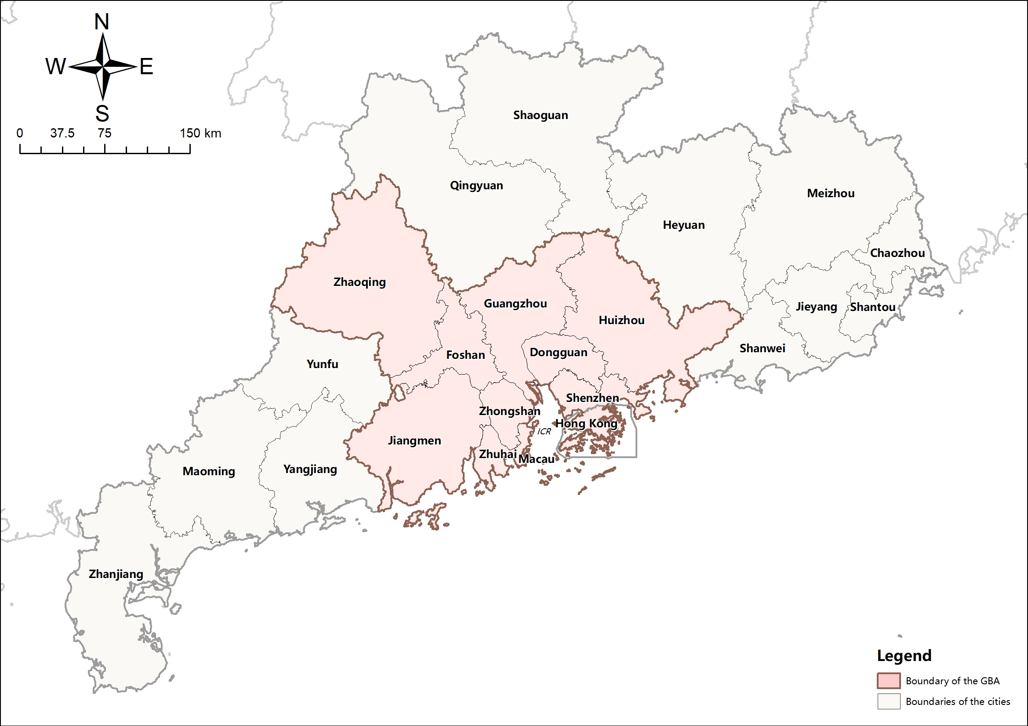

Figure 3-1 Map of cities in the study area

## Research framework

The research framework consists of 1 data preparation stage and two research stages (Figure 3-2).

In the data preparation stage, four types of data, namely travel time, travel flow, socio-economic data, and corresponding topological data of traffic networks and city boundaries, are collected from various sources and pre-processed for subsequent analysis.

The first research stage concentrates on the current equity analysis of road transportation and train transportation. It starts with the comparison of ATT for each city from and to all the other cities by car and by train, respectively, by plotting the ATT and the difference between them. Then the CV of the ATTs is calculated at both the GBA level and the extended 23-city level for comparison. Similar analyses can then be performed on PV and total traffic flow (TTF, sum of inbound and outbound flows of a specific city) to investigate transportation equity. Once changes in accessibility and flow are calculated, the 23 cities are classified into different groups according to their gains and performance in HSR constructions.

The second stage of the research applies a calibrated spatial interaction model to simulate train flows in planning scenarios using preprocessed data. Analysis similar to the above one is then performed to compare accessibility distribution and flows of HSR trips in current and planning scenarios. The main objective of this stage is to understand how each city benefits from new HSR constructions in planning scenarios and to investigate whether planned HSR networks improves HSR transportation equity.

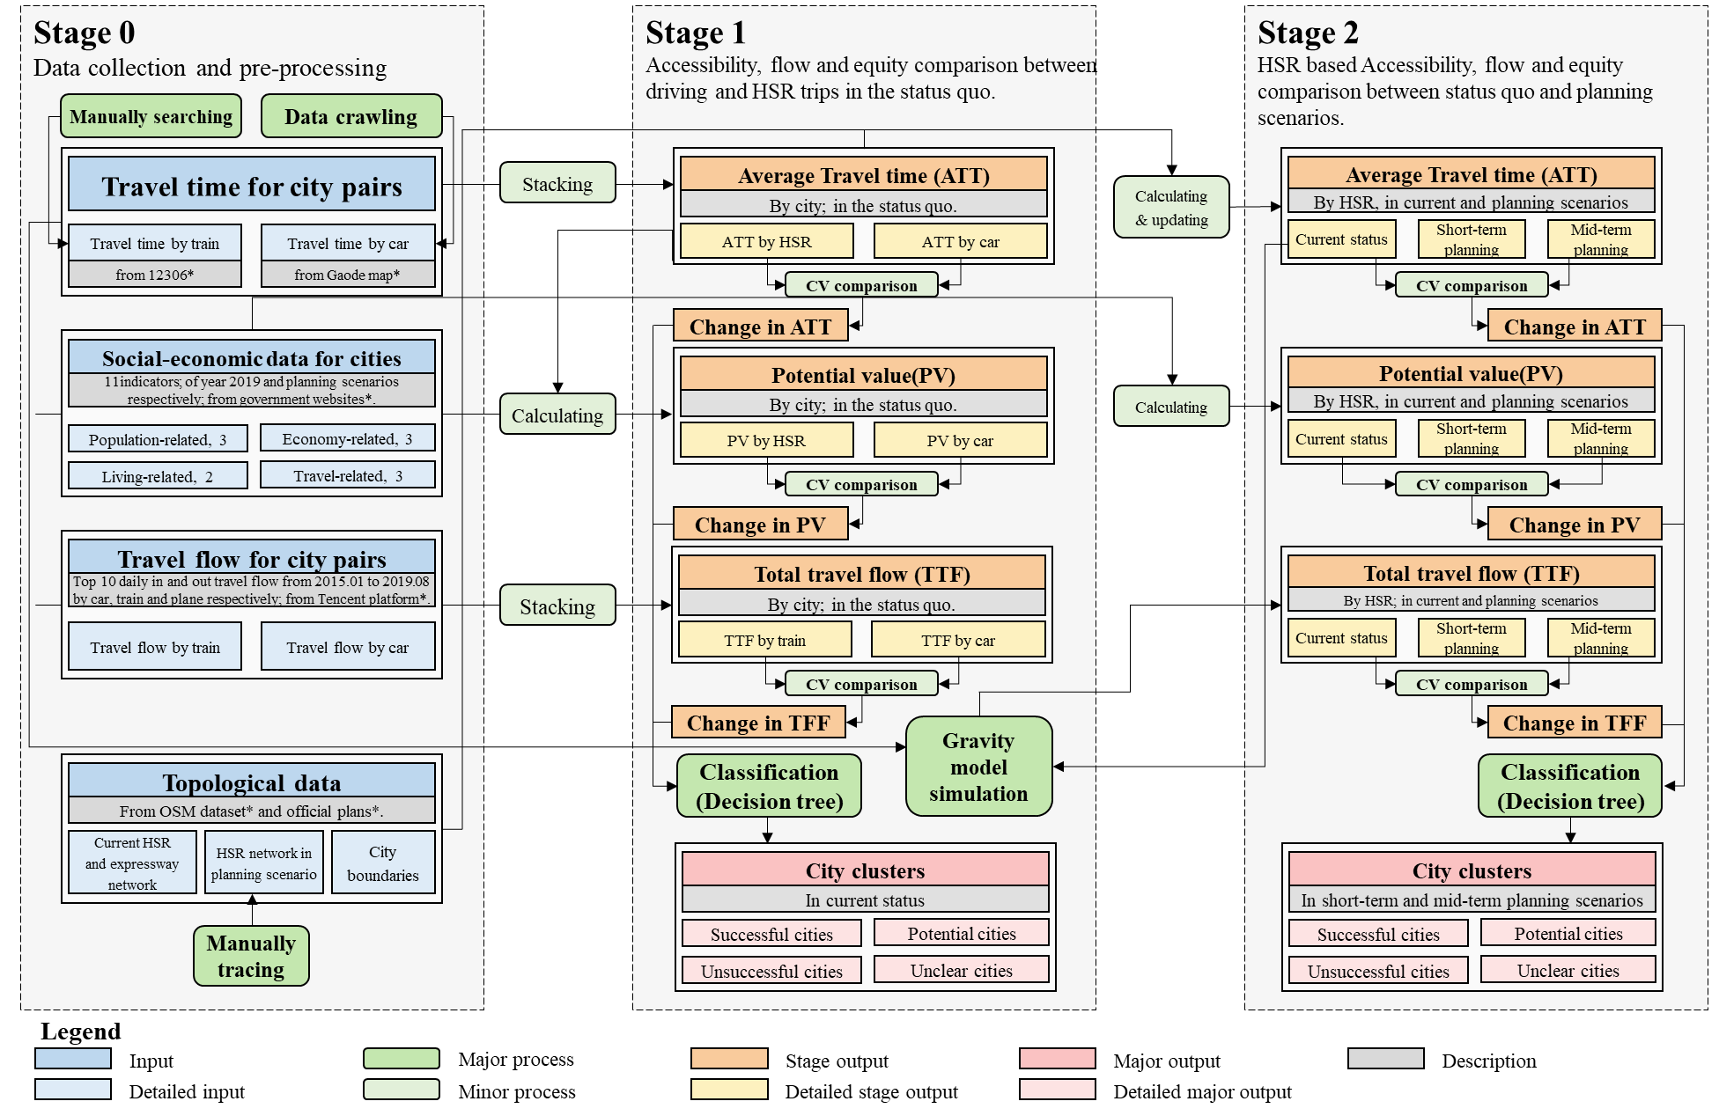

Figure 3-2 Research framework

## Data extraction and processing

The study employs four dataset types extracted from nine online data sources. Section 7.1 presents details of the data sources, whilst Sections 7.2 to 7.4 present the processed travel time data, flow data, and socio-economic information[1].

### Travel time

Travel time denotes the travel cost. It’s one of the primary indicators to measure the accessibility pattern and is also essential for the gravity model for flow simulation. Unlike physical distance deployed in existing studies (Rees and Dennett, 2019), travel time naturally unifies driving and HSR trip costs. This research adopts two types of travel time from three different sources. The driving travel time is captured from Gaode Map Direction API[2] using Python. This API automatically suggests the best route according to the start and end coordinates with a preference for the shortest real-time travel time. The corresponding travel time and distance are returned upon each inquiry. Exact origins and destinations are uniformly set at the prefecture cities’ government buildings, as many cities have multiple railway stations and coach stations. All driving time is collected at around 2 a.m. Beijing time. The process is repeated several times on different dates to get the shortest driving time possible and avoid the impact of traffic conditions. A driving time matrix between all 23 cities is built when the minimum driving time for each O-D pair tends to stabilize.

Current travel times by train are obtained from *12306 China Railway*, the official website for booking all kinds of railway tickets[3]. The website returns all trains scheduled between two selected stations or cities on any specific date in the next 30 days upon inquiries or transfer plans if direct trains are unavailable. This task is manually conducted as there is no API available. Besides, there are usually multiple stations in a prefecture-city, and trips between the most appropriate stations (i.e. most close to prefecture-level city centre rather than county centres or new districts) can only be manually identified. Even for the same origin city, the most appropriate station changes with the destination. Furthermore, the train schedules or transfer plans available can be different on different dates, and the one with the shortest travel time can only be validated through multiple manual inquiries. As expected, the minimal travel time for most O-D pairs is by HSR, and if not, usually there is no HSR line in operation for the specific O-D pair. In other words, the minimal travel time by train already fully represents the impact of current HSR construction on travel time.[4]

Change in travel time in planning scenarios is necessary for investigating future HSR construction’s impact on accessibility and equity pattern. The travel time by HSR in planning scenarios is updated from the current travel time with topological HSR networks (introduced in Section 3.3.4 ). If a shorter route is constructed between a specific O-D pair, then the corresponding travel time will be updated. The average speed is set at 210km/h, considering the acceleration and deceleration during departure and arrival at each station along the route. Travel time remains unchanged as long as the shortest routes are unchanged. The long-term HSR plan is more about connecting peripheral cities with cities outside GD with limited travel time impacts intra-regional journeys within the study area. Thus only time matrixes for short-term and mid-term plans are created.

### Travel flows

Travel flow is used as a substitute indicator for ELI(Wu *et al.*, 2017; Zheng and Cao, 2021) to validate the accessibility pattern and depict the change in transportation equity. Current flow is also essential for the simulation of flow in planning scenarios. Official flow data from bureaus of statistics and transportation is scarce. GD statistic yearbooks only record the annual number of passengers by city and by transportation mode that is not divided into O-D pairs (China State Council, 2020). However, a growing number of big tech companies are establishing their platforms to provide nationwide passenger flow data and regional heatmap based on anonymous location information of their application users.

Examples are the Baidu migration platform[5], the Tencent Location Big Data Platform[6], and the Gaode migration platform[7], all of which provide flow data publicly available on the internet and free of charge. This research investigates equity patterns by scraping and studying flow data from the Tencent platform, which classifies the passenger flows by three major modes of transportation, i.e., driving, railway and plane.

The raw flow data downloaded is 1.46 gigabytes in size and consists of daily records of the top 10 inbound and outbound flows of major prefecture cities in China with transportation mode information. It covers a period from Jan 1st 2015 to Aug 31st 2019. The flow of each transportation mode within the study area is extracted and aggregated by month. The directions of all records are then unified, and duplicate records with the same O-D information, transportation mode and time are deleted. As flow data after summation fluctuated strongly before January 2017 and after April 2019 (Figure 3-1), only flow within this period is selected and added up, making the final flow matrixes for subsequent analysis (Table 7‑6 and Table 7‑7). Furthermore, the time coincides with the socio-economic data, which is collected towards the end of 2019 and used in this research.

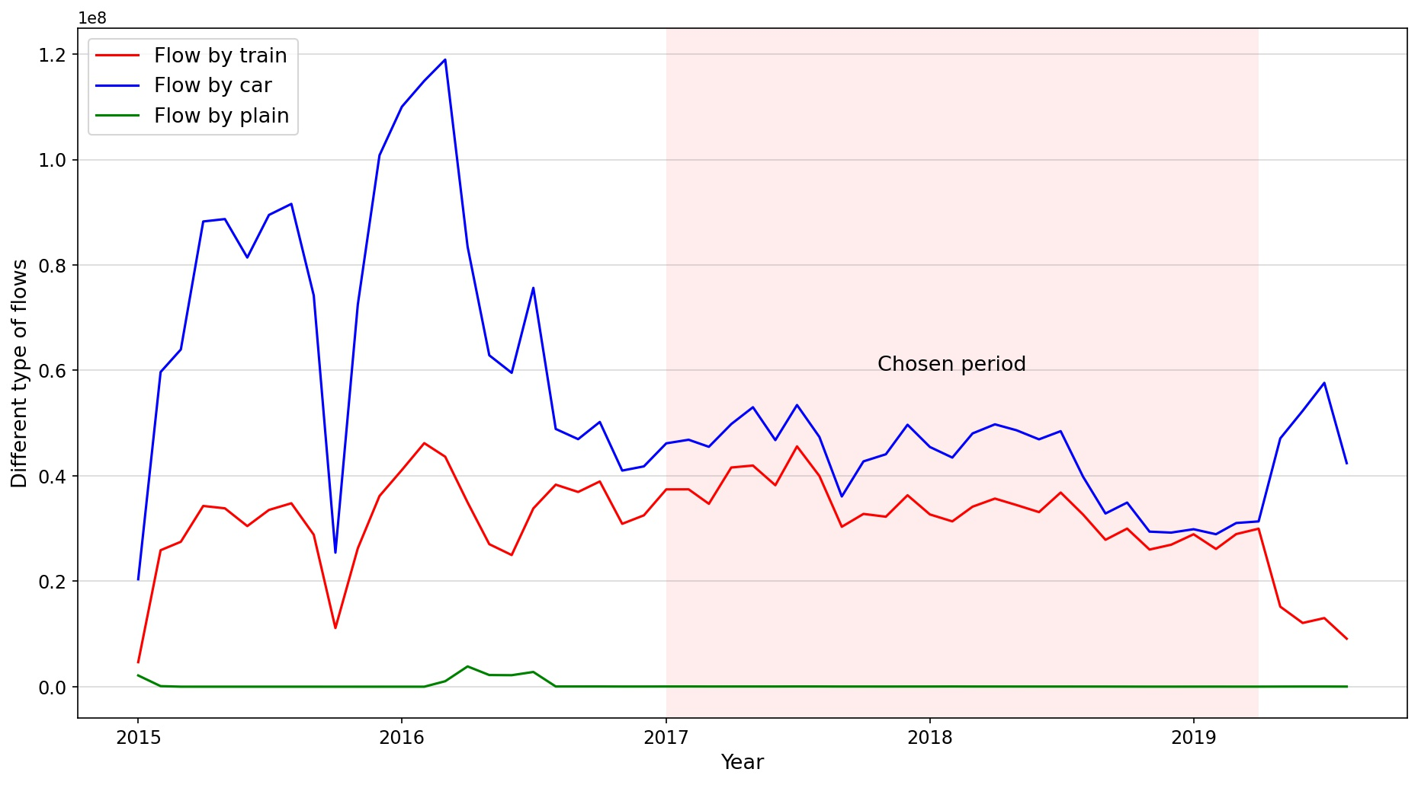

Figure 3-3 Fluctuation of flow between cities in the study area

### Socio-economic data

Apart from observed flow and travel cost represented by travel time, socio-economic indicators are the other essential type of data for spatial interaction modelling. There are 11 indicators employed in this research from the four aspects of population, economy, life and travel (Table 3‑1). Most data are available in GD statistical yearbook 2020, with three exceptions. The housing price is obtained from Anjuke[8], an online real estate trade platform. The railway length is calculated from current and planned HSR networks. Finally, part of the statistics for Hong Kong and Macau is supplemented by data from Hong Kong annual digest of statistics 2020[9] and the Macau yearbook of statistics 2020[10]. The date of all data is uniformly set at 2019, as data from the latest official statistical yearbook is collected towards the end of 2019, which also coincides with the flow data employed.

Table 3‑1 Definition of socio-economic data used in this research

|  |  |  |  |  |
| --- | --- | --- | --- | --- |
| **Aspects** | **Indicators** | **Description** | **Unit** | **Label** |
| Population | **Population** | Registered population at the end of 2019 | 10000 persons | Pop |
| **Labour force** | Number of Employed Persons at the end of 2019 | 10000 persons | Lab |
| Economy | **Per capita GDP** | Per capita gross domestic product of 2019 | 10000 yuan /1 person | Gdp |
| **Investment in fixed assets** | Investment in fixed assets of 2019 | 100 million yuan | Ifa |
| **Foreign trade** | Total exports and imports of 2019 | 100 million yuan | Ft |
| **R&D investment** | Research and development expenditure of 2019 | 10000 yuan | Rdi |
| Life | **Number of primary schools** | Number of primary schools owned by unit population in 2019 | unit/10000 persons | Edu |
| **Housing price** | Average housing price per unit area in 2019 | 10000 yuan /㎡ | Hp |
| Travel | **Car ownership** | Possession of civil vehicles by unit population in 2019 | unit/10000 persons | Co |
| **Highway length** | Length of highways in 2019 | km | Hwl |
| **Railway length** | Length of railways in 2019 | km | Rwl |

### Topological data

Topological data renders it possible to estimate travel time and simulate flow in the planning scenarios. It is also used to plot the base map for visualization and comparison of different accessibility indicators in this research. There are three types of topological data employed in this research: current traffic networks, including expressway and railway networks, the administrative boundaries of GD and the 23 cities, and the HSR networks in planning scenarios. The former 2 are OpenStreetMap data downloaded from Geofabrik’s free download server[11], while the planned HSR networks are manually collected and traced from various sources.

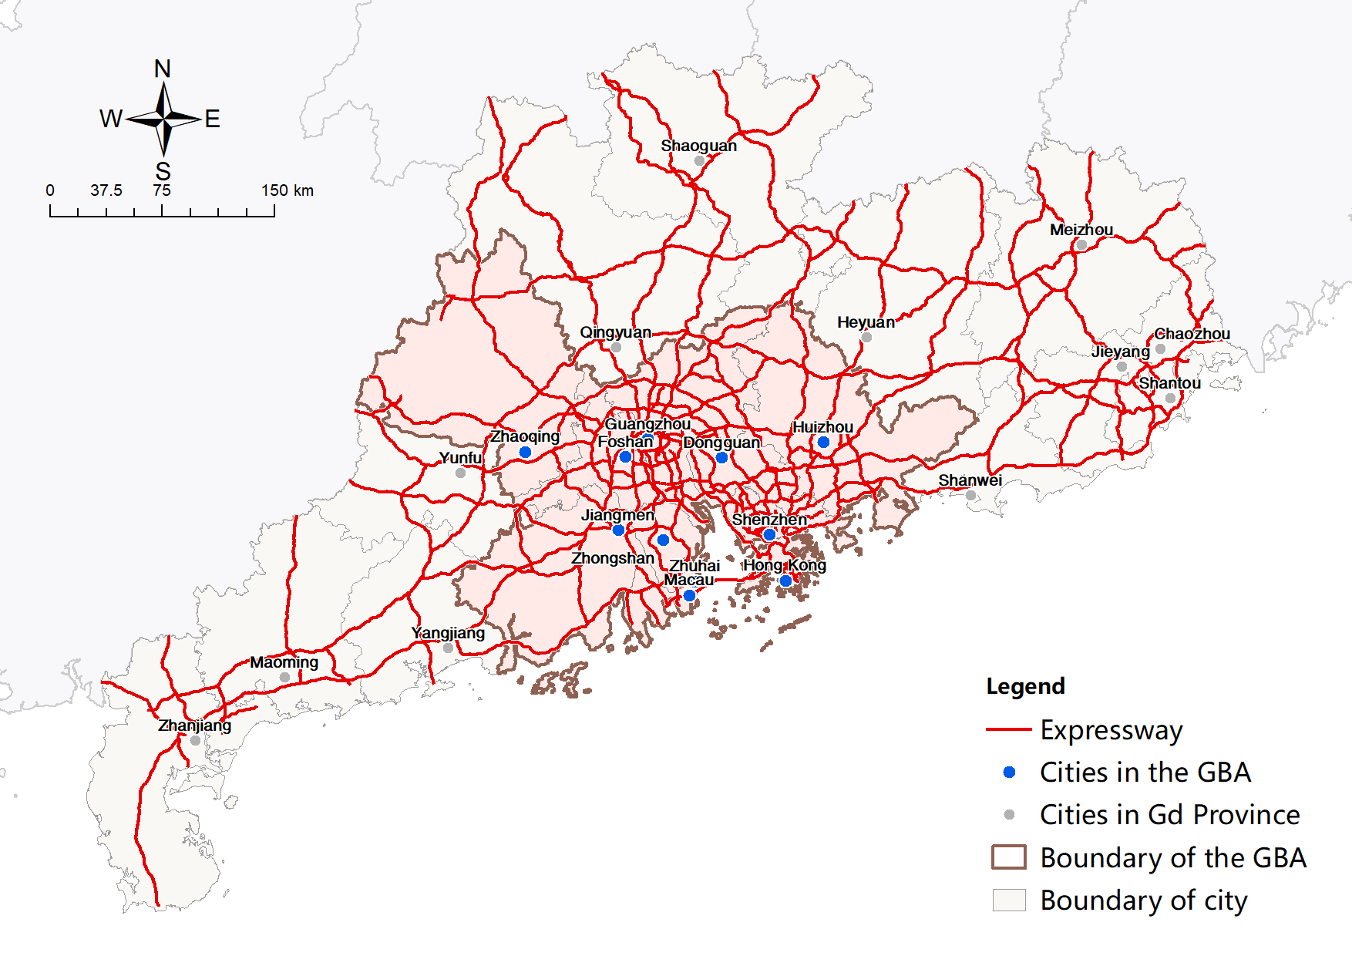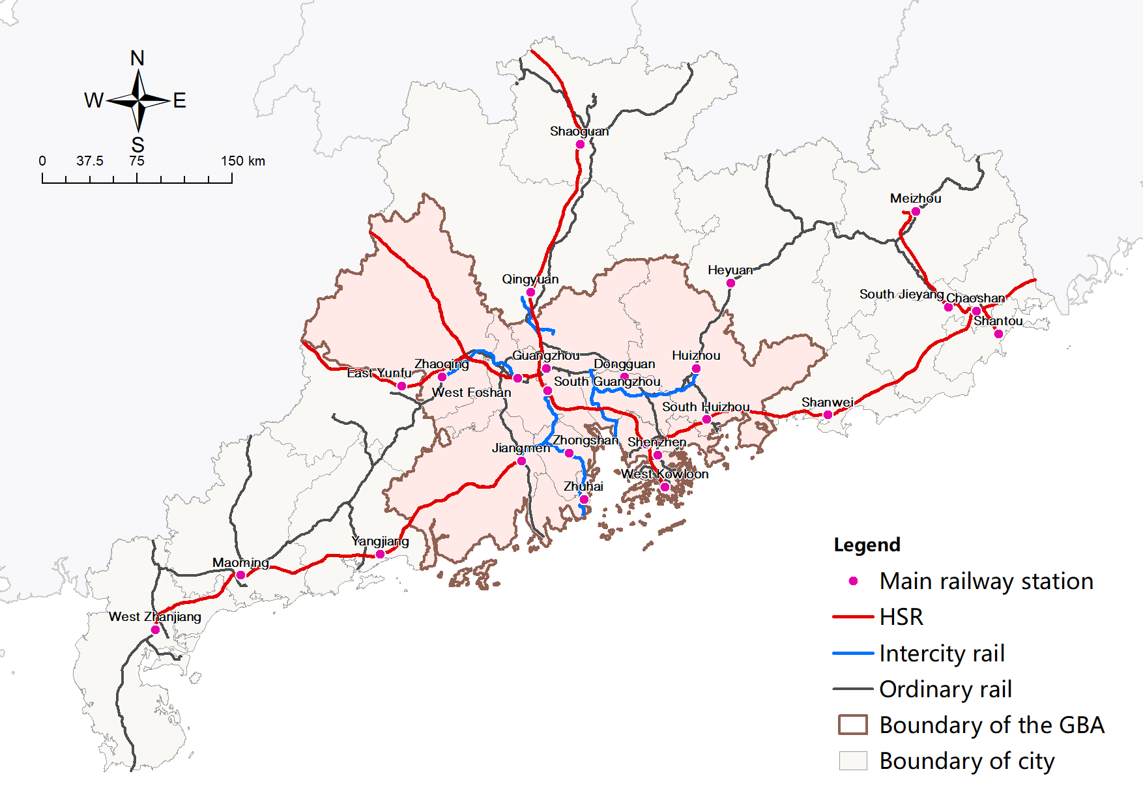

Figure 3-4 Expressway (left) and Railway (right) network in the study area

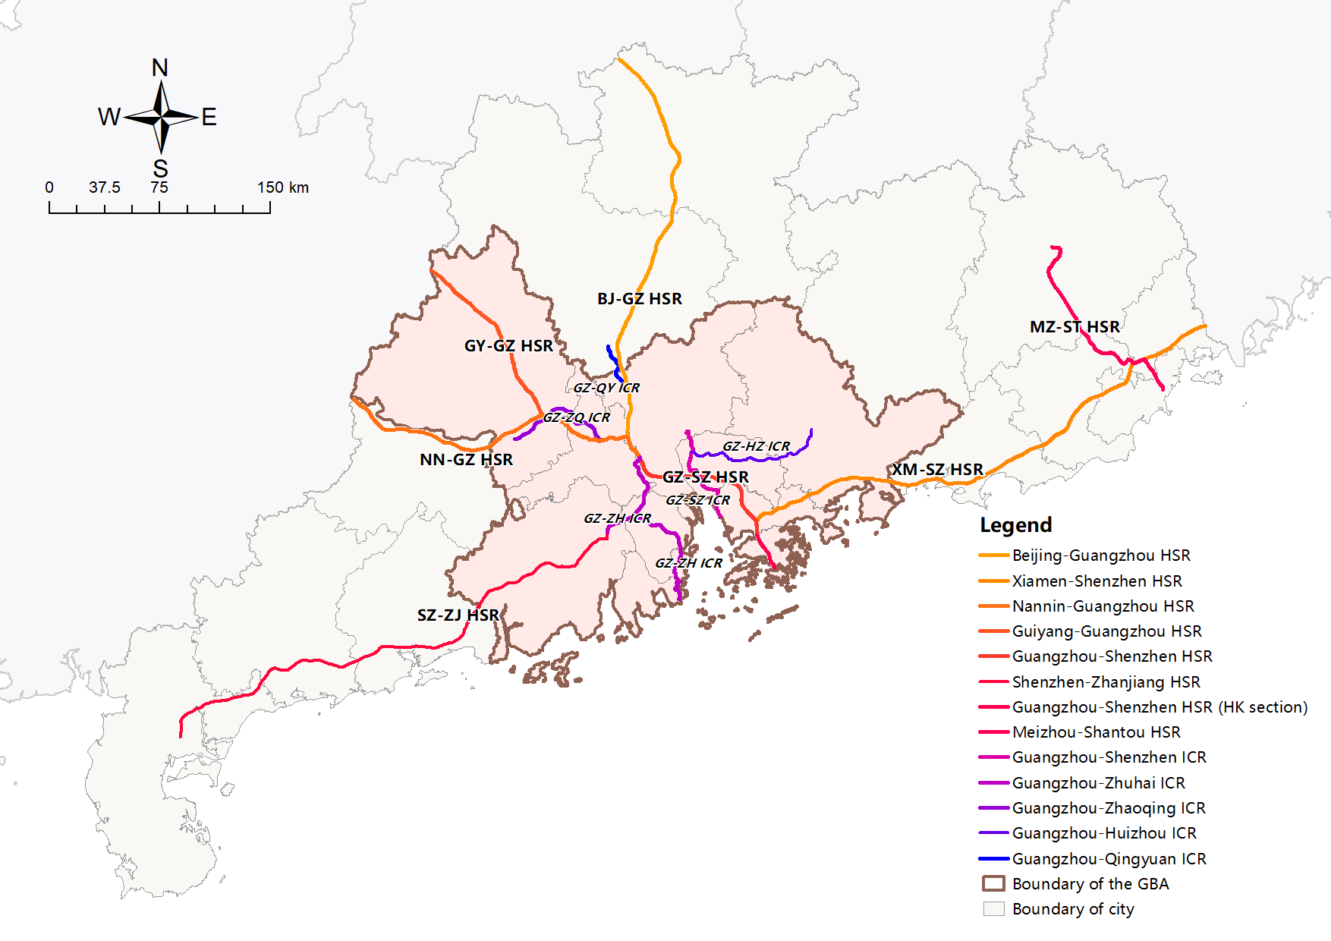

Figure 3-5 Current HSR lines in the study area

Currently, there are 7 HSR lines and 5 ICR lines in operation (Figure 3-5). Their completion time is listed in chronological order inTable 3‑2[12]. The network is gradually taking shape with a distinct core, Guangzhou, where most lines converge, and trips between peripheral cities transfer. HSR construction is far from complete as four cities out of 23 are still not connected by the network, namely Heyuan, Zhuhai, Macau and Huizhou. Some of the lines are partially completed and disconnected to the regional HSR network, and only an end-end line connects most peripheral cities.

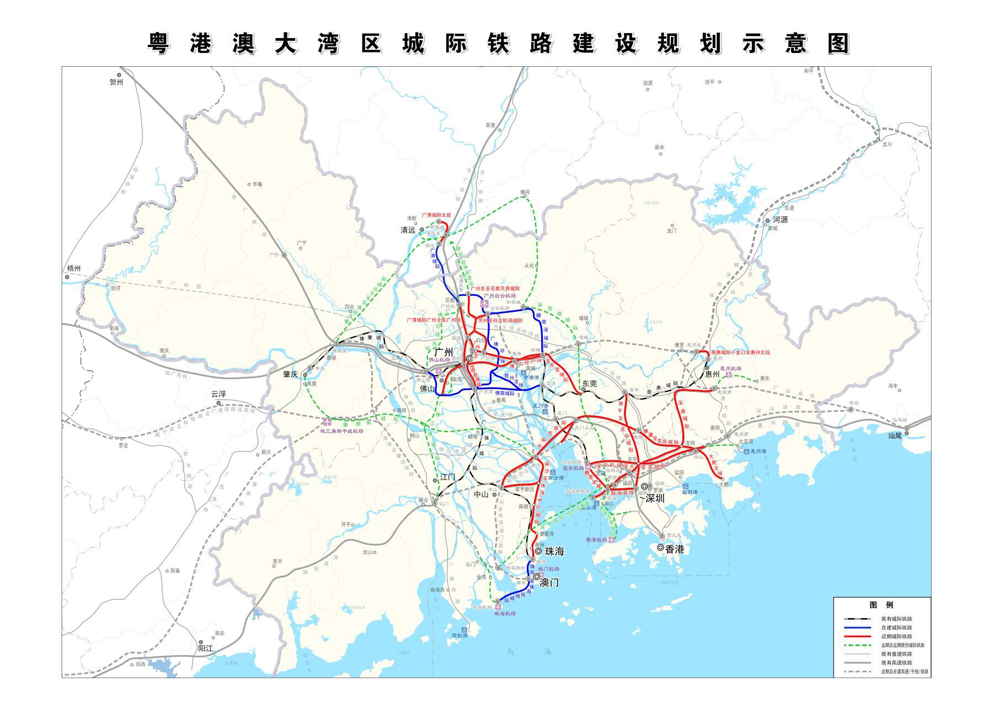

Figure 3-6 Schematic diagram of the ICR construction plan for the GBA (NDRC, 2016b)

Table 3‑2 Completion time of current HSR and ICR lines in the study area

|  |  |  |  |
| --- | --- | --- | --- |
| **Line type** | **Name** | **Time of completion** | **Cities connected** |
| **HSR** | Beijing-Guangzhou HSR | Dec 2009 | Guangzhou, Qingyuan, Shaoguan |
| Xiamen-Shenzhen HSR | Dec 2013 | Shenzhen, Huizhou, Shanwei, Jieyang, Shantou, Chaozhou |
| Nanning-Guangzhou HSR | Dec 2014 | Guangzhou, Foshan, Yunfu, Zhaoqing |
| Guiyang-Guangzhou HSR | Dec 2014 | Guangzhou, Foshan, Zhaoqing |
| Guangzhou-Shenzhen HSR | Jan 2015 | Guangzhou, Shenzhen |
| Shenzhen-Zhanjiang HSR(Zhanjiang-Jiangmen section） | Jul 2018  (partially completed) | Zhanjiang, Maoming, Yangjiang, Jiangmen |
| Guangzhou-Shenzhen HSR(Hong Kong section) | Sep 2018 | Shenzhen, Hong Kong |
| Meizhou-Shantou HSR | Oct 2019 | Shantou, Chaozhou, Jieyang, Meizhou |
| **ICR** | Guangzhou-Shenzhen ICR | Apr 2007 | Guangzhou, Shenzhen |
| Guangzhou-Zhuhai ICR | Dec 2012 | Guangzhou, Foshan, Zhongshan, Zhuhai, Jiangmen |
| Guangzhou-Zhaoqing ICR | Mar 2016 | Guangzhou, Foshan, Zhaoqing |
| Guangzhou-Huizhou ICR | Mar 2016 | Guangzhou, Dongguan, Huizhou |
| Guangzhou-Qingyuan ICR | Nov 2020 | Guangzhou, Qingyuan |

The construction plan of the HSR network in the GBA has been determined and can be reflected in the ICR construction plan for the GBA approved by China’s central government in July 2020 (NDRC, 2016b) (Figure 3-6). However, HSR construction in other parts of GD has not been determined up till now. Governments of different levels put forward plans for their interest, most of which are neither legally effective nor open to the public. In this research, an integrated plan from various online sources is collated and manually traced. The constructions in the short-term and mid-term planning scenarios focus on establishing and strengthening connections between cities in GD. All peripheral cities have been connected to central cities in the short-term plan, and further connections between peripheral cities are established in the mid-term scenario (Figure 3-7). In contrast, long-term planning is more dedicated to connecting cities within and outside the province.

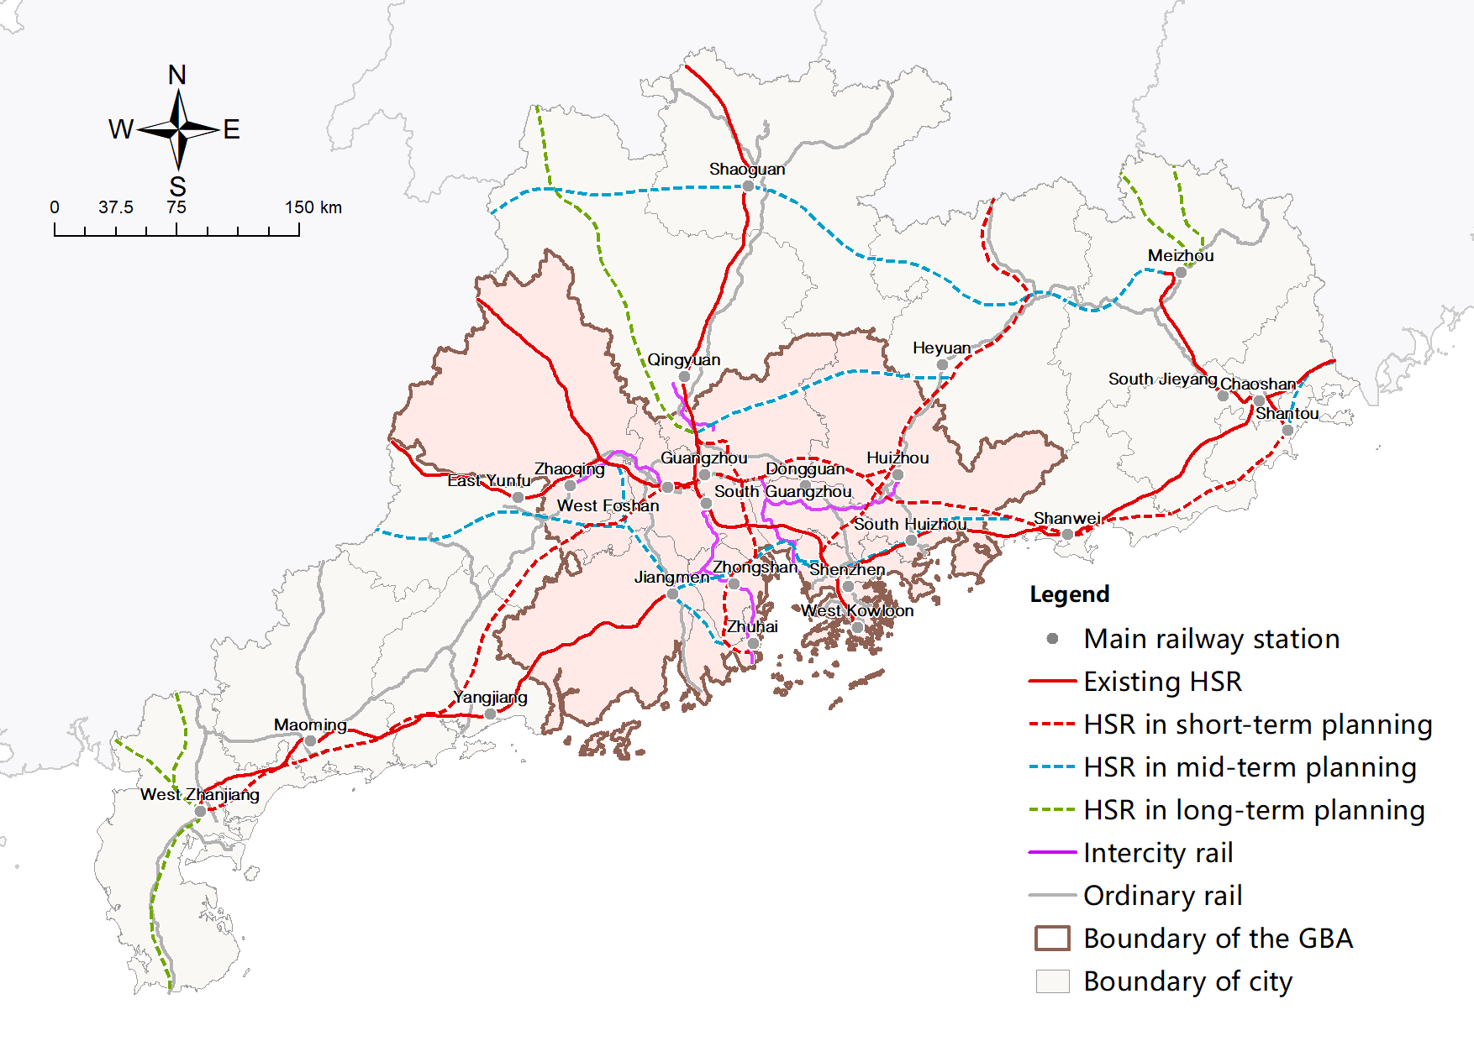

Figure 3-7 HSR network in planning scenarios

(source: collated and traced from various sources)

## Accessibility measurement

Among the three most commonly used indicators for accessibility measurement reviewed in Section2.4.1 , only ATT and PV are applied in this research. DA is excluded on the grounds that most cities are possibly within a 4-hour HSR radius from any other city in planning scenarios. Moreover, ELI is replaced by actual traffic flow, which will supplement and validate gravity-type theoretical estimations of PV.

### Average travel time (ATT)

This research uses ATT between a prefecture-level city and all the other cities in the study area to measure HSR’s space-time compression effects and calculate accessibility from a time and distance cost perspective. Unlike WATT (Gutiérrez, 2001; Jiao *et al.*, 2014; Xu *et al.*, 2019), which is affected by the cities’ economic size, ATT focuses only on the transportation network itself and corresponding travel time benefits, as shown below:

${TA}_{i}=\sum_{j=1}^{n}{t_{ij}}/n$ ( 3‑1 )

where ${TA}_{i}$ comprises the ATT from city i to all the other cities; $t_{ij}$ signifies the shortest travel time from city i to city j; n is the number of cities.

### Potential value (PV)

PV is another frequently-applied attractiveness-based accessibility metric reflecting the total amount of socio-economic opportunities in destination cities and the ease of access to them (Gutiérrez, 2001; López et al., 2008; Monzón, 2013). In this research it takes the following form:

$PA_{i}=\sum_{j=1}^{n}{\sqrt{P_{j}G_{j}}}/t_{ij}^{α}$ ( 3‑2 )

where $PA_{i}$ represents the PV of city i; $P_{i}$ and $G_{i}$ comprise the population and GDP of city j; $t_{ij}$ denotes the travel cost represented by corresponding minimum travel time; $α$ reflects the distance decay effect or rate at which travel decrease with travel cost increase represented by travel time. It’s usually obtained from local travel surveys, which are unavailable in China, and thus set to be 1 following various accessibility modelling cases in various contexts (e.g. Hou and Li, 2011; Cao et al., 2013;The World Bank, 2014;Zhu, Yu and Chen, 2015; Chen and Haynes, 2017;Gutiérrez, 2001). Unlike previous studies using only one variable (Vickerman, 1999; Gutiérrez, 2001), the number of opportunities is represented by the square root of the population and GDP of the destination as per Jiao(2014) and Zheng (2021), which differs from previous research that used only GDP or population. As can be seen from the above equation, PV is a particular case of spatial interaction model. More general forms such as ELI will be introduced later.

### Total traffic flow (TTF)

ELI is also a gravity-type indicator widely used in accessibility measurement (Liu and Zhang, 2021). Compared to PV, which only includes attractions in destination cities, ELI evaluates economic interactions’ strength based on the attractiveness of both destinations and origins, using the following calculation:

$EA_i=\sum_{j=1}^{n}{\sqrt{P_{i}G_{i}}}\sqrt{P_{j}G_{j}}/t_{ij}^{2}$ ( 3‑3 )

where $EA_i$ represents the ELI of city i; $P_{i}$, $G_{i}$, $P_{j}$, $G_{j}$, are the population and GDP of city i and j; $t_{ij}$ is the minimum travel time from city i to city j.

As ELI’s calculation strictly complies with the form of the gravity model, this research replaces ELI with the TTF of each city in the current and planning scenarios. Since both PV and ELI are theoretical estimations while TTF and ATT are actual results from observations, it is reasonable to believe that TTF is more convincing than ELI. Combining theoretical estimations and realistic observations can better explain the degree and change in accessibility more comprehensively from different dimensions. The TTF take the following form:

( ‑ )

where denotes the TTF of city i ; $F_{ij}$ and $F_{ji}$ are the flows from and to city i and city j respectively.

## Inequality measurement

This research applies CV to evaluate the degree of variation in accessibility and capture the change in inequality under different transportation scenarios, as it makes a simple to calculate, easy to understand index to monitor disparity changes (Liu and Zhang, 2018):

$CV=(SD/MN)*100\%$ ( 3‑5 )

where SD and MN refer to the standard deviation and mean of the chosen accessibility indicators, respectively.

## Flow simulation

The spatial interaction model is employed to simulate the HSR traffic flow in planning scenarios. First introduced by Wilson(1971), the family of spatial interaction models based on different constraints has been widely employed in existing studies (Karemera, Oguledo and Davis, 2000; Shen, 2017). Among the four types of model in the family, the unconstrained model (Wilson,1971) is selected to simulate the future flow:

$TD_{ij}=K_{d}O_{i}^{αd}D_{j}^{γd}t_{ij}^{-βd}$, $TH_{ij}=K_{h}O_{i}^{αh}D_{j}^{γh}t_{ij}^{-βh}$, ( 3‑6 )

w.r.t. ${TD}_{i}=\sum_{j=1}^{n}{{TD}_{ij}},$ ${TH}_{i}=\sum_{j=1}^{n}{{TH}_{ij}},$ ( 3‑7 )

and $TD=\sum_{j=1}^{n}{\sum_{j=1}^{n}{{TD}_{ij}}}$; $TH=\sum_{j=1}^{n}{\sum_{j=1}^{n}{{TH}_{ij}}}$; ( 3‑8 )

Where ${TD}_{ij}$ and ${TH}_{ij}$  are the flows from origin $O_{i}$ to destination $D_{j}$ by car and by HSR, respectively; ${TD}_{i}$ and ${TH}_{i}$ comprise the sum of flow from city i by car and by HSR respectively; ${TD}_{i}$ and ${TH}_{i}$ signify the sum of flow between all city pairs by car and by HSR respectively; $K$ is the scaling constant of proportionality calculated with the sum of all estimated flows; $O_{i}$ and $D_{j}$ are the mass of attraction of the origin $i$ and destination $j$ respectively; $α$, $γ$ are the parameters explaining how the origin and destination stimulates traffic flow; and $β$ is the parameter capturing the rate at which $t_{ij}$ impedes ${TD}_{ij}$ and ${TH}_{ij}$ .

Then the 11 socio-economic indicators introduced in Section 3.3.2 are deployed to replace $O_{i}^{α}$ and $D_{j}^{γ}$ to simulate the attraction of the origins and destinations following previous studies (Karemera, Oguledo and Davis, 2000; Fan, 2005; Shen, 2017). By taking logarithms at both sides, the above equations are transformed into the following statistical models:

$lnTD_{ij}=k_{D}+α_{d1}lnPop_{i}+α_{d2}lnLab_{i}+α_{d3}lnGdp_{i}+α_{d4}lnIfa_{i}+α_{d5}lnFt_{i}+α_{d6}lnRdi_{i}+α_{d7}lnEdu_{i}+α_{d8}lnHp_{i}+α_{d9}lnCo_{i}+α_{d10}lnHwl_{i}+γ_{d1}lnPop_{j}+γ_{d2}lnLab_{j}+γ_{d3}lnGdp_{j}+γ_{d4}lnIfa_{j}+γ_{d5}lnFt_{j}+γ_{d6}lnRdi_{j}+γ_{d7}lnEdu_{j}++γ_{d8}lnHp_{i}+γ_{d9}lnCo_{j}+γ_{d10}lnHwl_{j}-β_{d}lnt_{ij}$, ( 3‑9 )

$lnTH_{ij}=k_{H}+α_{h1}lnPop_{i}+α_{h2}lnLab_{i}+α_{h3}lnGdp_{i}+α_{h4}lnIfa_{i}+α_{h5}lnFt_{i}+α_{h6}lnRdi_{i}+α_{h7}lnEdu_{i}+α_{h8}lnHp_{i}+α_{h9}lnRwl_{i}+γ_{h1}lnPop_{j}+γ_{h2}lnLab_{j}+γ_{h3}lnGdp_{j}+γ_{h4}lnIfa_{j}+γ_{h5}lnFt_{j}+γ_{h6}lnRdi_{j}+γ_{h7}lnEdu_{j}+γ_{h8}lnHp_{j}+γ_{h9}lnRwl_{j}-β_{d} lnt_{ij}$, ( 3‑10 )

To deal with multicollinearity, variables are selected using two stepwise selection processes based on $p$-value and adjusted $R^{2}$, respectively. Both processes are based on the bidirectional elimination approach, which adds variables with the most significant improvement of fit, and then removes the variables causing the most insignificant deterioration of fit.

## Binary tree classification

Based on previous work, the 23 cities within the study area are classified into groups to comprehensively evaluate their gains and performance in HSR constructions. Trials have been made using unsupervised classification methods such as K-means clusterings. However, the outcomes from the unsupervised classification are hard to interpret. Therefore, the supervised binary tree classification is employed for its clear rules, which lead to more meaningful results. In the current scenario, cities high in both ΔATT and ΔPV are classified as successful cities, and cities high in ΔATT but low in ΔPV comprise unsuccessful cities. Potential cities are cities with low ΔATT and high ΔPV, and unsuccessful cities are cities low in both ΔATT and ΔPV. Then cities from each of the four types with the highest ΔFlow values are identified, generating the final result. Cities are also classified based on the difference in these values under current and planned scenarios to evaluate their benefits in planning scenarios.

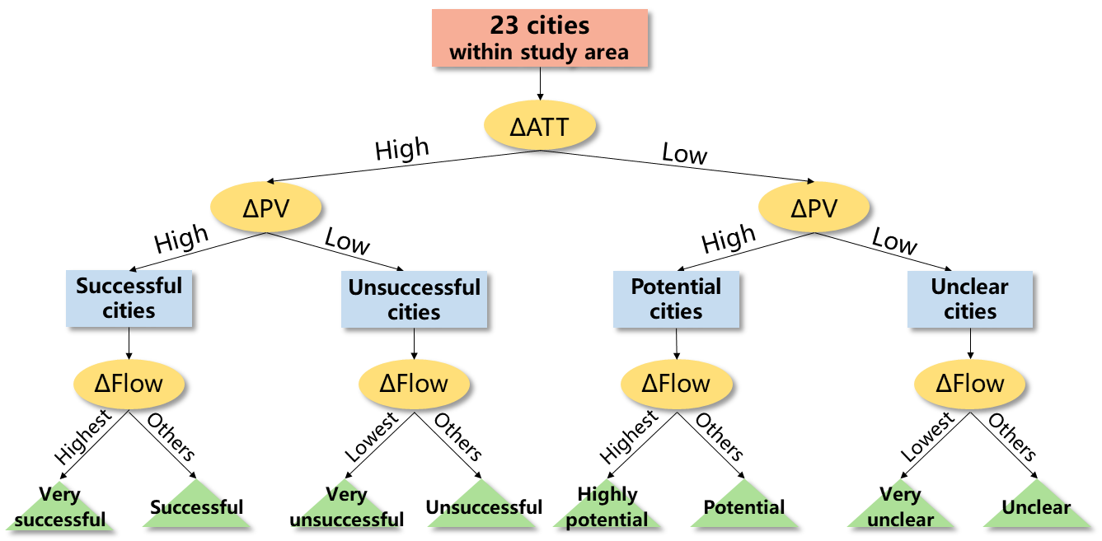

Figure 3-8 City classification procedure based on ATT, PV and flow differences

## Ethical statement

The ethical risk in this research is minimal. All data employed is public and freely available online and contains no personal information. The passenger flow records are anonymized, and the socio-economic data is published on China’s government-run statistical websites and available for academic research. Traffic times and topological data were obtained from online public sources and are not restricted to a specific use. Data sources are listed in Section 7.1 and the preprocessed datasets have been published online for public supervision.

# Results and Discussions

## Current situation

### ATT impacts of HSR

ATT is employed in the research to identify the time-saving impacts of the HSR network without considering the relative economic magnitude of cities (Liu and Zhang, 2021). The travel time reductions resulting from HSR constructions are evident across the study area.

Figure 4-1 reveals that driving ATT conforms to a distinct core-periphery pattern, with the lowest values from central mainland cities (Guangzhou and Shenzhen) and the highest values from cities at the east (Chaozhou), west (Zhanjiang and Maoming), and north (Shaoguan). The high ATT values at both eastern and western sides are attributed partly to restrictions caused by the narrow shape of GD, while the mountainous terrain in the north also hindered improvements to Shaoguan’s traffic. With the advent of HSR, ATT shifted to a corridor pattern, with the lowest ATT values concentrated along the Wuhan-Guangzhou corridor and a gradual increase towards the east and west. Cities with the highest ATT values vary in driving and HSR scenarios, with Zhanjiang witnessing the highest driving ATT value and Heyuan, the only city without HSR connection, possessing the highest ATT for HSR. The ATT surface for HSR is more abrupt compared to the smooth driving ATT surface as a result of having an HSR network with much lower density and coverage.

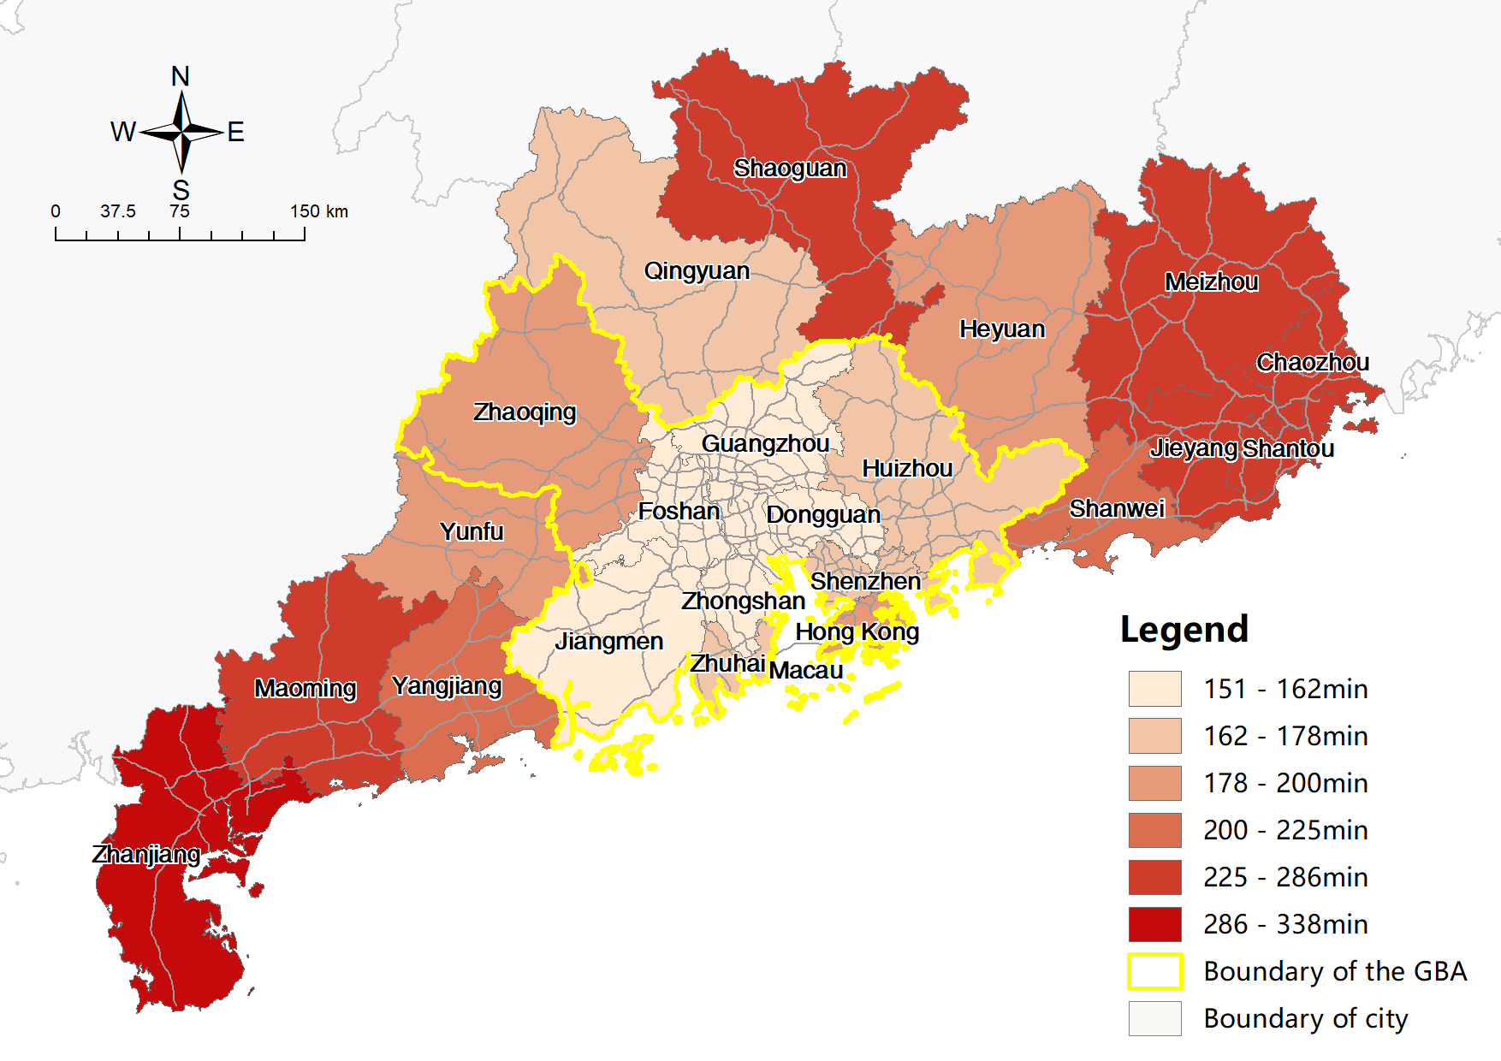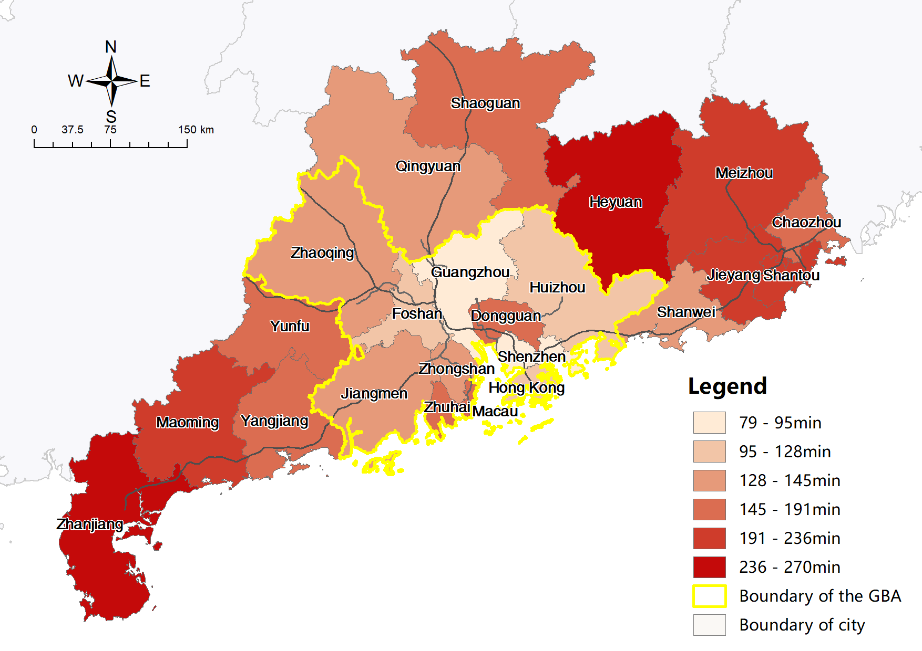

Figure 4-1 Maps of ATT by car (left) and by HSR (right) of study area cities

Table 4‑1 and Figure 4-2 reveals HSR significantly shortened the time distance between cities and reduced intra-city travel costs. The overall ATT dropped from 210 min to 168 min after the introduction of HSR. The reduction of 19.8% is smaller than 30%-60% reported in previous European and Asian studies (e.g., de Rus and Inglada, 1997; Fröidh, 2005; Cascetta et al., 2011; Albalate and Bel, 2012; Jiao et al., 2014; Liu and Zhang, 2017) that focused on the time-saving effects between major cities along main corridors. The spatial scale in this research is much smaller, and the benchmark, namely expressways, are faster than the benchmarks used in previous studies (conventional railways). ATT in the GBA cities decreased by 20.09%, while ATT in cities outside the GBA fell by 19.61%. In the HSR scenario, the disparity pattern of ATT worsened as CV increased from 25.08% to 29.26%. The CV within the GBA increased dramatically from 7.81% to 23.50%, while the magnitude of the CV increase among cities outside the GBA was much smaller. Furthermore, the CVs for the whole study area are much higher than that for cities within or outside the GBA, indicating a huge disparity in cost-based accessibilities between these two city types.

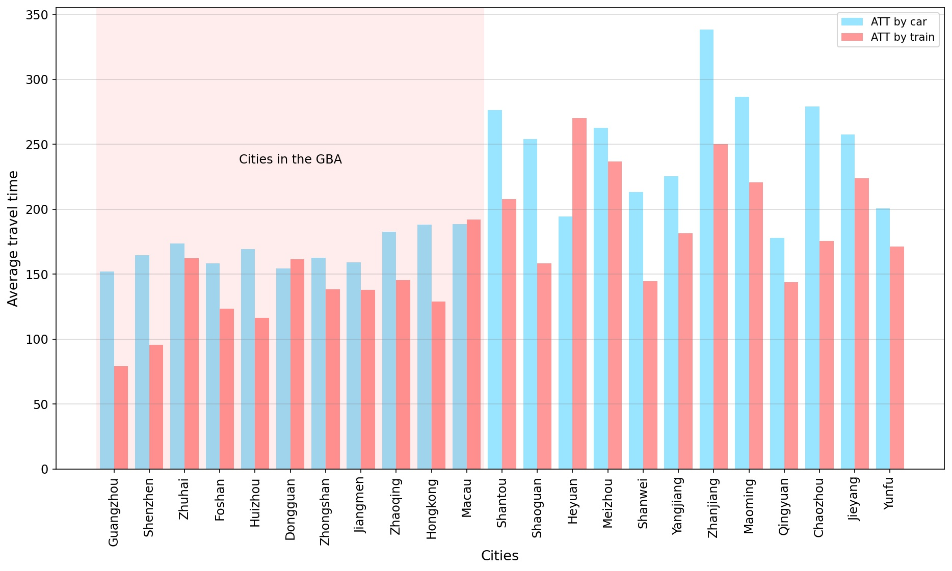

Figure 4-2 ATT by car (left) and by train (right) of study area cities

Table 4‑1 CV and Mean of ATT in current driving and HSR scenarios

|  |  |  |  |  |
| --- | --- | --- | --- | --- |
| **Indices** | **CV** | | **Mean (minute)** | |
| **Driving** | **HSR** | **Driving** | **HSR** |
| **All cities** | 25.08% | 29.26% | 210 | 168 |
| **Cities within GBA** | 7.81% | 23.50% | 168 | 135 |
| **Cities outside GBA** | 18.68% | 21.24% | 247 | 199 |

The distributions of absolute and relative changes in ATT (Figure 4-3) are inconsistent. However, Heyuan is undoubtedly the biggest loser, with the largest ATT increases in both absolute and relative terms, which means railway transportation from and to Heyuan takes even longer than driving. This is because Heyuan is the only prefecture-level city not connected by the HSR network. It is neither a major city nor on the path of the inverse T-shaped HSR corridors (NDRC, 2016b). There are two types of winners in travel time savings, one being that the central cities Guangzhou and Shenzhen benefit from their locations, with the highest relative decreases. The other benefit is that those on the remote ends of the inverted T-shaped HSR Corridors have the highest absolute decreases (Zhanjiang, Shaoguan, and Chaozhou) due to their lowest original driving ATTs. Other cities exhibit more moderate absolute and relative decreases.

Noticeably, cities on the west coast at the estuary of the Pearl River and the north side of the GBA reported significantly lower decreases in ATT than more developed cities on the east coast due to their lower priority and preliminary progress in HSR construction than that of central cities, which coincides with earlier investigations (Cao *et al.*, 2019). Dongguan witnessed an increase in ATT only second to Heyuan despite its location between two central cities, which is attributed to the Bypass effects reported in previous studies (e.g.,Moyano and Dobruszkes, 2017; Liu and Zhang, 2021). This can be explained by the fact that Dongguan is only at the end of a branch HSR line from Guangzhou with no connections to a third city. Similarly, cities located between the central cities and cities on the peripherals also reported significantly lower declines in ATT than end cities. Cities in the middle have better driving conditions than cities on the east and west ends, rendering improvements less obvious, as with Shanwei and Jieyang (compared to Chaozhou, eastern side), Yangjiang and Jiangmen (compared to Zhanjiang and Maoming, western side), and Qingyuan (compared to Shaoguan, northern side).

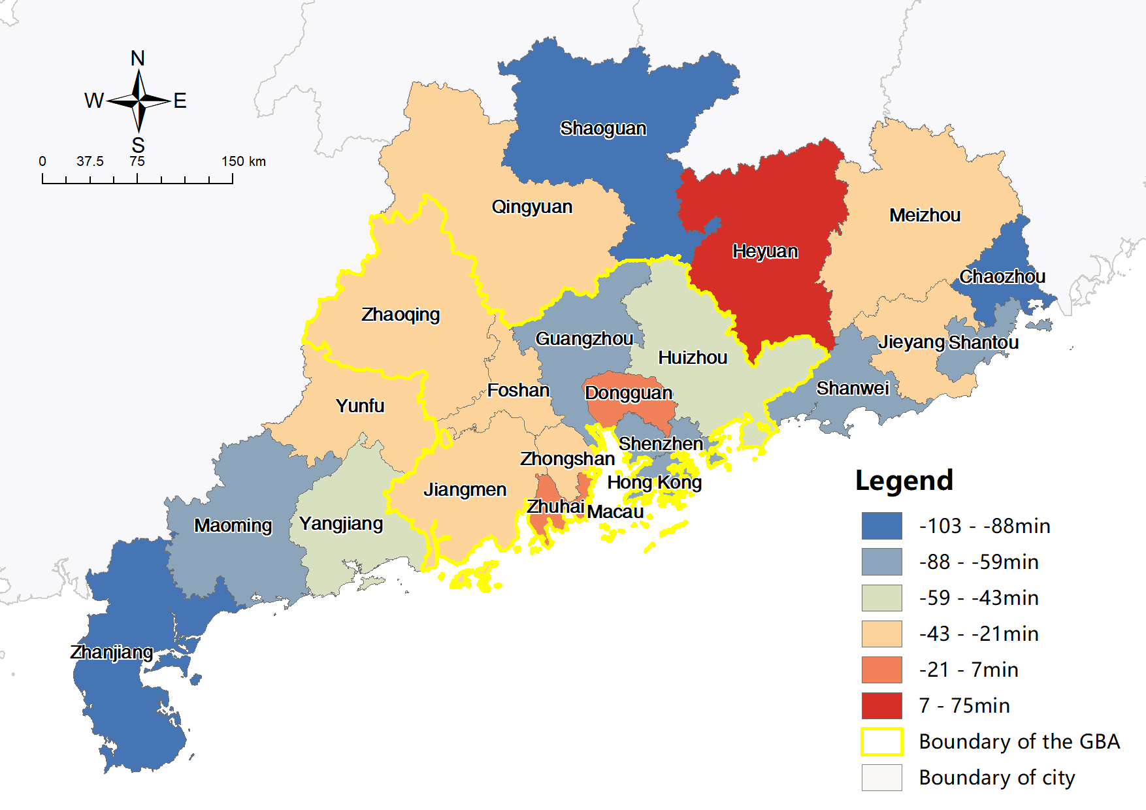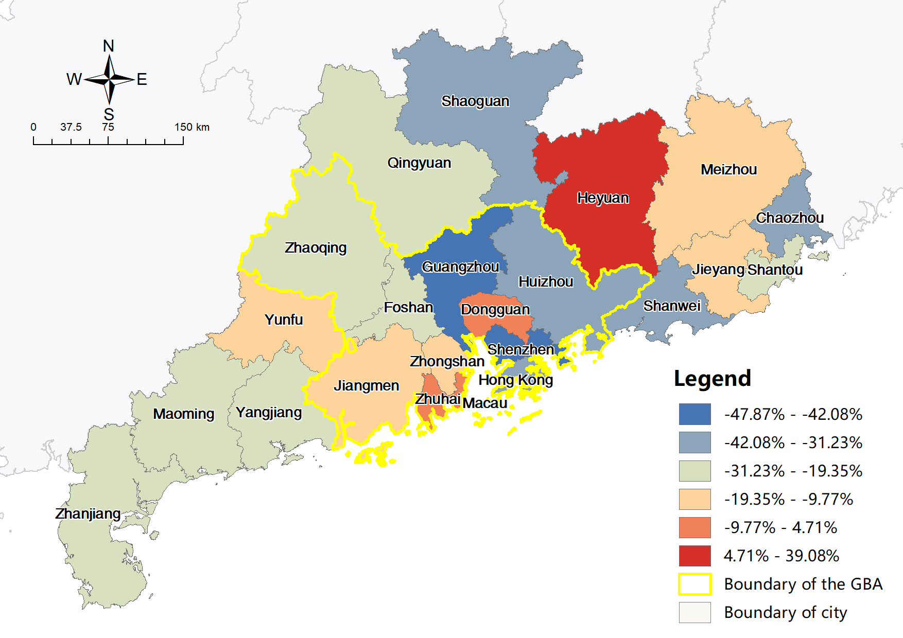

Figure 4-3 Maps of absolute (left) and relative (right) change in ATT between driving and HSR

### PV impacts of HSR

All cities in the study area have improved PVs after the introduction of HSR, while the magnitude of accessibility enhancements vary dramatically.

As is shown in Figure 4-4, PV distributions also present similar core-periphery patterns in both driving and HSR scenarios. The lowest values are uniformly from cities on the peripherals, namely Zhanjiang and Maoming at the west side in the driving scenario, and Meizhou and Heyuan at the east side in the HSR scenario. However, Cities with the highest PVs are not consistent. They are switched from central cities, namely Guangzhou and Shenzhen, in the driving scenario to cities located on the west coast of the Pearl River, such as Jiangmen, Foshan in the HSR scenario.

Two differences are evident between the PV distributions of driving and HSR. First, in the driving scenario, the PVs of cities on the west coast of the Pearl River is higher than those on the east coast. The situation is reversed in the HSR scenario. Secondly, in the HSR scenario, cities with higher PVs are more concentrated in the centre of the GBA, with a much wider gap between the PVs of central and other cities. Conversely, the HSR construction in peripheral cities lags behind that in central cities. Apart from the polarization effect brought by HSR construction, as noted in previous studies (e.g., Nakamura *et al.*, 1989; Jiao *et al.*, 2014; Kim and Sultana, 2015), the slower HSR construction progress in cities on the west coast and in the peripherals is also responsible for the phenomenon. The corresponding lower PVs of peripheral cities are far from the final state, which needs to be verified in the planning scenarios.

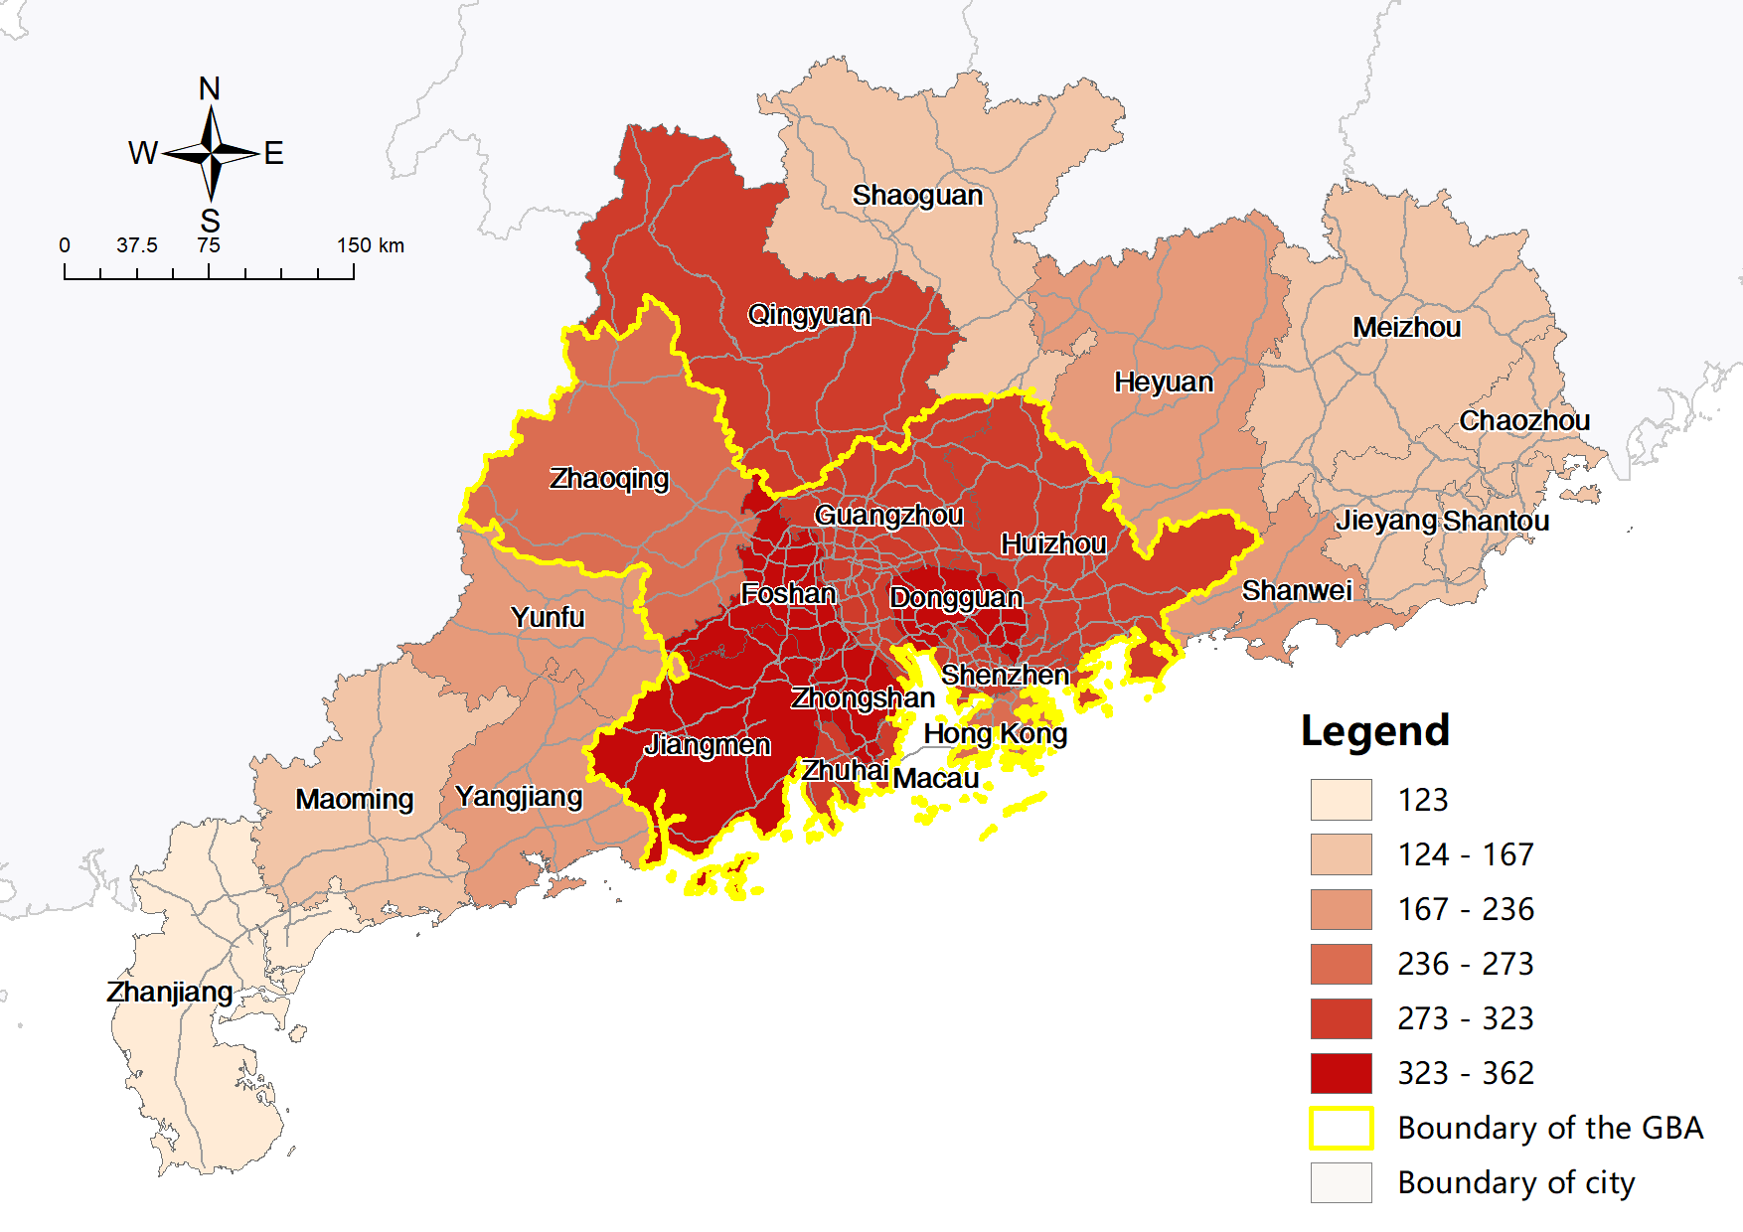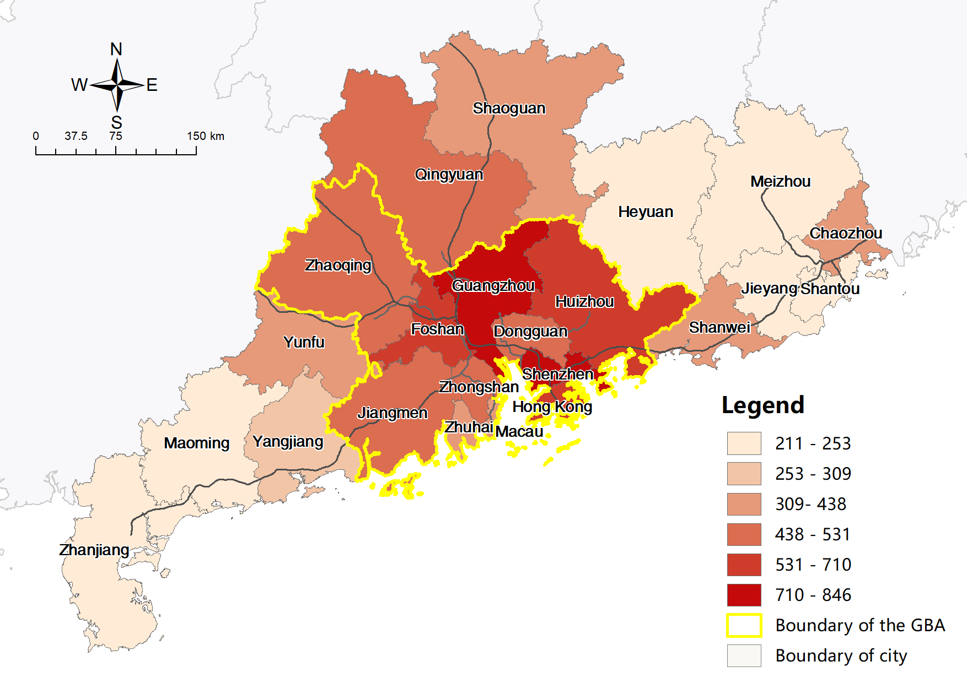

Figure 4-4 Maps of PV by car (left) and by train (right) within the study area

Table 4‑2 and Figure 4-4 reveals overall PV increased by 78.31% in the HSR scenario, which is exceeds the 19.8% decrease in ATT, indicating significantly improved accessibility across the study area in terms of opportunities for intra-city interaction. Cities in the GBA also enjoyed a slightly greater PV increase (82.14%) than the 72.35% increase in cities outside the GBA.

The findings from the CV change in PVs and ATTs are similar. Despite universally enhanced accessibility, the overall CV of PVs increased from 31.40% to 42.28%, indicating greater inequalities led by HSR construction. The overall CVs in both scenarios are also higher than the CVs for cities within or outside the GBA, indicating a huge disparity in these two types of cities. The CV of cities within the GBA increased from 10.71% to 28.93%, which is much higher than the CV of cities outside the GBA, suggesting inequalities inside GBA increasing at a much faster pace than external inequalities

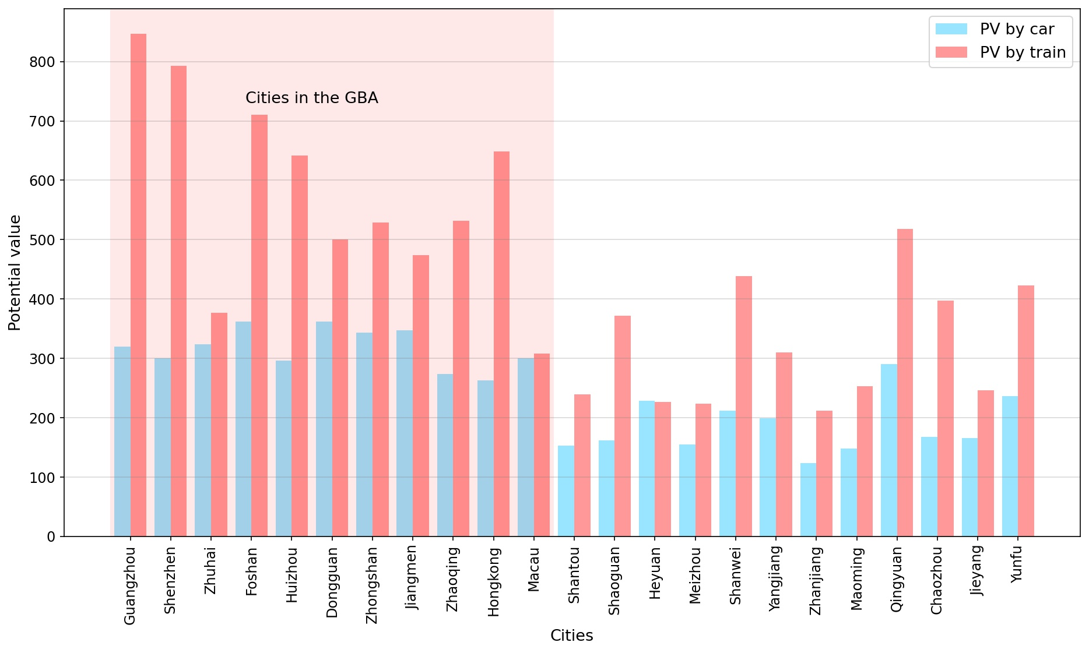

Figure 4-5 PV by car and by train of study area cities

Table 4‑2 CV and Mean of PV in current driving and HSR scenarios

|  |  |  |  |  |
| --- | --- | --- | --- | --- |
| **Indices** | **CV** | | **Mean** | |
| **Driving** | **HSR** | **Driving** | **HSR** |
| **All cities** | 31.40% | 42.28% | 249 | 444 |
| **Cities within GBA** | 10.71% | 28.93% | 317 | 578 |
| **Cities outside GBA** | 25.48% | 32.31% | 187 | 322 |

Unlike ATT, where the distributions of absolute and relative changes differ from each other, the distributions of absolute and relative changes in PVs (Figure 4-6) are largely consistent, indicating clearer winners and losers. The biggest winners in terms of increased opportunities are the central cities Guangzhou and Shenzhen, with the surrounding cities on the east coast being the next biggest beneficiaries. Conversely, Heyuan remained the biggest loser, with the least absolute and relative gain in PV. Besides, the distributions of change in PV confirm three findings from the ATT investigation. First, cities on the west coast, such as Zhuhai and Jiangmen, and on the north side of the GBA such as Zhaoqing, enjoyed less improvement in accessibilities than more developed cities on the east coast in both absolute and relative terms, largely due to the preliminary condition of HSR construction. Secondly, with the emergence of the inverse T-shaped HSR corridors, cities on the remote north (Shaoguan) and east (Chaozhou) ends also reported significant increases in PV, which illustrates the corridor effect reported in previous Asian research (Nakamura *et al.*, 1989; Jiao *et al.*, 2014; Kim and Sultana, 2015). However, Zhanjiang, on the west end of the coastal HSR corridor, reported less increase because the construction of the HSR line connecting it with central cities was unfinished, and the ICR lines were operating as an interim substitute. The third consistent finding is the bypass effect faced by Dongguan, wherein only minimal gain in accessibilities was achieved, despite its location.

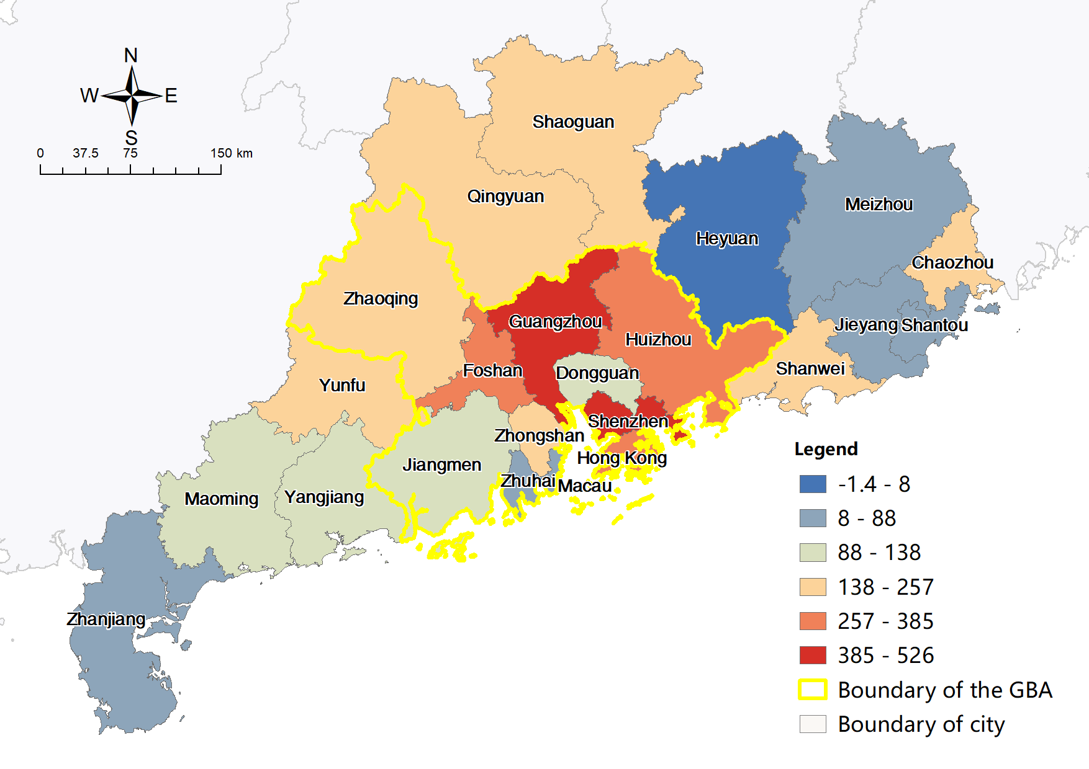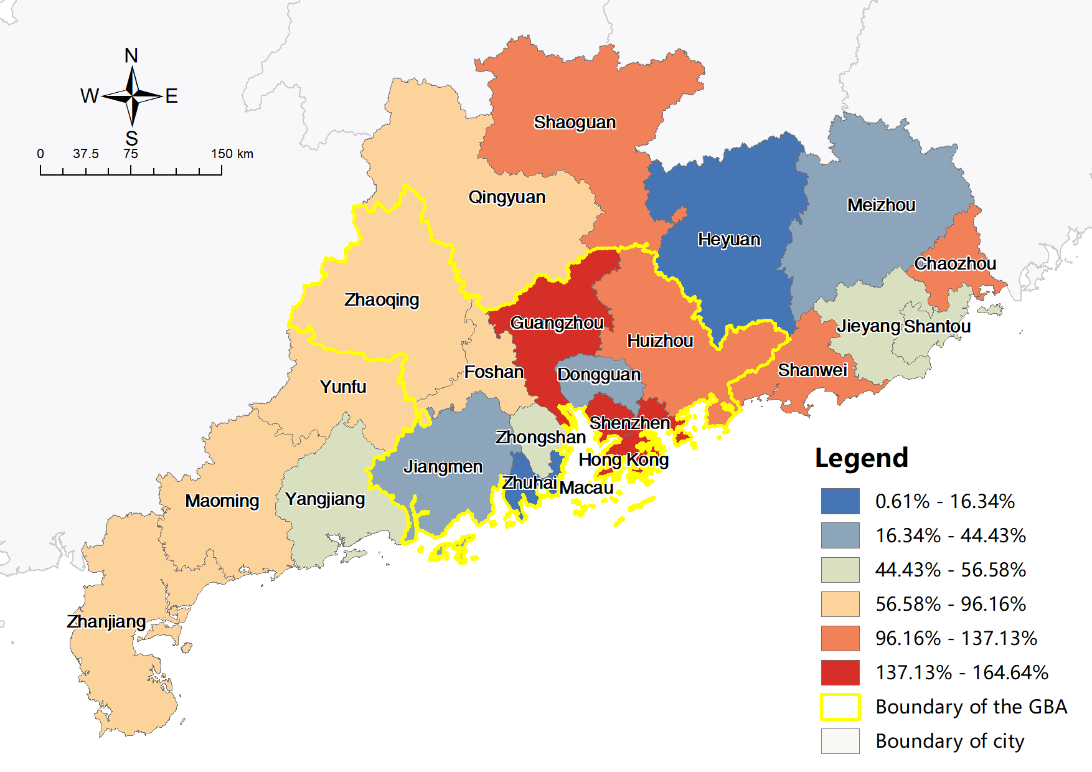

Figure 4-6 Maps of absolute (left) and relative (right) change in PV between driving and HSR

### TTF impacts of HSR

Travel flow analysis comprised two steps. First, the distribution of traffic flows between each O-D pair was visualized and analyzed. Subsequently, the concept of total inbound and outbound traffic flow (TTF) of each city was introduced to replace the ELI and supplement gravity-type theoretical estimations and examine the equity pattern after HSR construction in a more tangible way.

Figure 4-7 presents both driving and HSR scenarios and reveals flows between cities within the GBA takes up the majority and forms a distinct core. The dominant flows between Guangzhou, Shenzhen, Dongguan, and Huizhou form a Z-shaped geographic structure as per previous regional migration studies (Sun *et al.*, 2019). This is followed by flows connecting cities within the GBA to external cities and flows between external cities. Figure 4-7 indicates that most driving trips are less than 200 km and form three distinct clusters, the largest being the clusters of the GBA cities plus Shaoguan in the north, with the other two being formed by cities east of the GBA and cities west of the GBA, respectively. There are relatively fewer flows between these three clusters. HSR flows generally cover longer distances than driving flows. According to Givoni(2006), HSR is the most competitive means of transportation for distances between 200 and 800 km, a spatial scale that corresponds to mega-city regions like the GBA. A higher proportion of flows connect cities within the GBA to external cities in the HSR scenario, and no obvious cluster other than that within the GBA is detected.

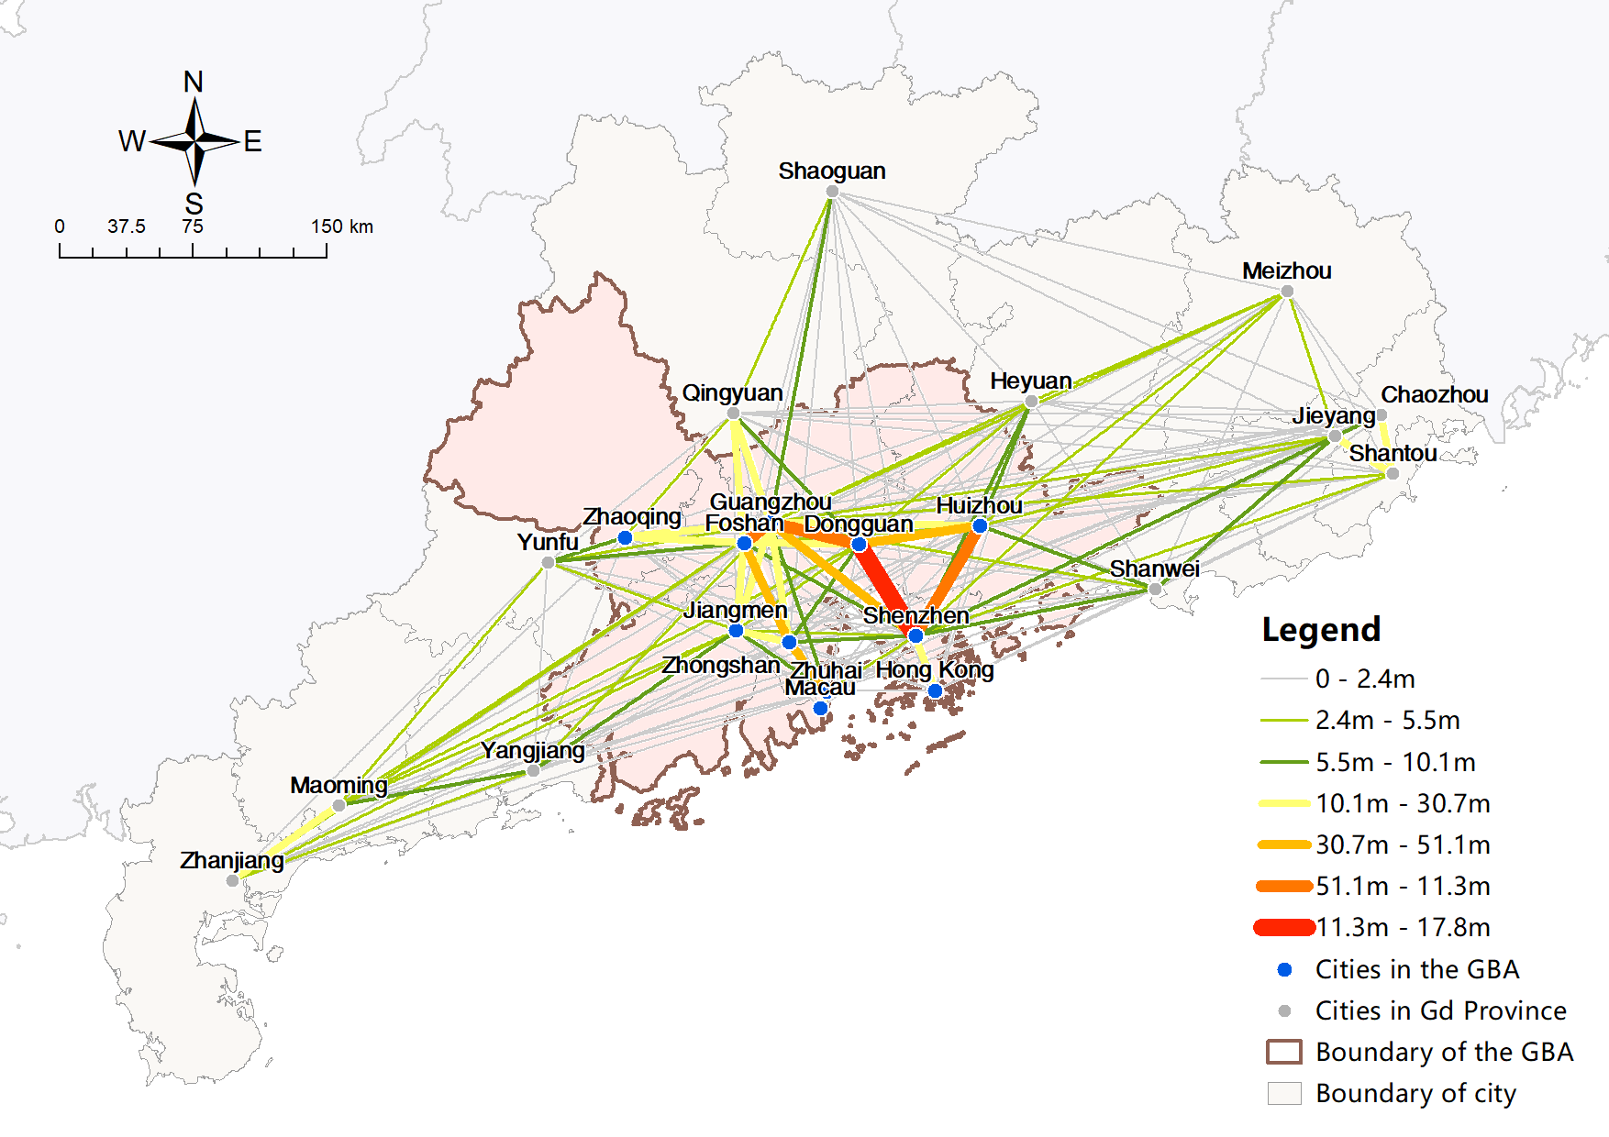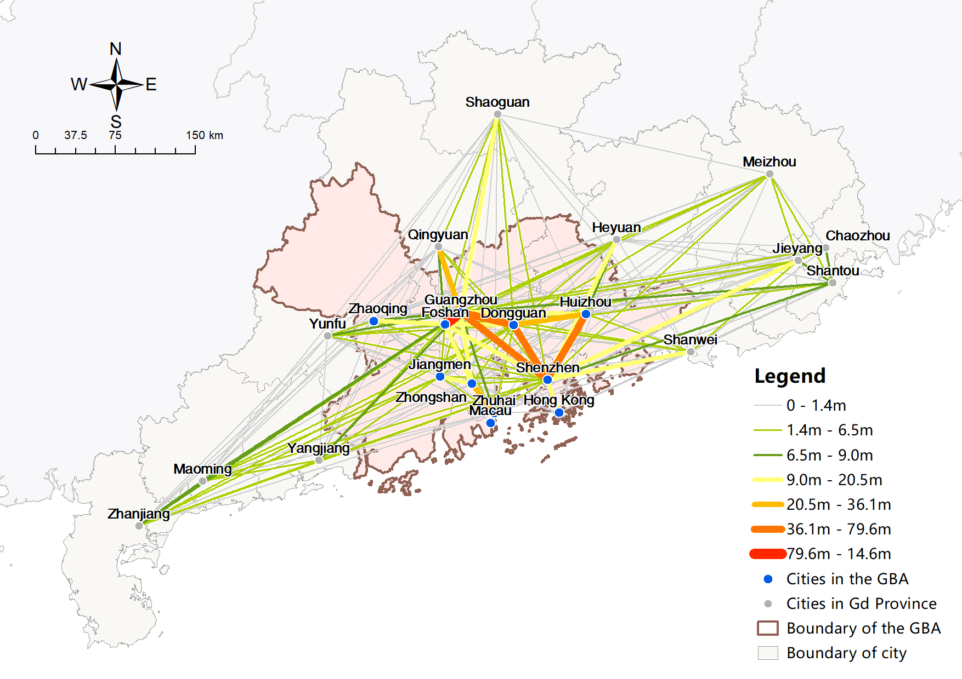

Figure 4-7 Flow map of driving (left) and HSR (right) trips between study area cities

In terms of the aggregated sum of flows across the study area, the driving flows outnumber the railway flows, the latter comprising only 80.04% of the driving flows. Figure 4-8 reveals that the five cities with the most TTFs in both driving and HSR scenarios are Guangzhou, Shenzhen, Dongguan, Foshan, and Huizhou, accounting for 64.51% of all traffic in the driving scenario and 66.21% in the HSR scenario. Other cities have similar percentages in both scenarios. The slight difference is that in the HSR scenario, Shenzhen assumed the pole position formerly occupied by Guangzhou, while Foshan replaced Dongguan as number three.

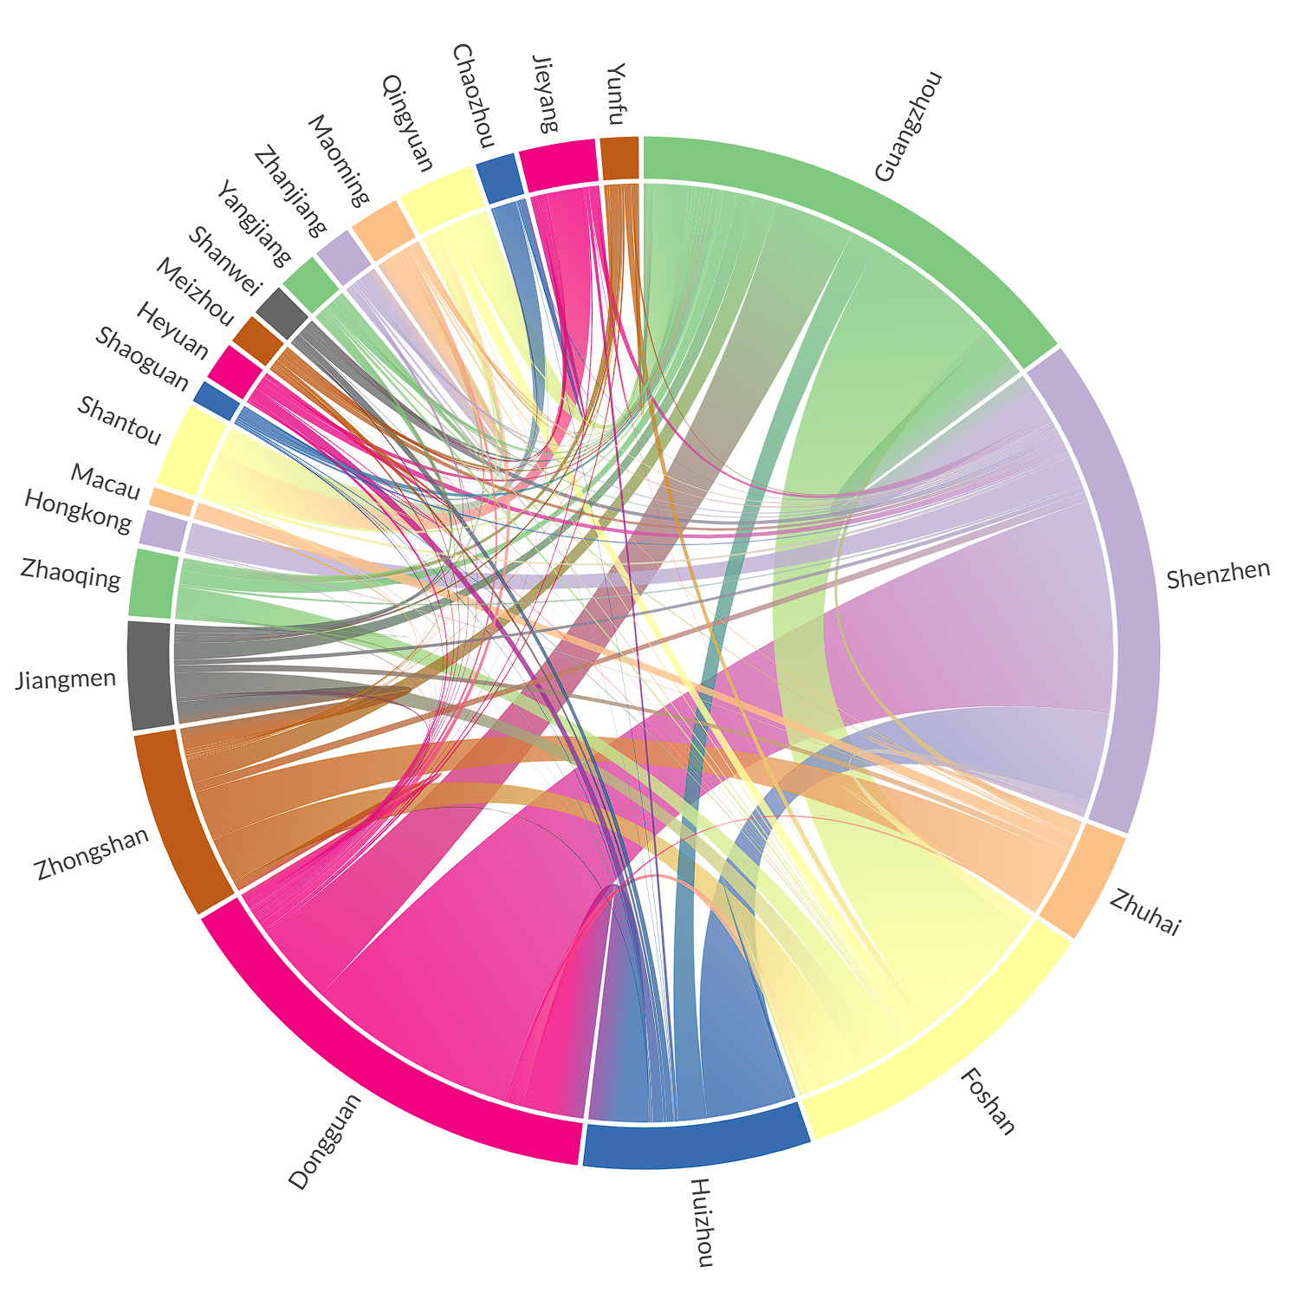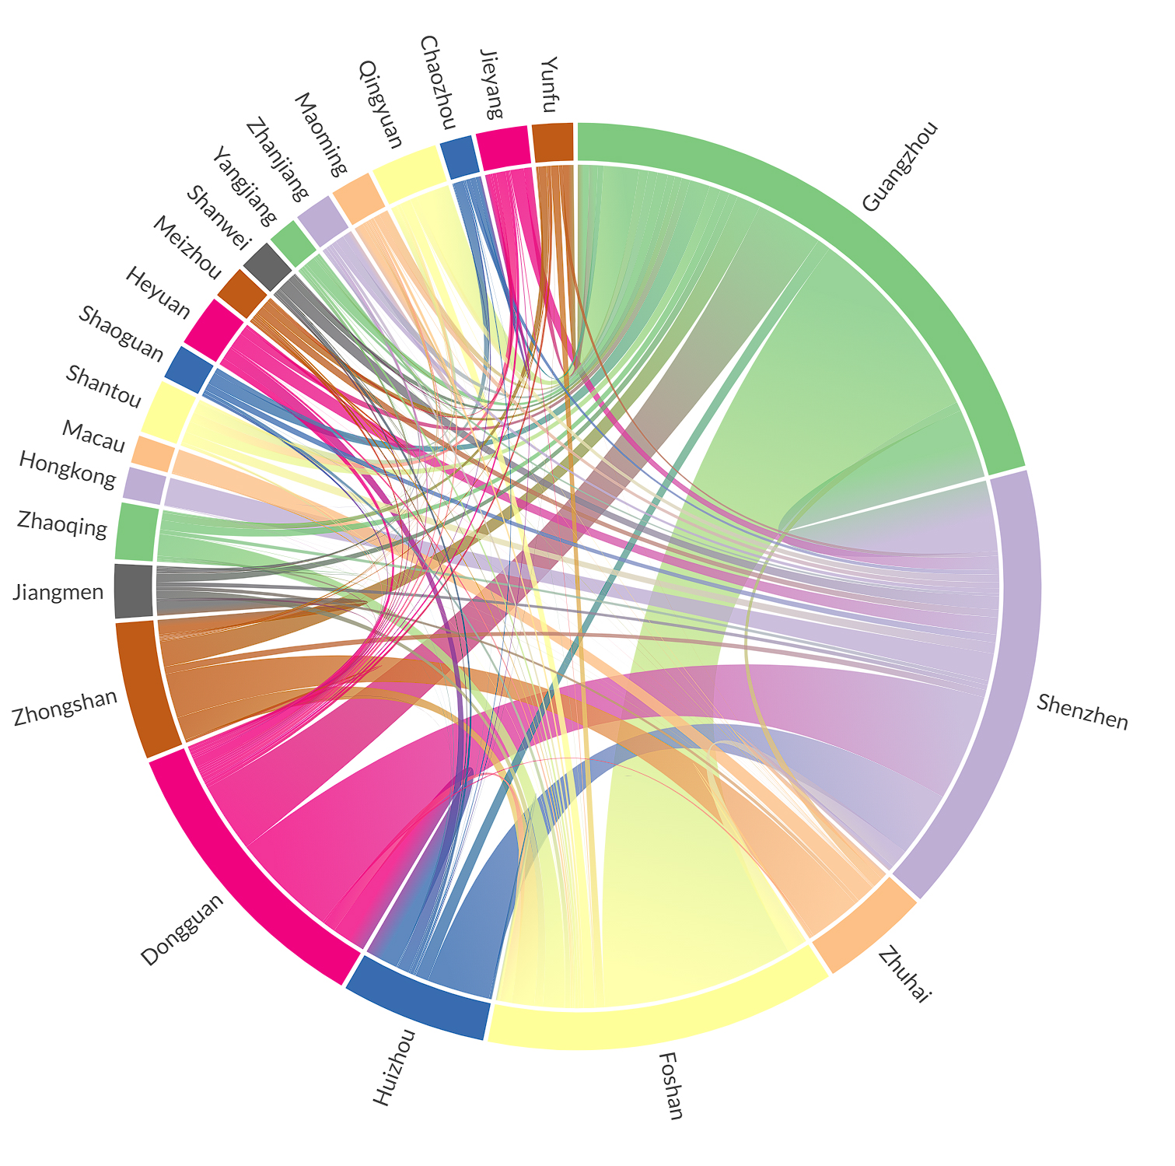

Figure 4-8 Chord charts of driving (left) and HSR (right) flows between cities

TTFs distributions in both driving and HSR scenarios display distinctive core-periphery patterns (Figure 4-9), whilst inside the GBA, there are more TTF in cities on the east coast of the Pearl River than on the west coast and in the north. Conversely, TTFs are more concentrated towards GBA cities in the HSR scenario. Figure 4-10 reveals that most cities have decreased HSR flows compared to driving flows. The central city Guangzhou saw the largest flow increase in absolute terms, but in relative terms, it was Shaoguan and Heyuan that reported the greatest increases. The changes distribution has disparate patterns in absolute and relative terms because the distribution of relative changes tends to be more chaotic and abrupt, unlike the smooth and gradual distribution of absolute changes.

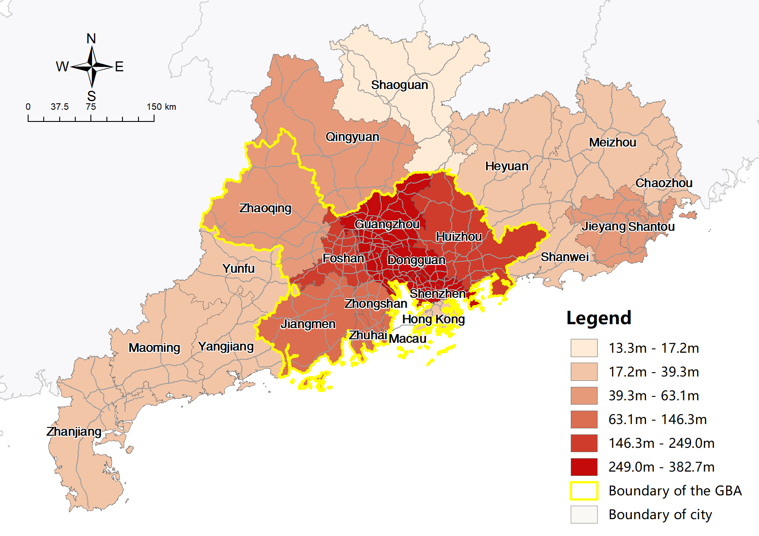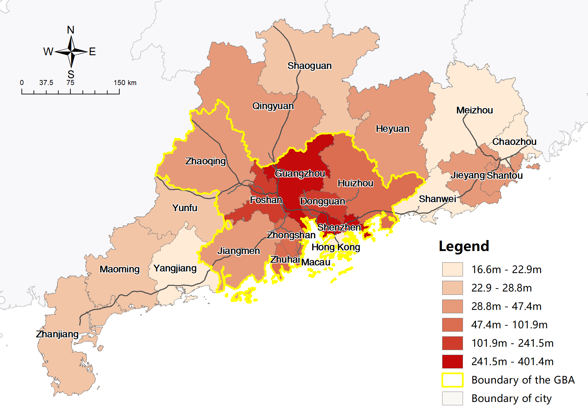

Figure 4-9 Map of TTF by car (left) and by train (right) of study area cities

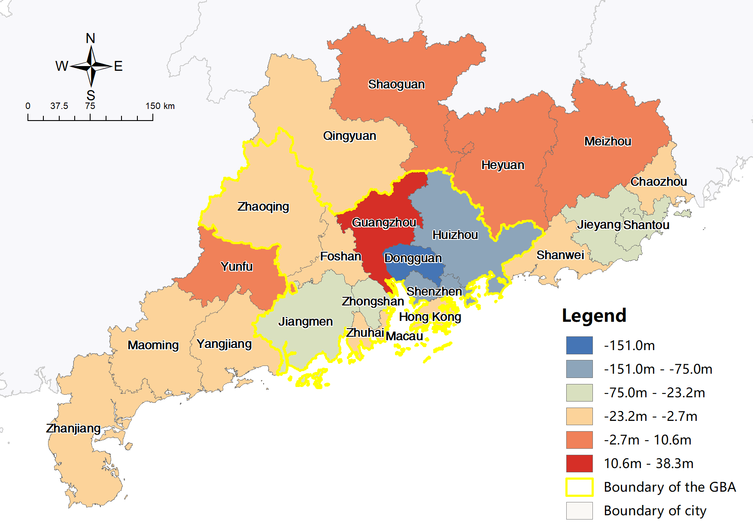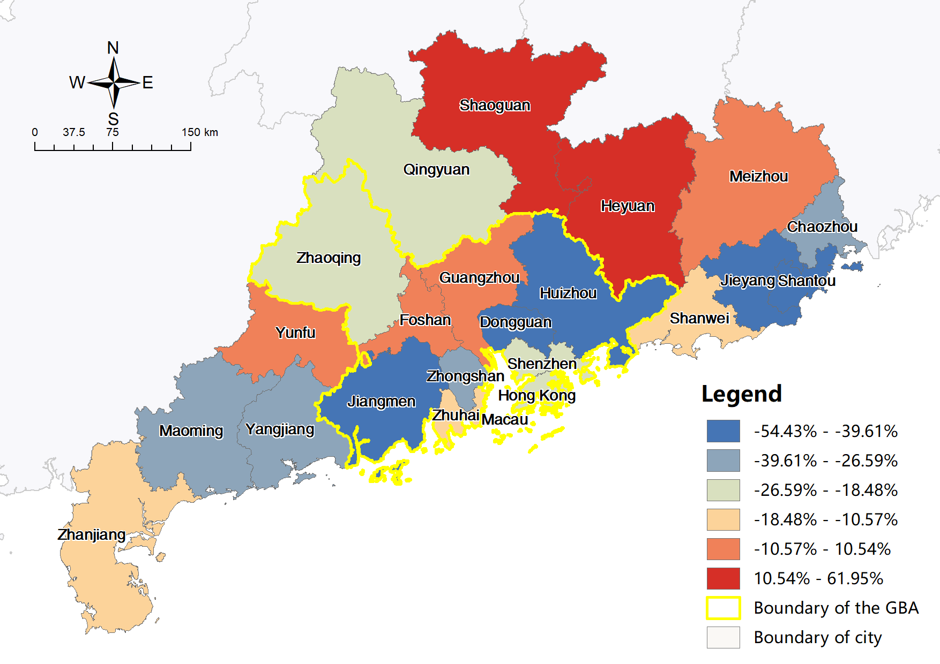

Figure 4-10 Map of absolute (left) and relative (right) change in TTF between driving and HSR

Table 4‑3 indicates that changes in CVs of TTF resemble those of ATT and PV, with an overall increase during the transition from driving to HSR. Meanwhile, in both scenarios, the overall CV exceeds that for cities inside or outside the GBA, and the CV for GBA cities exceeds that for external cities, suggesting a significant gap in the TTFs of cities inside and outside the GBA, and greater variation in the TTFs inside the GBA than with external cities. The mean TTFs in the table also confirm earlier research with an approximately four times difference between cities inside and outside the GBA.

Table 4‑3 CV and Mean of TTF in current driving and HSR scenarios

|  |  |  |  |  |
| --- | --- | --- | --- | --- |
| **Indices** | **CV** | | **Mean** | |
| **Driving** | **HSR** | **Driving** | **HSR** |
| **All cities** | 115.58% | 126.56% | 102.59m | 82.11m |
| **Cities within GBA** | 79.94% | 92.94% | 175.10m | 139.37m |
| **Cities outside GBA** | 42.31% | 26.89% | 36.12m | 29.62m |

### City classification

Assuming ATT measures the progress of infrastructure in terms of travel time reduction, and PV measures the opportunities increment based on infrastructure improvement, cities can be classified according to their benefits from HSR construction using two dimensions with a total of four categories, namely: successful or unsuccessful cities and potential or unclear cities. Leading representatives can be selected from each category by superimposing the changes in TTF, resulting in a total of eight categories of cities.

There is a very distinct pattern in the distribution of the various types of cities (Figure 4-11). Most successful cities, including Hong Kong, are located on the east coast in the GBA, which enjoys not only a significant reduction in travel time (surpassing half of all cities) but also significant increases in opportunities (surpassing half of all cities). Guangzhou is the most successful city, with its tremendous increase in TTF, consistent with the previous analysis. Unsuccessful cities are mostly located on the west and north of the GBA, and Shantou in the east. Despite a significant travel time reduction (top half of all cities), they have only limited increases in accessibilities (bottom half of all cities). Shantou was identified as the most unsuccessful city, with the largest flow decrease.

Similarly, potential cities, among which Yunfu has the most potential, are largely cities distributed in the northern part of the GBA, in addition to Dongguan. These cities have achieved increased accessibility based on limited travel time reductions. The unclear cities, of which half are located on the west coast of the Pearl River and half are scattered to the east of the GBA, have limited travel time reductions and opportunity increments. Although Heyuan has gained the least increase in accessibility in terms of both ATT and PV, the most unclear city is Jiangmen due to its more significant flow reduction.

The classification shows that the overall distribution of successful cities accords with the preliminary findings of the previous analysis, be it the huge benefits of the central cities, the lack of accessibility increments of the peripheral cities, the Bypass effects for Dongguan, or the imbalance between the east and west coasts of the Pearl River. Moreover, it is only with such comprehensive rules that Shantou, Yunfu, and Jiangmen are deemed to be representative of the unsuccessful, potential or unclear cities.

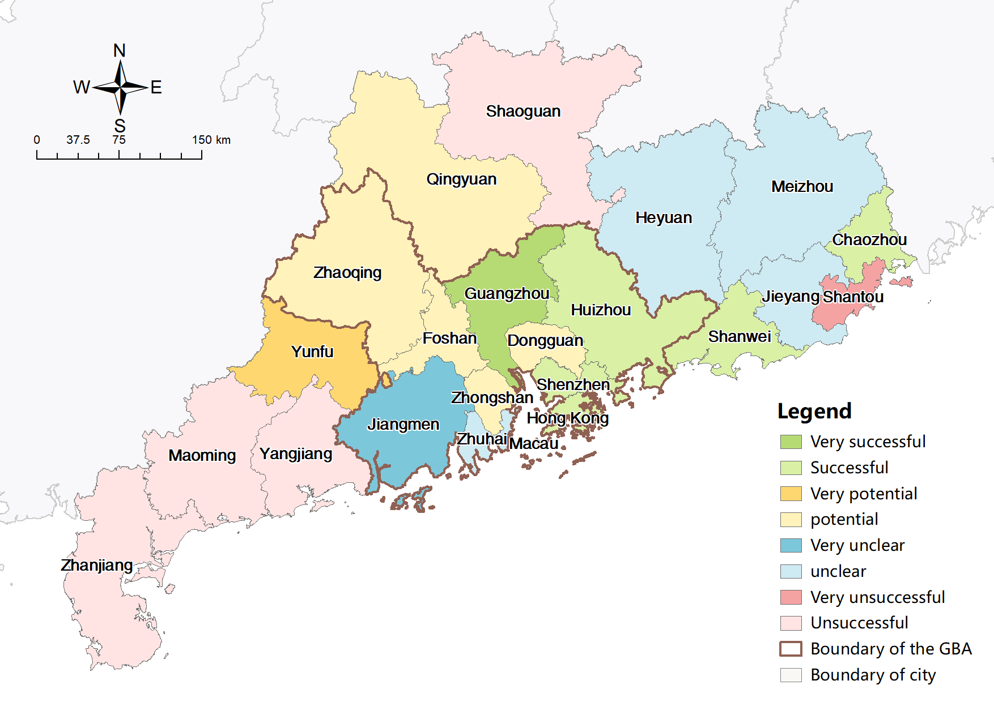

Figure 4-11 City classification by accessibility benefit in HSR construction

The above analysis successfully addresses the first three research questions:

**Question 1:** Quantitatively, accessibility is enhanced in most cities, with only a few, including Heyuan, reporting reduced accessibility. Spatially, distributions of ATT, PV, and TTF all indicate a distinct centre-periphery or corridor pattern in both driving and HSR scenarios. The changes resemble the pattern in absolute values but generally have no clear distribution pattern in the relative proportion. Although the aggregated TTF of HSR transportation accounts for only 80.04% of the TTF of driving trips, the proportions of TTF of cities remained stable with the change of traffic mode. HSR flows typically cover a longer travel distance. Hence, clusters of flows to the east and west of the GBA observed in the driving flow map have disappeared.

**Question 2:** CVs for the ATT, PV, and TTF indices between cities have statistically increased, indicating a significant increase in transportation inequalities in terms of time costs, opportunities, and observed flows. Moreover, the overall CV increase is significantly larger than the CV increase of cities within or outside the GBA, and the increase from cities within the GBA is larger than that of cities outside the GBA, suggesting that the disparities are significant between inside and outside the GBA, and the differences between cities within the GBA are greater than those outside the GBA.

**Question 3:** The biggest travel time reduction and opportunity increase beneficiaries are the central cities on the mainland, especially Guangzhou, and the smallest beneficiary is Heyuan. Cities at the east, west, and north ends of GD generally have inadequate accessibility increments. There is a significant divergence in the peripheral cities outside the GBA, in that they are the main beneficiaries apart from the central cities in terms of travel time reduction. However, they demonstrate fewer increments in terms of opportunity, especially in the east and west.

Within the GBA, cities on the east coast of the Pearl River have enjoyed more accessibility gains than those on the west coast, thus amplifying inequities. Specifically, in the driving scenario, cities on the west coast, which are less developed and have much smaller populations and economies, have lower ATTs and higher PVs. However, in the HSR scenario, these cities have higher ATTs and lower PVs than cities on the east coast. Dongguan, as an atypical city located on the east coast between two central cities, experienced Bypass effects with very limited accessibility gains.

In addition to the polarization effects of HSR extension, the unsatisfactory accessibility gains of peripheral cities outside the GBA, especially Heyuan and cities on the west coast, are due to their lagging behind central and major cities in construction. According to China’s mid-term and long-term railway plan, the current HSR development focuses on inter-regional corridors of HSR connecting provincial capitals and major cities, and only in the next stage of HSR extensions will the focus be shifted to the secondary prefecture and county level cities (NDRC, 2016a).

## Planning scenarios

The construction of HSR in the study area is far from complete. Similar analyses are carried out to evaluate future HSR extension’s impact on accessibility and traffic inequalities.

### Flow simulation

As explained in Section 3.6 , the unconstrained gravity model is employed to simulate the HSR flows in planning scenarios with detailed socio-economic variables. The statistical model applied for the simulation is Poisson regression. The 11 variables in Table 3‑1 were filtered twice using stepwise selection based on P-values and adjusted R squares. The variables LAB, RDI, FT, and EDU were excluded due to their insignificant P-values or increase d adjusted R squares. The remaining variables are employed in flow simulations, with POP, GDP, IFA and HP being general variables, while CO and HWL are exclusive variables of driving flows, and RWL is an exclusive variable of HSR flows. The final formulas are:

$lnTD_{ij}=-17.5119+2.3856lnPop_{i}+1.1664lnGdp_{i}+0.4201lnIfa_{i}+1.0623lnHp_{i}+1.4387lnCo_{i}-0.0323lnHwl_{i}+2.2109lnPop_{j}+1.3378lnGdp_{j}+0.4462lnIfa_{j}++0.9123lnHp_{j}+1.4068lnCo_{j}-0.0759lnHwl_{j}-2.4143lnt_{ij}$, ( 4‑1 )

$lnTH_{ij}=23.3216-0.0257lnPop_{i}+1.1664lnGdp_{i}-0.1813lnIfa_{i}-0.8332lnHp_{i}-0.2761lnRwl_{i}+0.0449lnPop_{j}+1.3378lnGdp_{j}-0.2905lnIfa_{j}-1.0214lnHp_{j}-0.3702lnRwl_{j}-1.2321 lnt_{ij}$, ( 4‑2 )

with detailed results of the two gravity models listed inTable 7‑11 and Table 7‑12. The purpose of driving flow simulation is to test the original flow data and to compare the fit of the HSR flows. The fitted flows of most O-D pairs are close to observed values (Figure 4-12), and the residuals have a slightly uneven distribution. Variation in the residuals may be due to the travel time data obtained from the train timetable with various realistic considerations, which is not as good a fit as the ideal travel time calculated from HSR networks. The flow data might also have some minor flaws. Figure 4-13 reveals the fit is satisfactory, with the fitted values being close to the original values. HSR flows in planning scenarios can be estimated using the parameters obtained above. To simplify the model, the socio-economic data, such as population and GDP, remain unchanged.

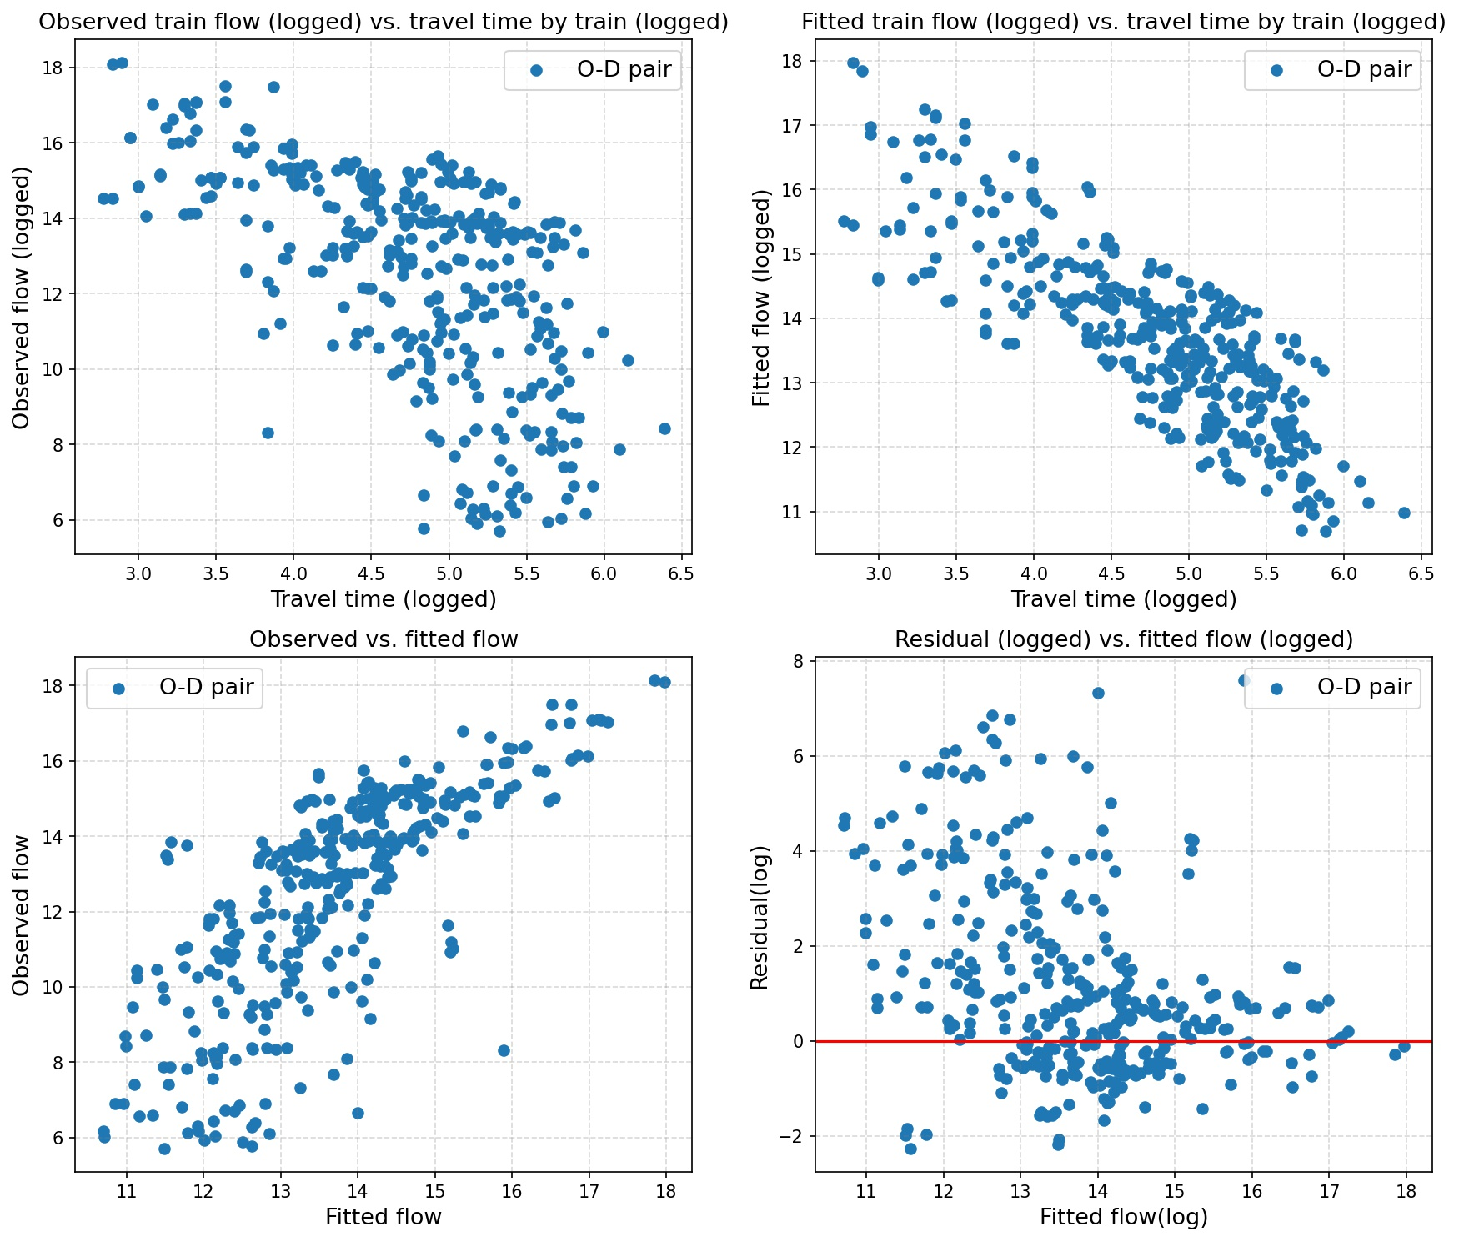



Figure 4-12 Scatter plots of spatial interaction modelling results

Upper left: observed flow vs. fitted flow. Upper right: residuals vs. fitted flow (logged).  
Lower left: observed flow vs. travel time (logged). Lower right: fitted flow vs. travel time (logged).

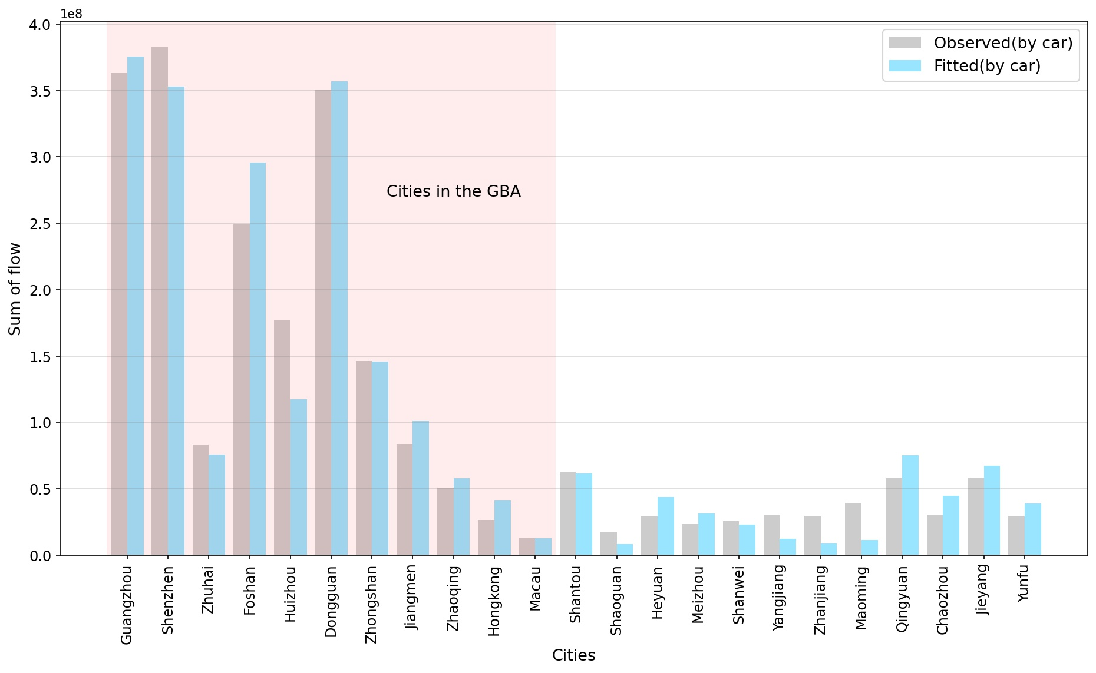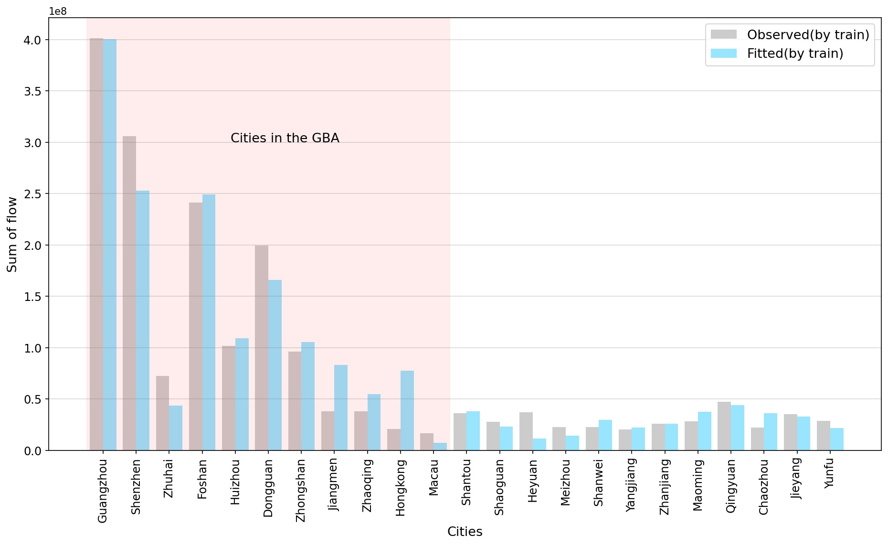

Figure 4-13 Observed and fitted TTF by car (left) and by train (right) by city

### Accessibility impacts of HSR

Figure 4-14 to Figure 4-19 reveals the ATT distributions in both planning scenarios still exhibit distinct core-periphery patterns. Similar results emerge from the PV and TTF indicators. Generally, accessibility within the GBA remains higher than that of external cities in all indicators, while within the GBA, there is no longer a significant gap in accessibility between west and east coast cities.

The distribution of change in ATT resembles that in current scenarios, with absolute values also showing a weak core-periphery pattern and relative values showing no explicit pattern. Meanwhile, none of the spatial distributions of absolute and relative changes in PV and TTF are regular. Contrary to the current scenario, central cities report the smallest increases in ATT and PV, with TTF decreases in the planning scenarios. Peripheral cities enjoy the largest accessibility increments, especially Heyuan, Shantou, Jiangmen, Zhanjiang, and Maoming, which obtained the least benefits in the current HSR scenario. Similarly, within the GBA, the increase in accessibility is greater in cities on the west coast and in the north than on the east coast and greater in Dongguan than in the two adjacent central cities. The results indicate that the transportation equity of HSR has been significantly improved at the GBA level and the extended provincial level in planning scenarios.

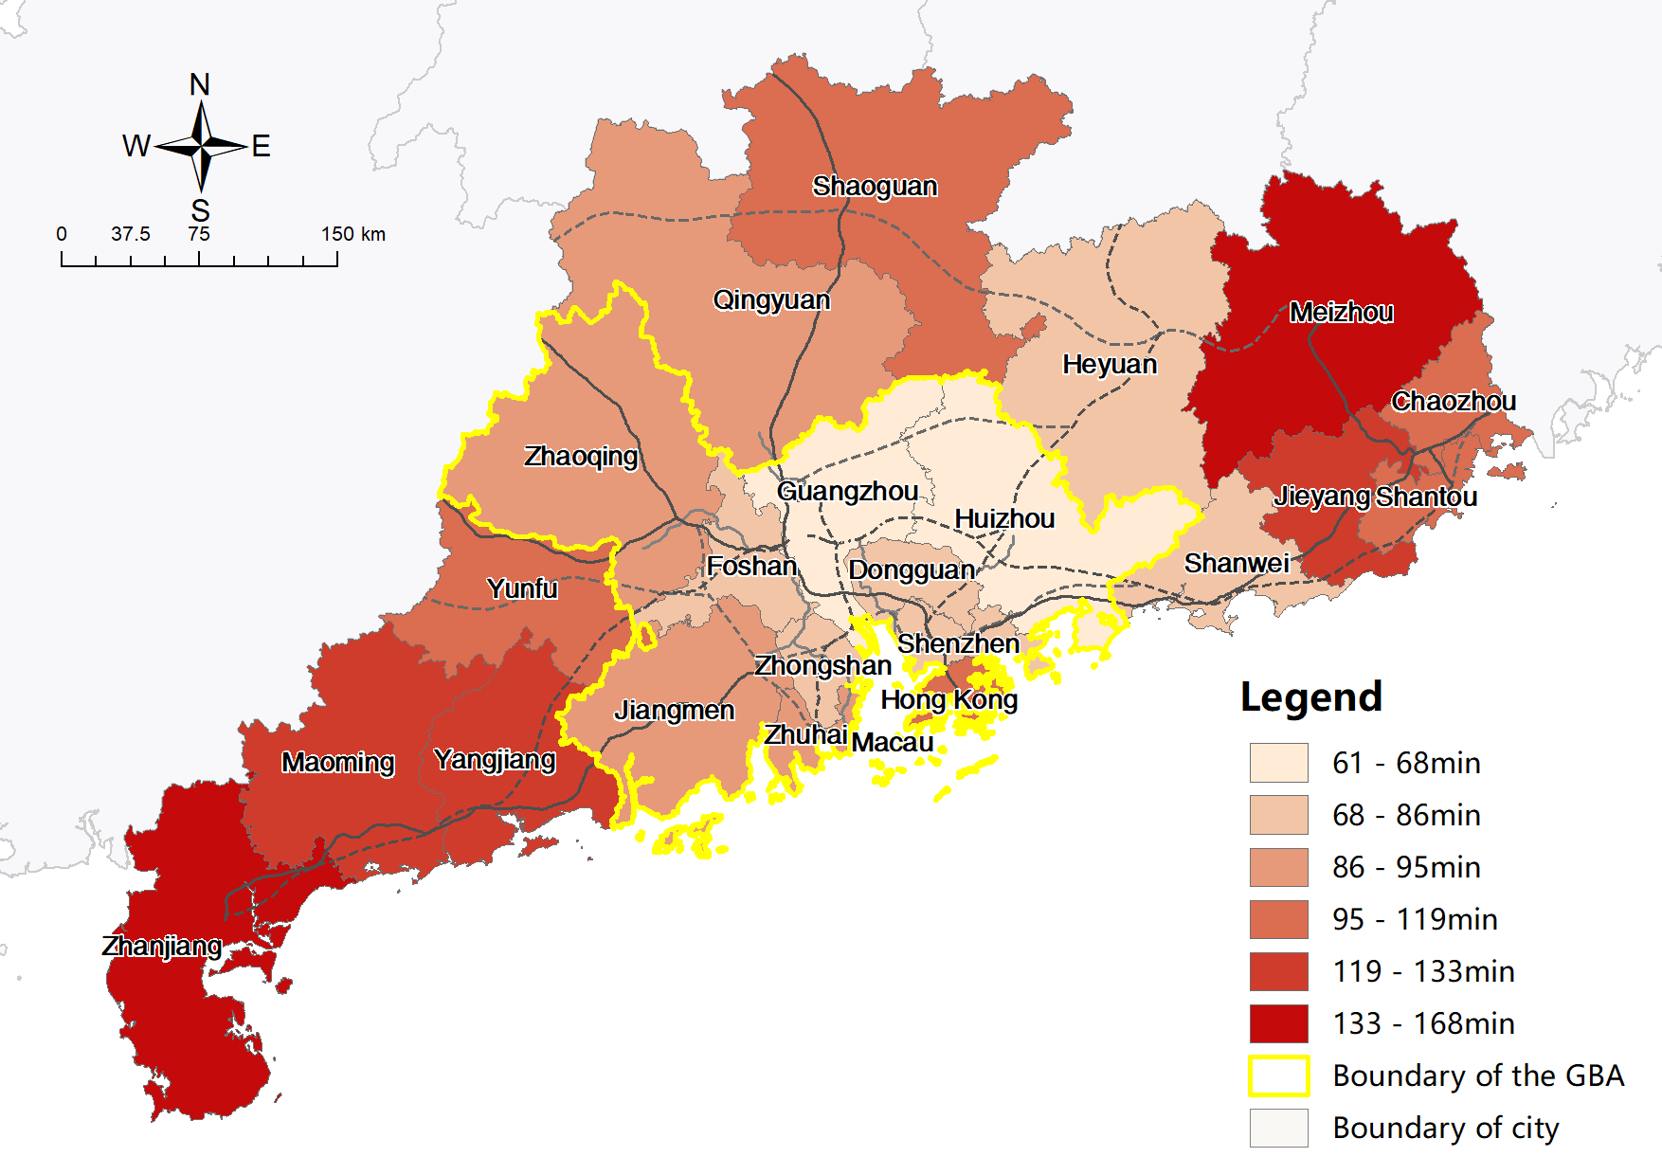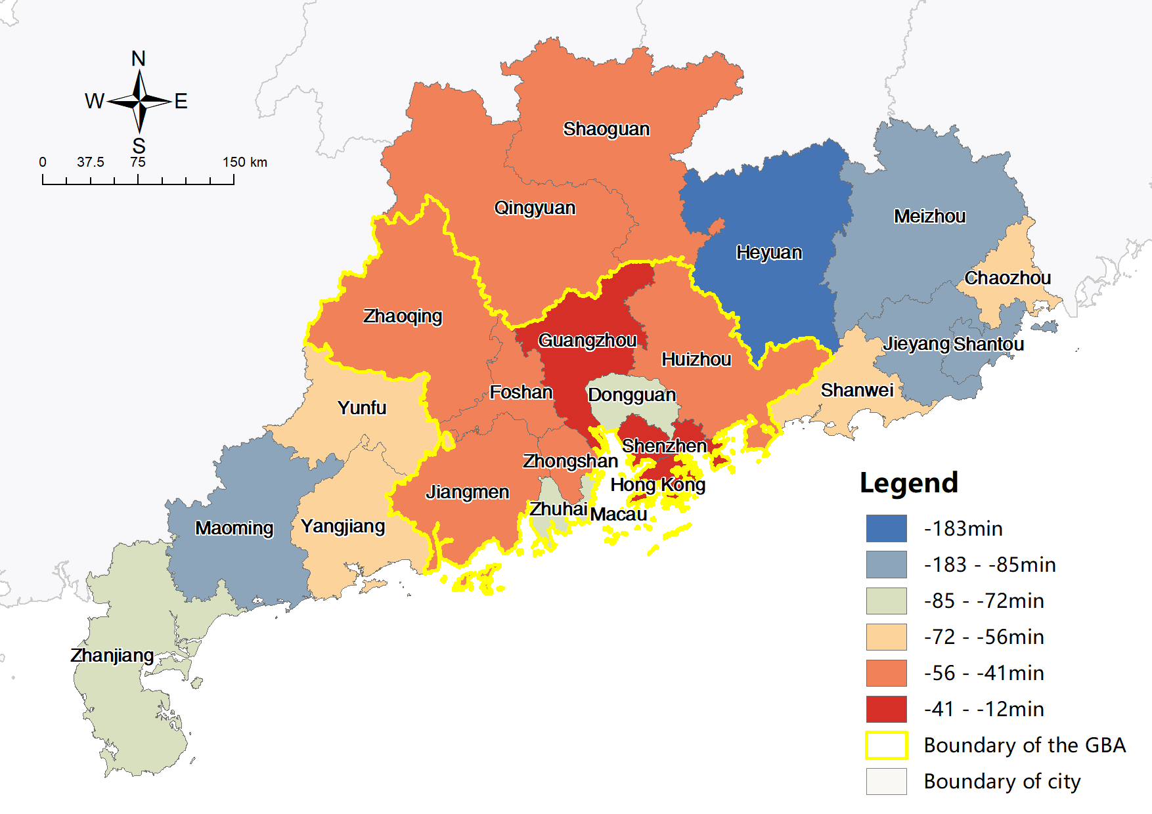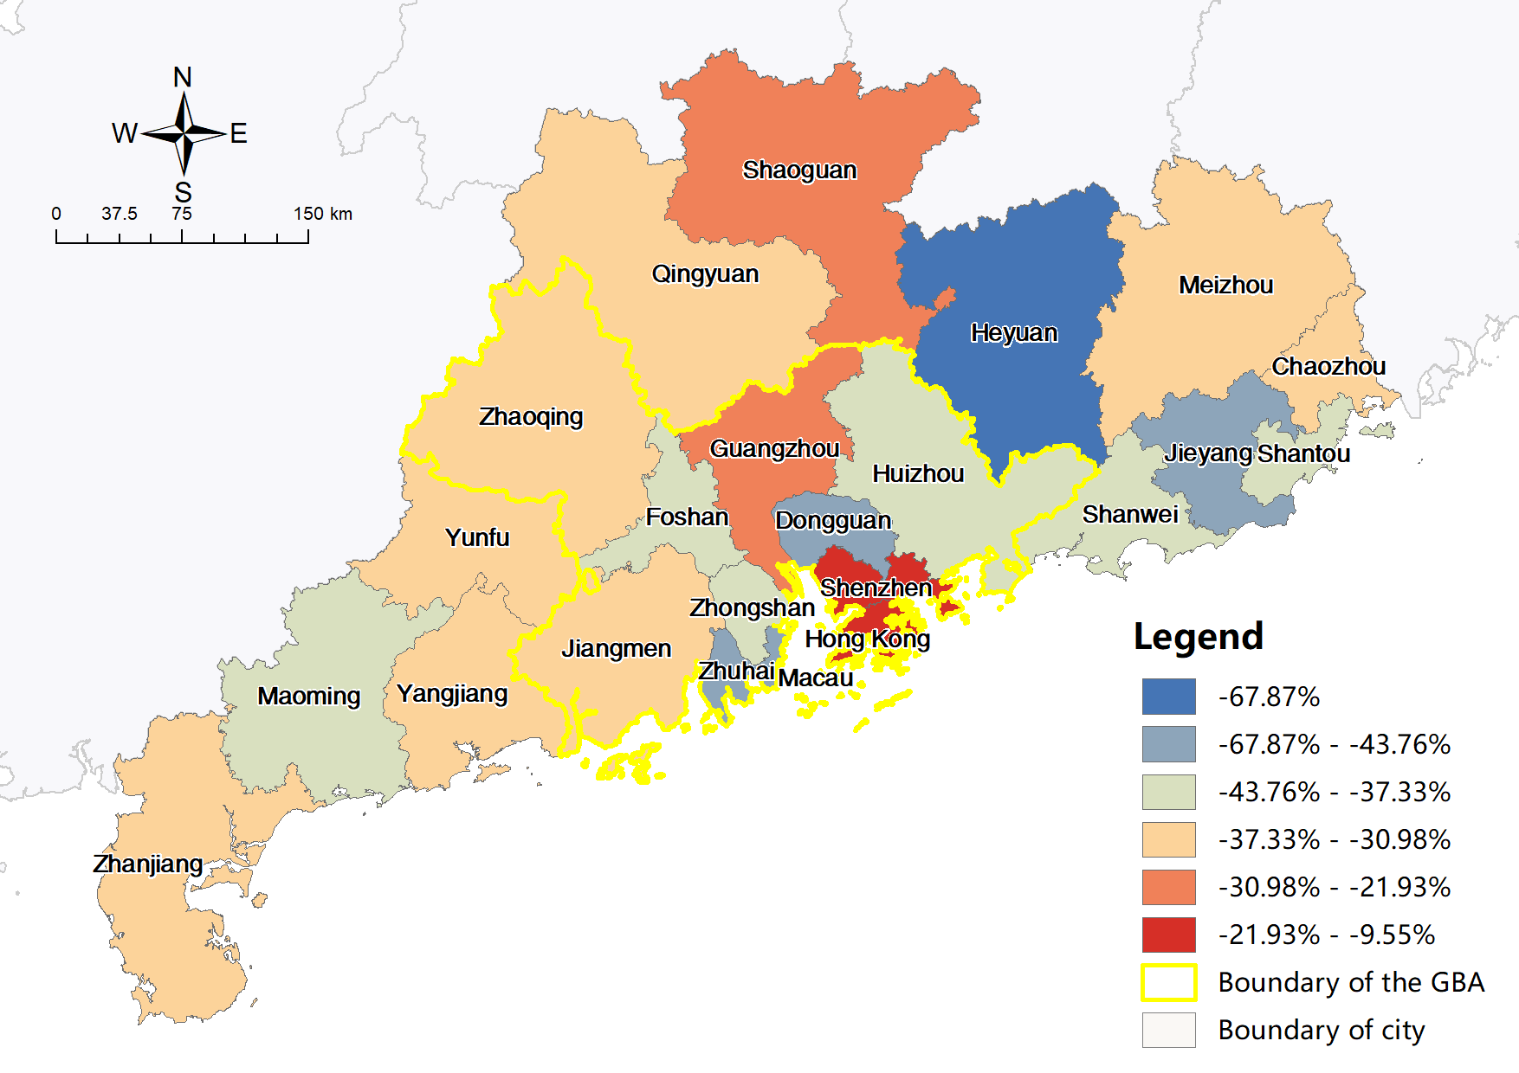

Figure 4-14 ATT by train in short-term planning scenario (left), and corresponding absolute (middle) and relative (right) change compared to current ATT

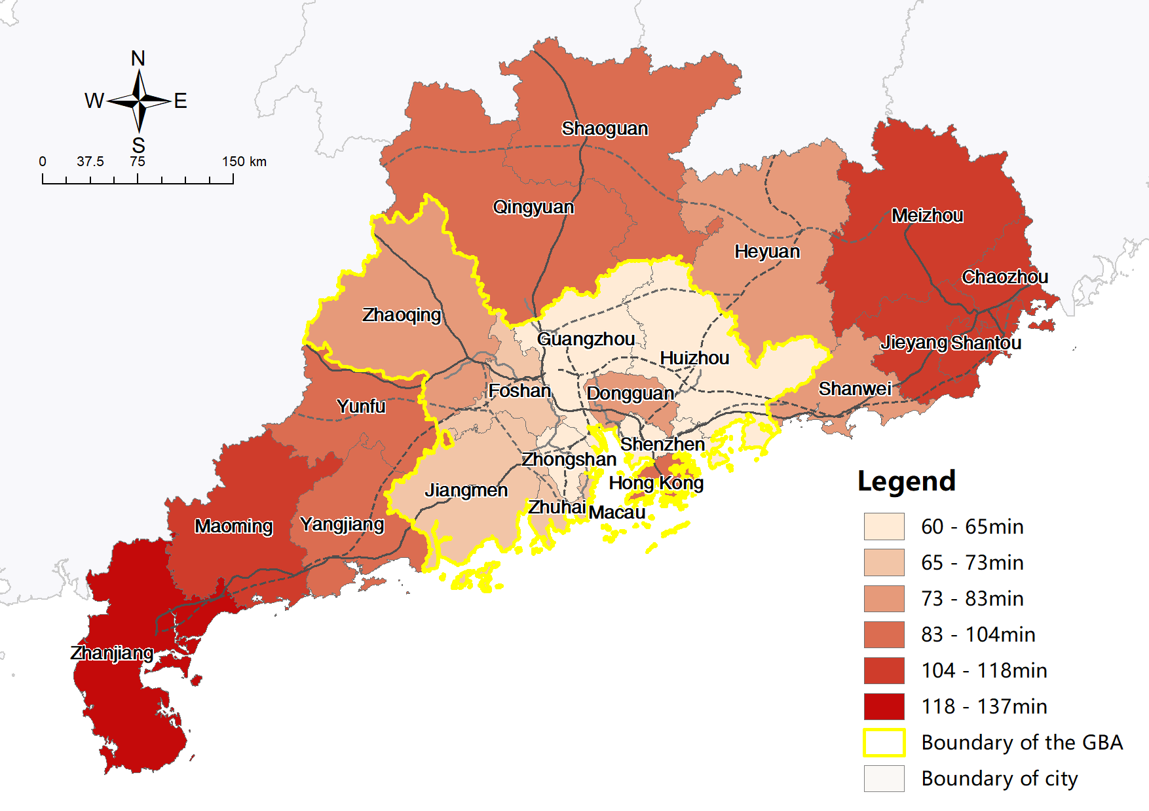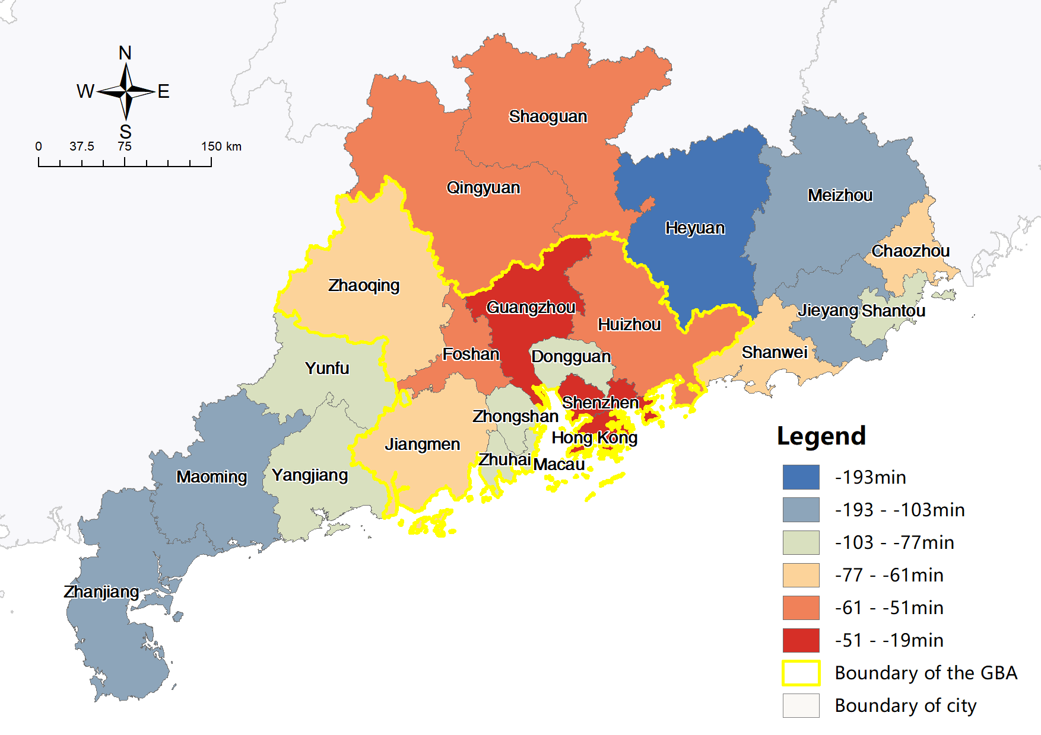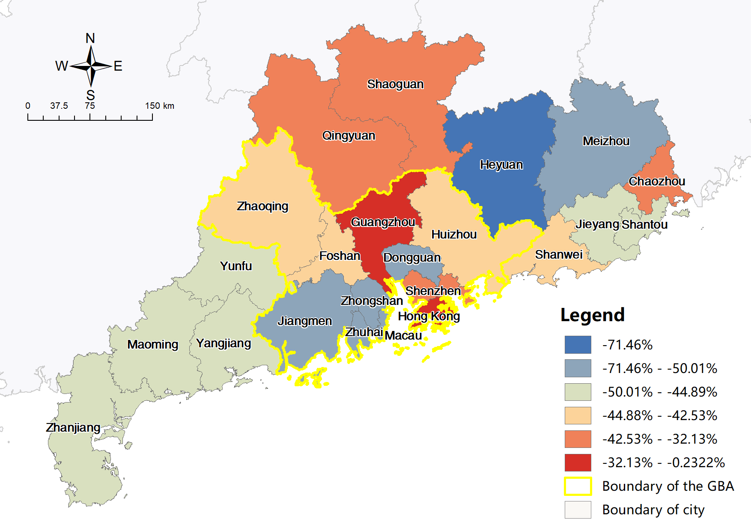

Figure 4-15 ATT by train in mid-term planning scenario (left), and corresponding absolute (middle) and relative (right) change compared to current ATT

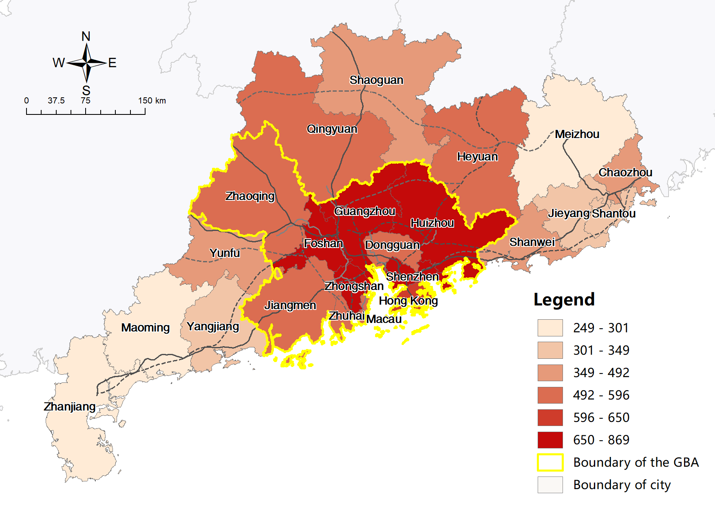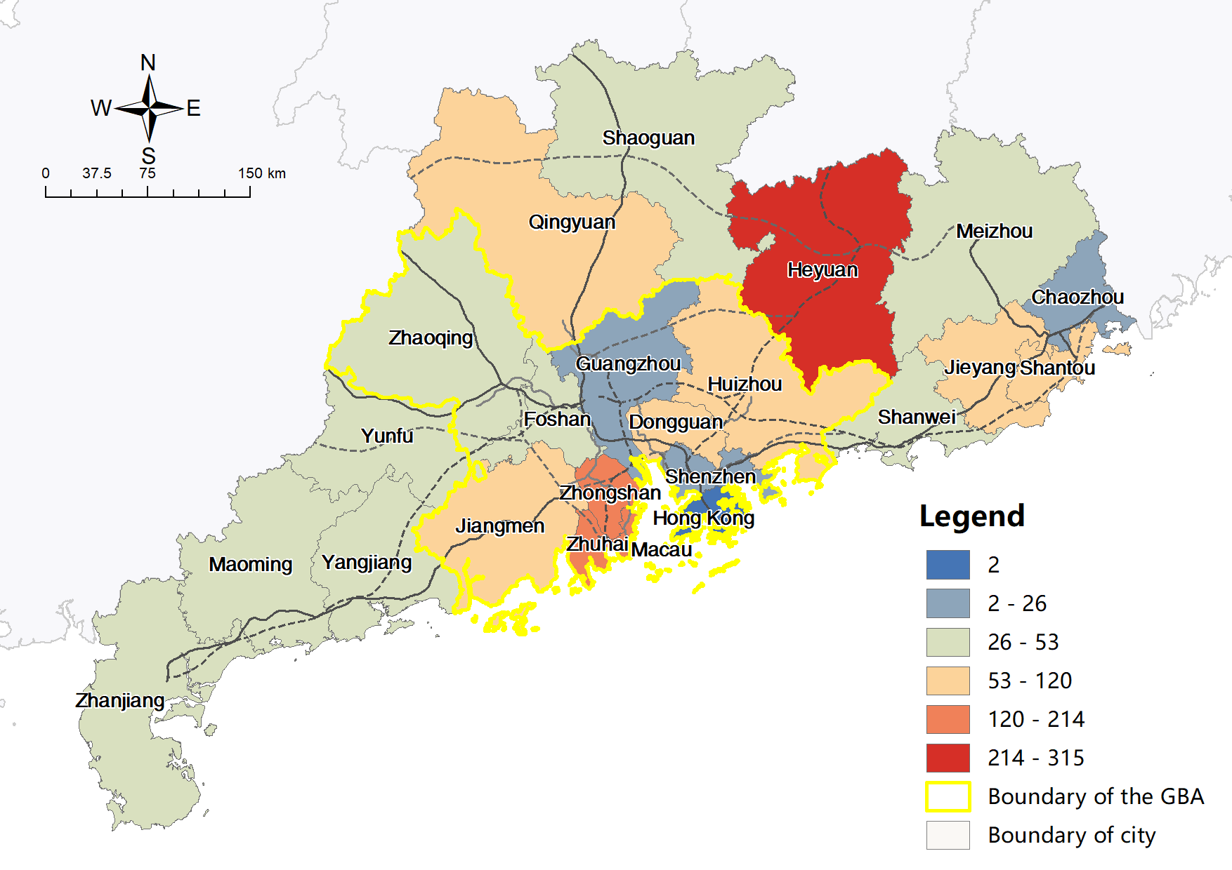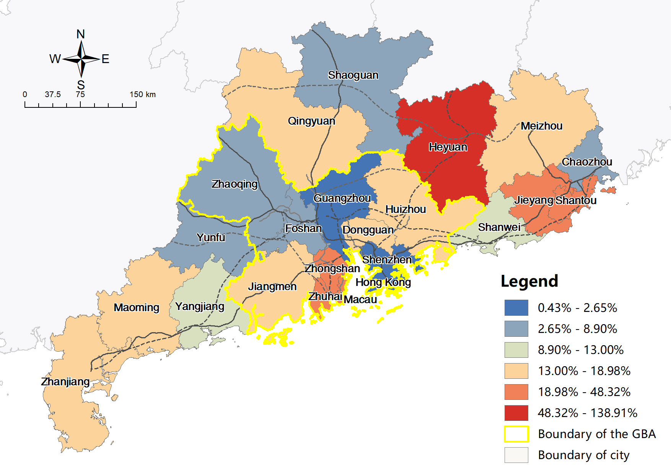

Figure 4-16 PV by train in short-term planning scenario (left), and corresponding absolute (middle) and relative (right) change compared to current PV

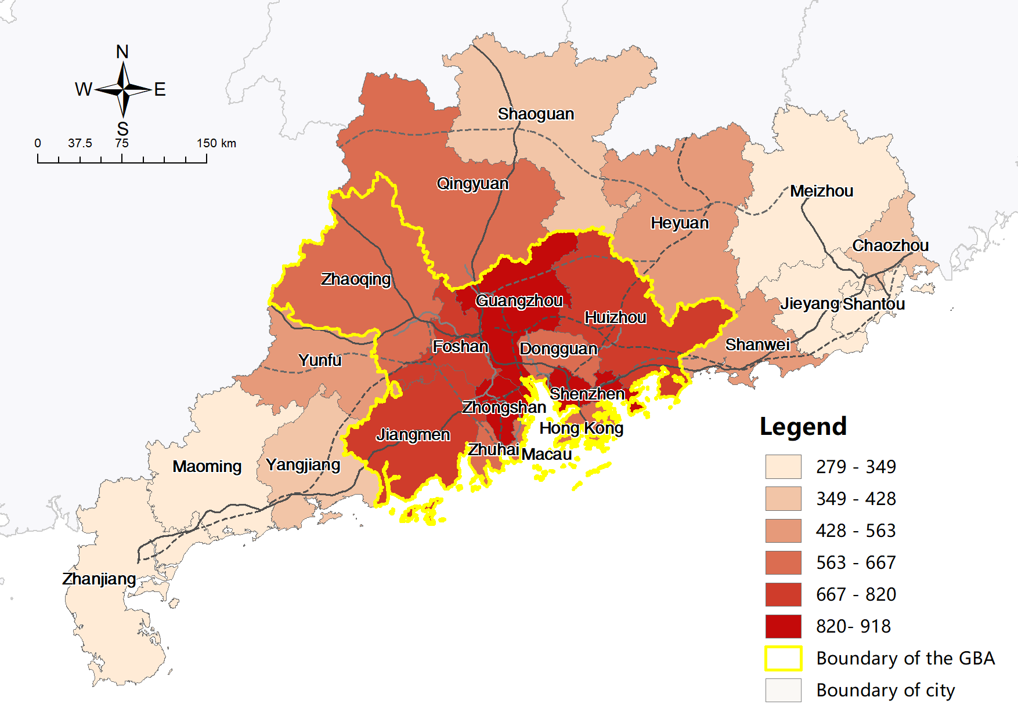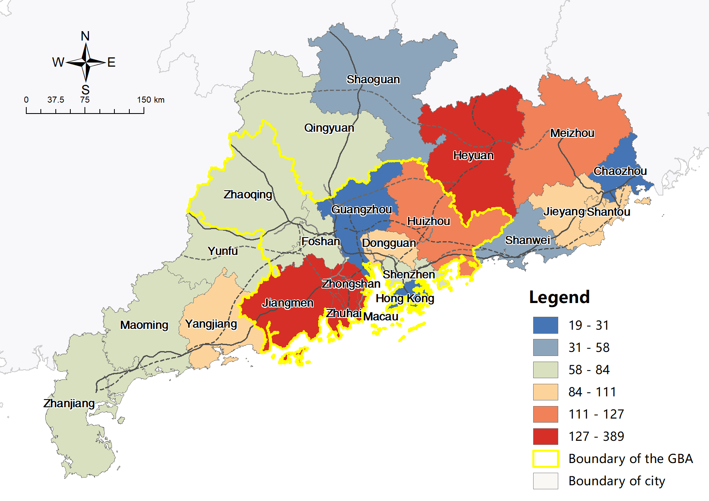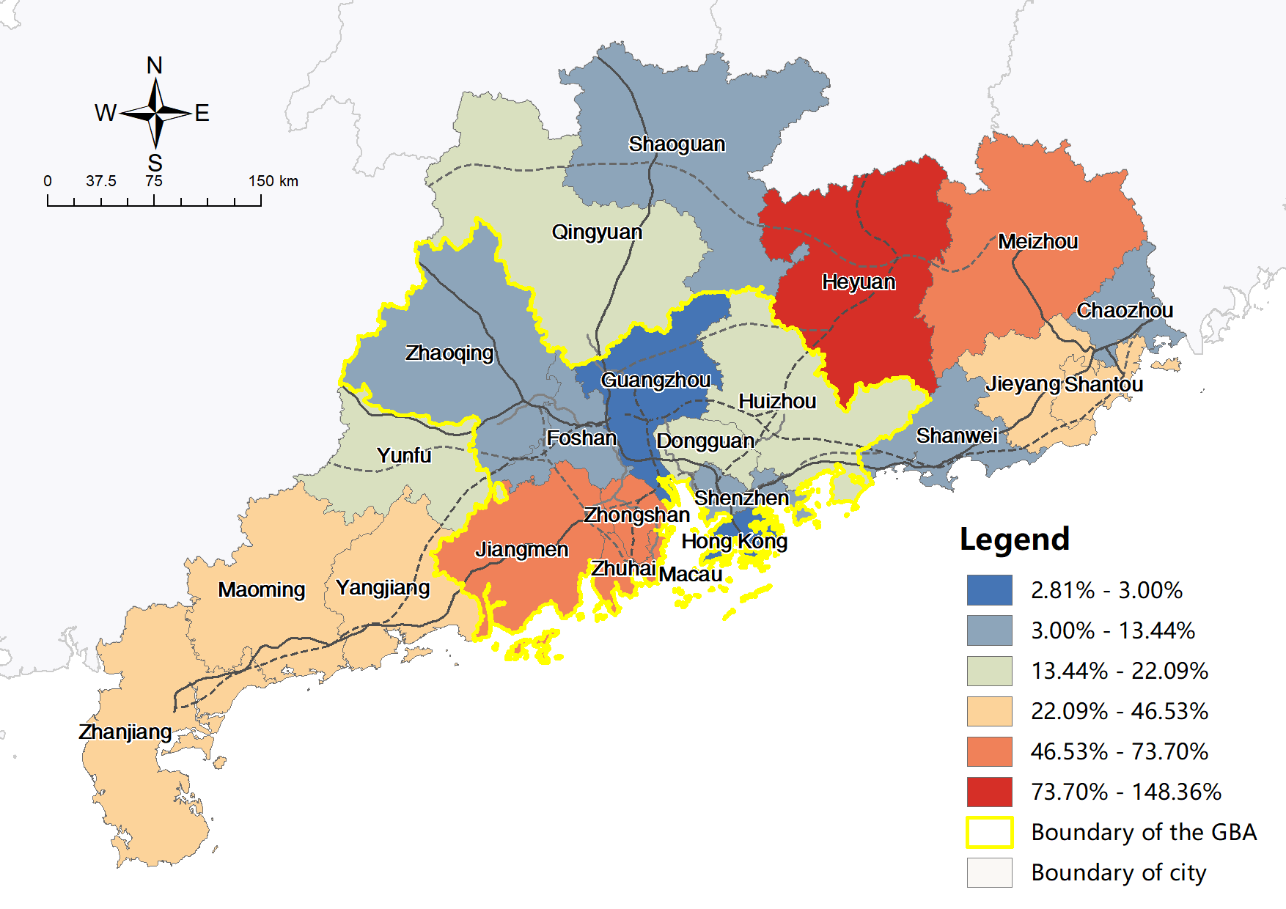

Figure 4-17 PV by train in mid-term planning scenario (left), and corresponding absolute (middle) and relative (right) change compared to current PV

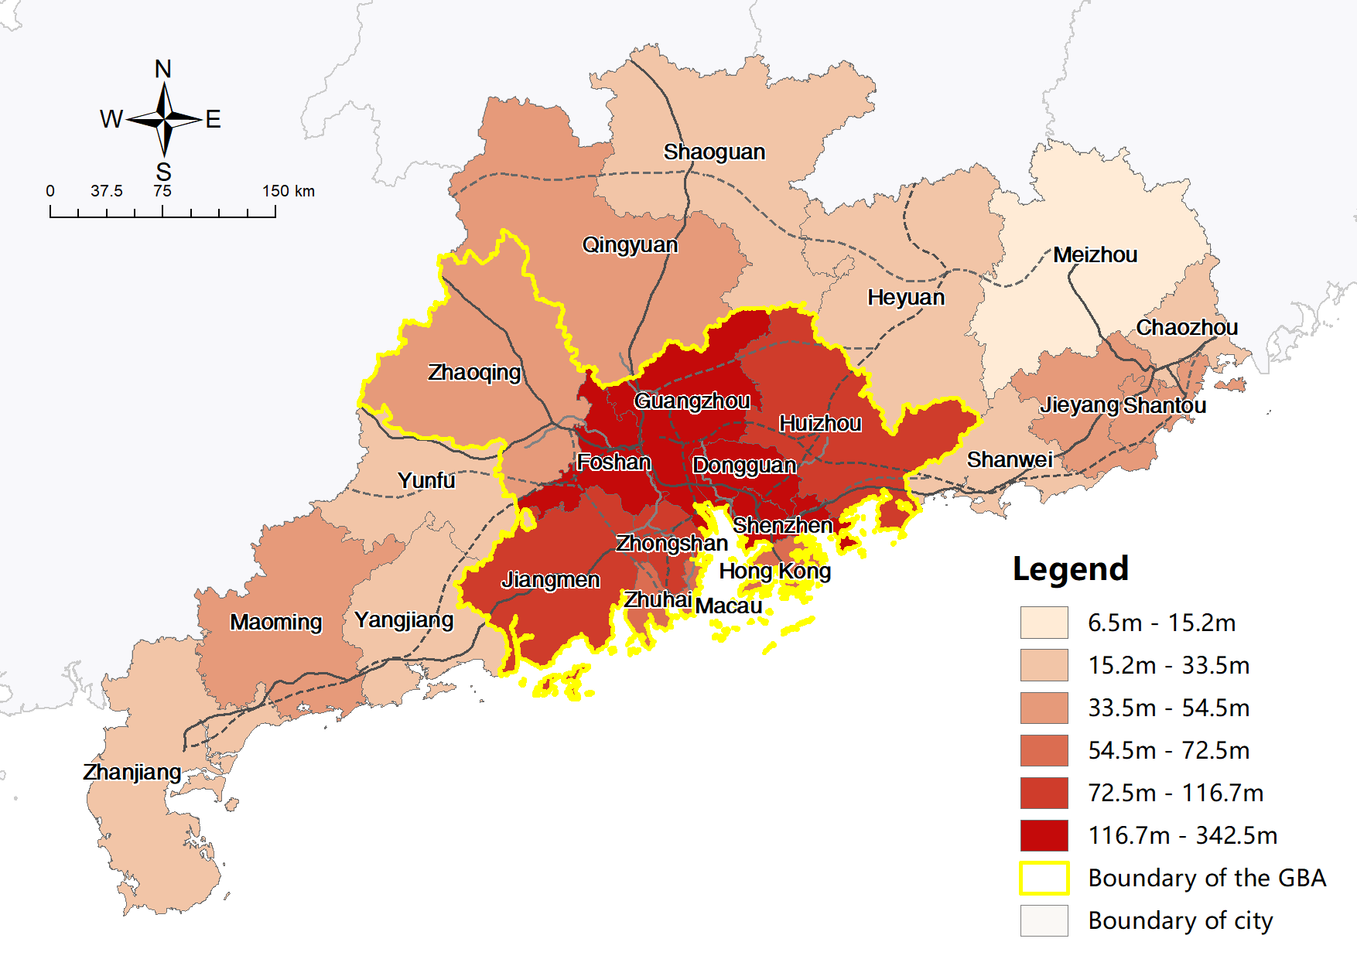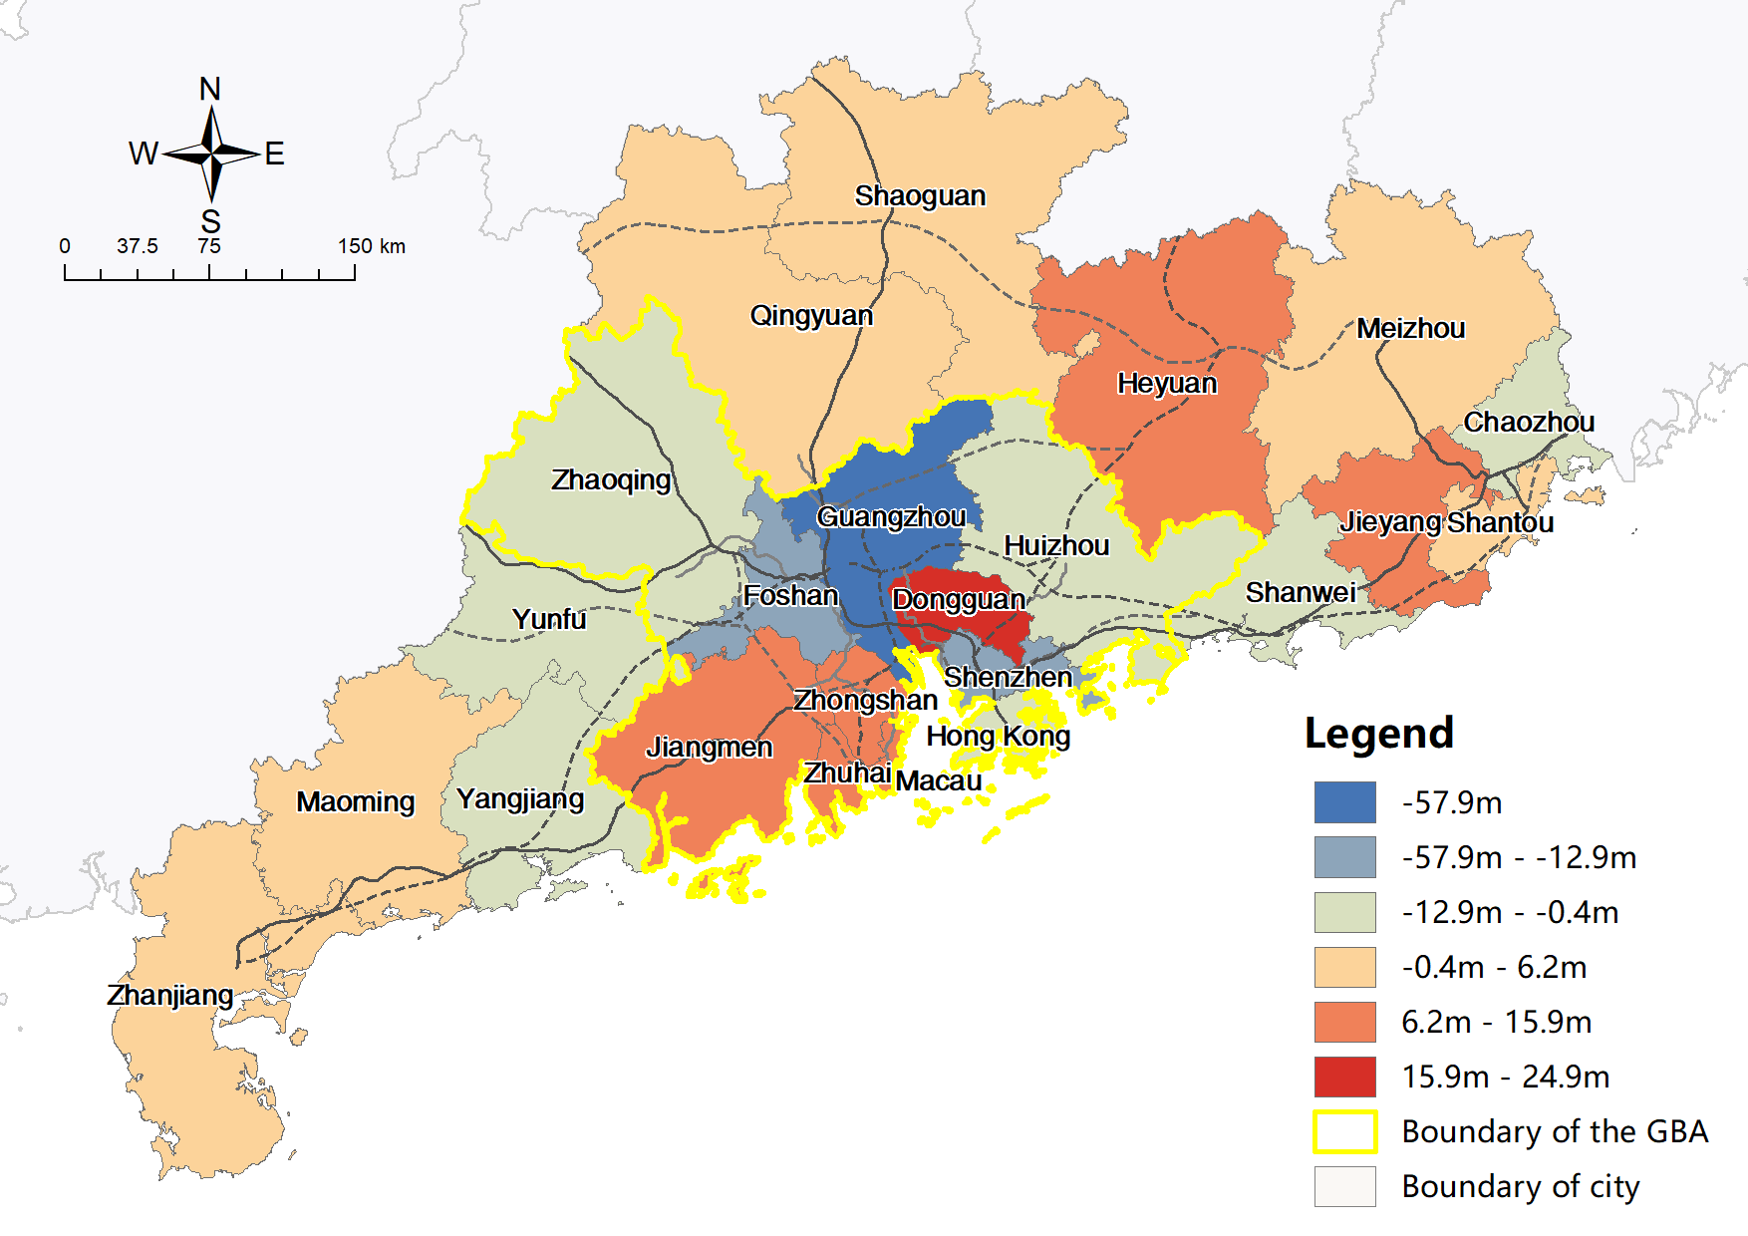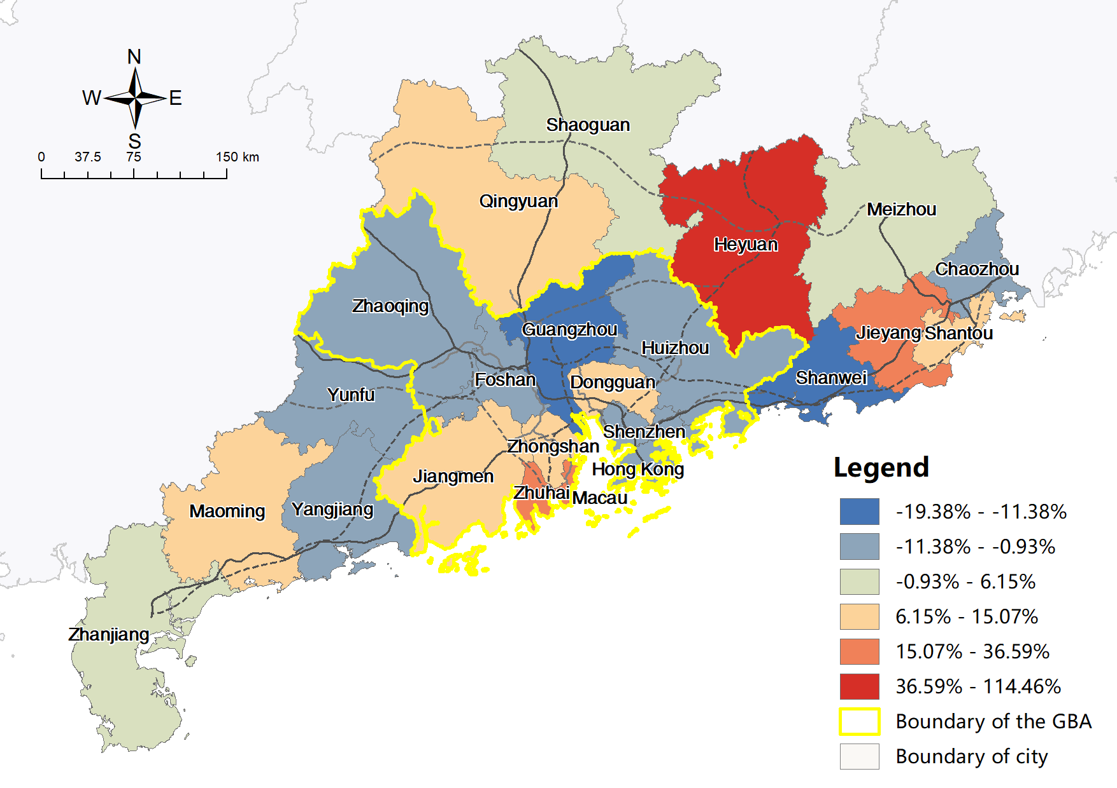

Figure 4-18 TTF by train in short-term planning scenario (left), and corresponding absolute (middle) and relative (right) change compared to current TTF

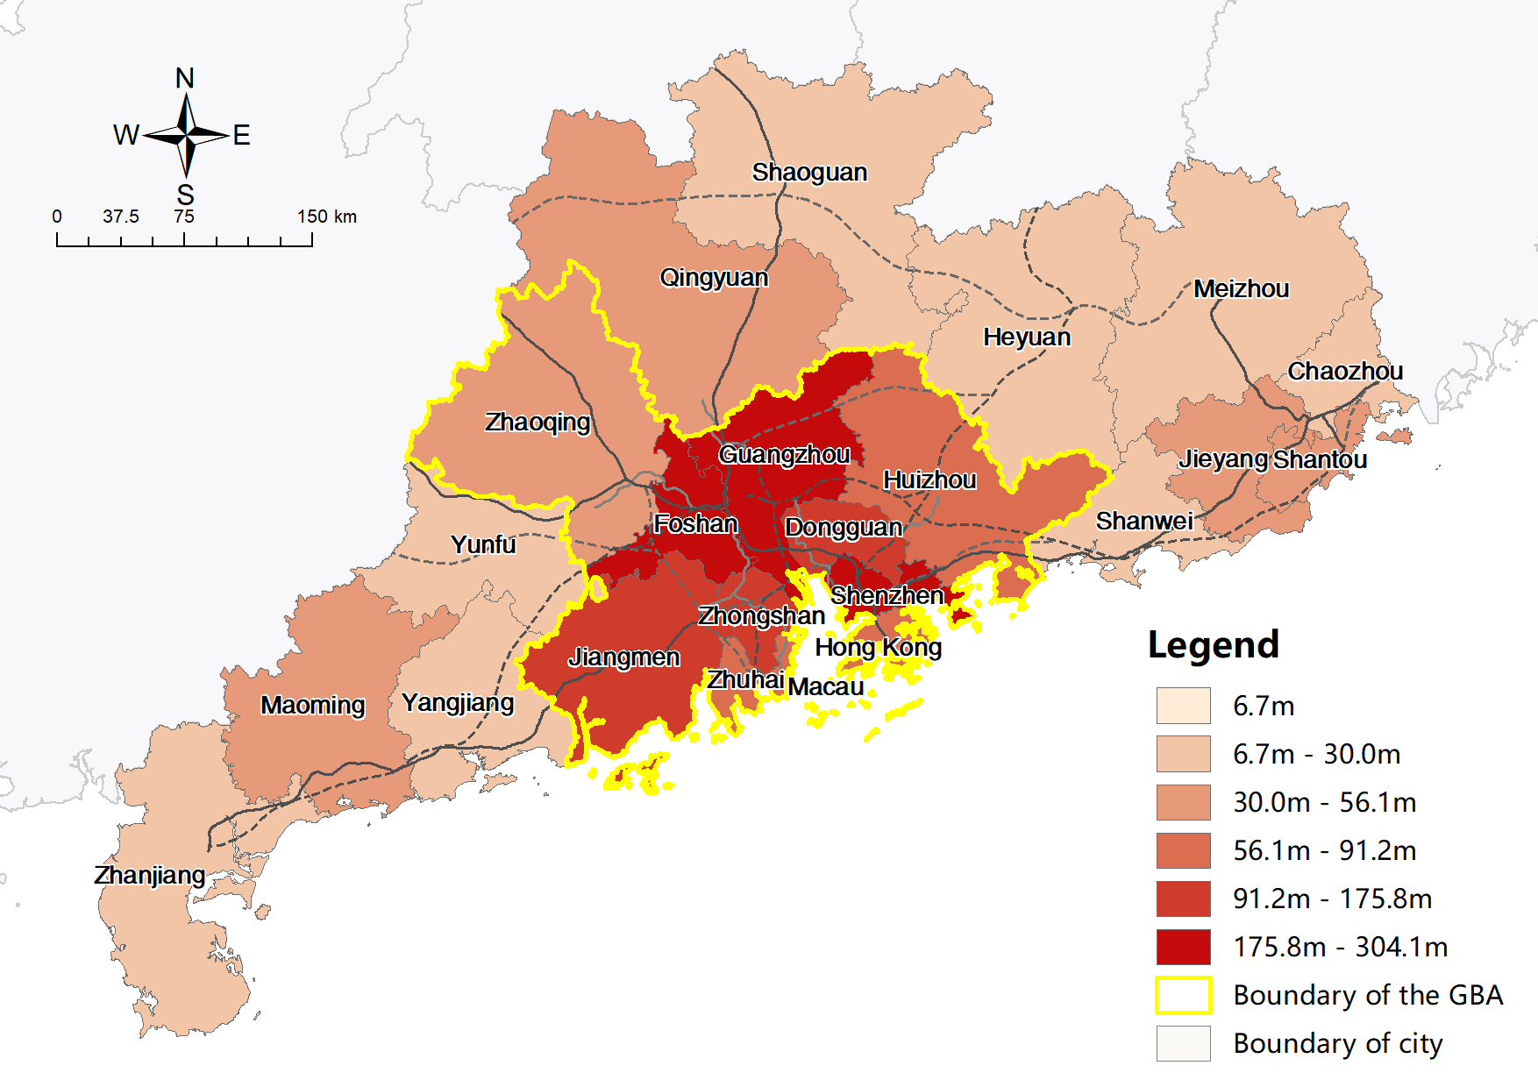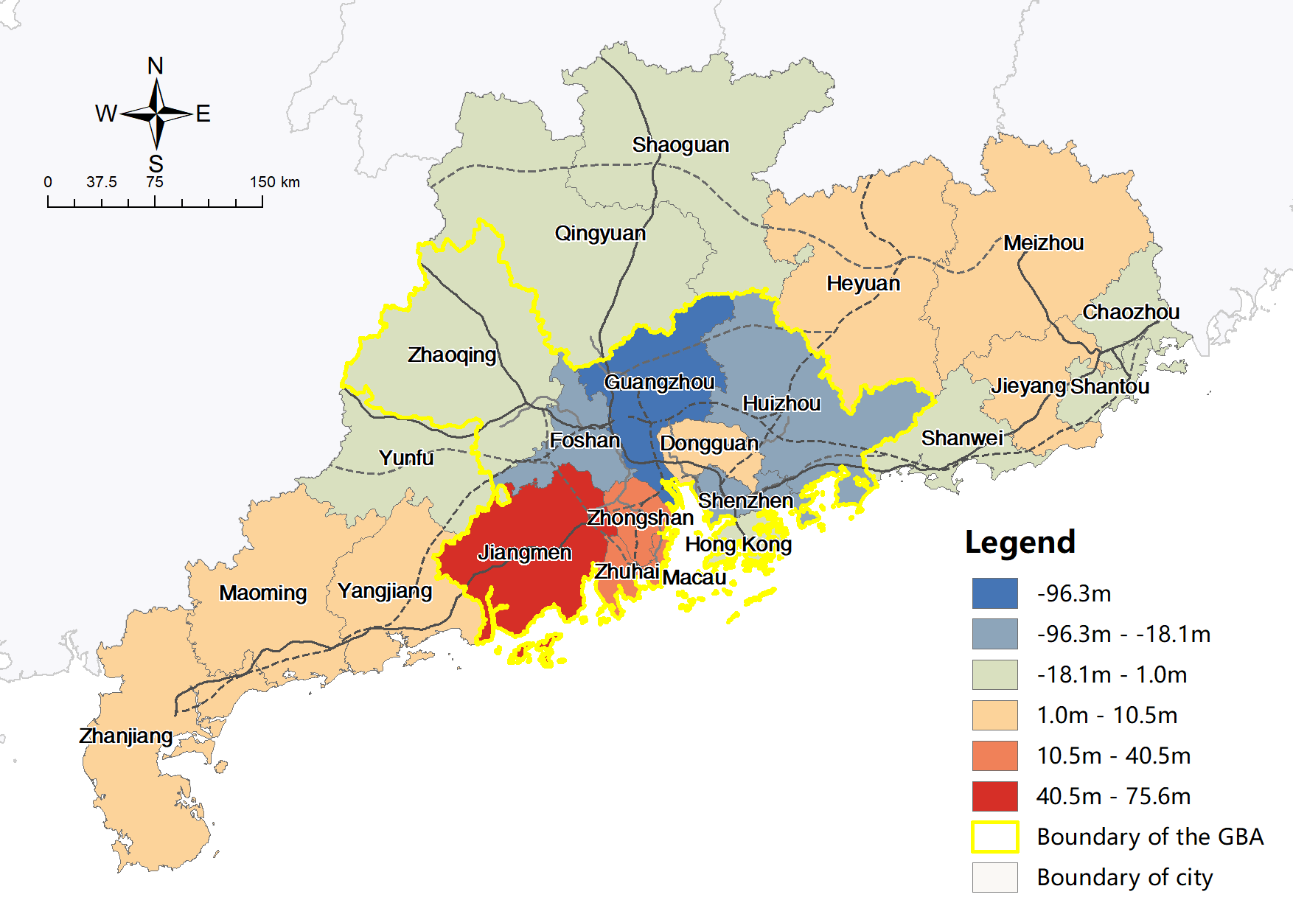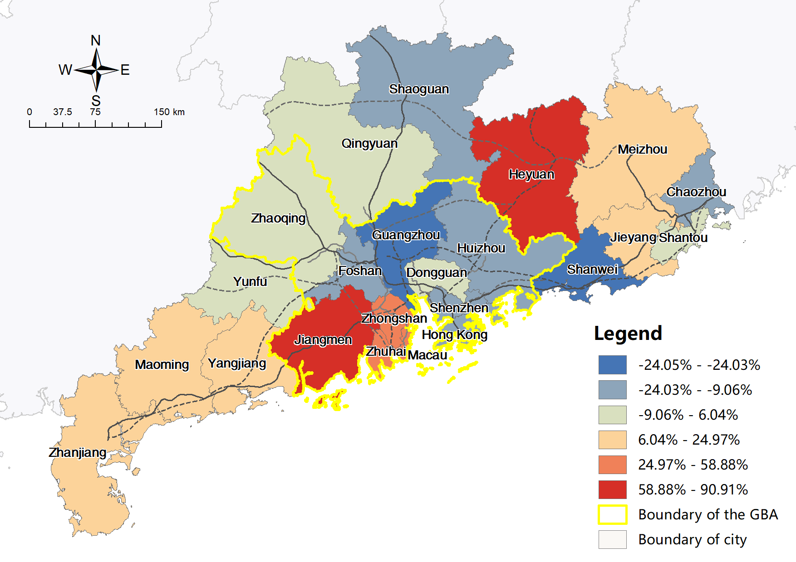

Figure 4-19 TTF by train in mid-term planning scenario (left), and corresponding absolute (middle) and relative (right) change compared to current TTF

Table 4‑4 and Figure 4-20 suggest the overall accessibility will keep increasing continuously with the implementation of HSR construction. Upon completion of the mid-term plan, the HSR network within the study area will reach a stable and ideal state (NDRC, 2016b), where the overall ATT will decrease from 168 min to 91 min, representing a reduction of 45.83%, and PV will increase from 444 to 565, comprising a 27.25% increase, whereas aggregated TTF will remain stable because of the unchanged socio-economic variables. Accessibility, as measured by ATT and PV, experiences more enhancement at the first short-term stage, with accessibility gains being significantly narrower in the second mid-term stage. In the short term, the overall ATT of the study area decreases from 168 min to 105 min by 37.5%. However, the mid-term construction only creates a 91 min reduction (8.33%). PV increased by 17.34% and 9.91% for the two stages, reflecting the same problem.

When the HSR network reaches the ideal state, the transportation inequalities also reduce significantly, with the CV of ATT decreasing from 29.26% to 23.91%, and the CV of PV and TTF showing similar results decreasing from 42.28% and 119.17% to 35.09% and 100.56% respectively. Meanwhile, under all conditions, the overall CV for any indicator significantly exceeds that for cities inside or outside the GBA. The CV for cities within the GBA is also higher than that of external cities, which accords with the results of the analysis in the current scenario, suggesting that a substantial accessibility difference between cities inside and outside the GBA remains. Furthermore, the extent of transportation inequality in the mature HSR network in the mid-term planning scenario will resemble that of current expressways, with the CV of ATT and TTF being slightly smaller than that of driving (ATT: 23.91% vs. 25.08%, TTF: 100.56% vs. 115.58%), and the CV of PV being slightly higher ( 35.09% vs. 31.40%).

Table 4‑4 CV and Mean of ATT, PV and TTF in different HSR scenarios

|  |  |  |  |  |  |  |  |
| --- | --- | --- | --- | --- | --- | --- | --- |
| **Indices** | **Scope** | **CV** | | | **Mean** | | |
| **Current** | **Short-term** | **Mid-term** | **Current** | **Short-term** | **Mid-term** |
| **ATT** | **All cities** | 29.26% | 25.44% | 23.91% | 168 | 105 | 91 |
| **GBA cities** | 23.50% | 21.29% | 21.16% | 135 | 89 | 76 |
| **External cities** | 21.24% | 20.73% | 16.31% | 199 | 119 | 104 |
| **PV** | **All cities** | 42.28% | 35.36% | 35.09% | 444 | 521 | 565 |
| **GBA cities** | 28.93% | 23.19% | 22.22% | 578 | 655 | 719 |
| **External cities** | 32.31% | 27.58% | 23.52% | 322 | 397 | 424 |
| **TTF** | **All cities** | 119.17% | 106.91% | 100.56% | 82.11m | 82.06m | 81.62m |
| **GBA cities** | 82.92% | 73.47% | 64.37% | 140.95m | 137.78m | 138.36m |
| **External cities** | 35.35% | 36.34% | 31.77% | 28.18m | 30.98m | 29.60m |

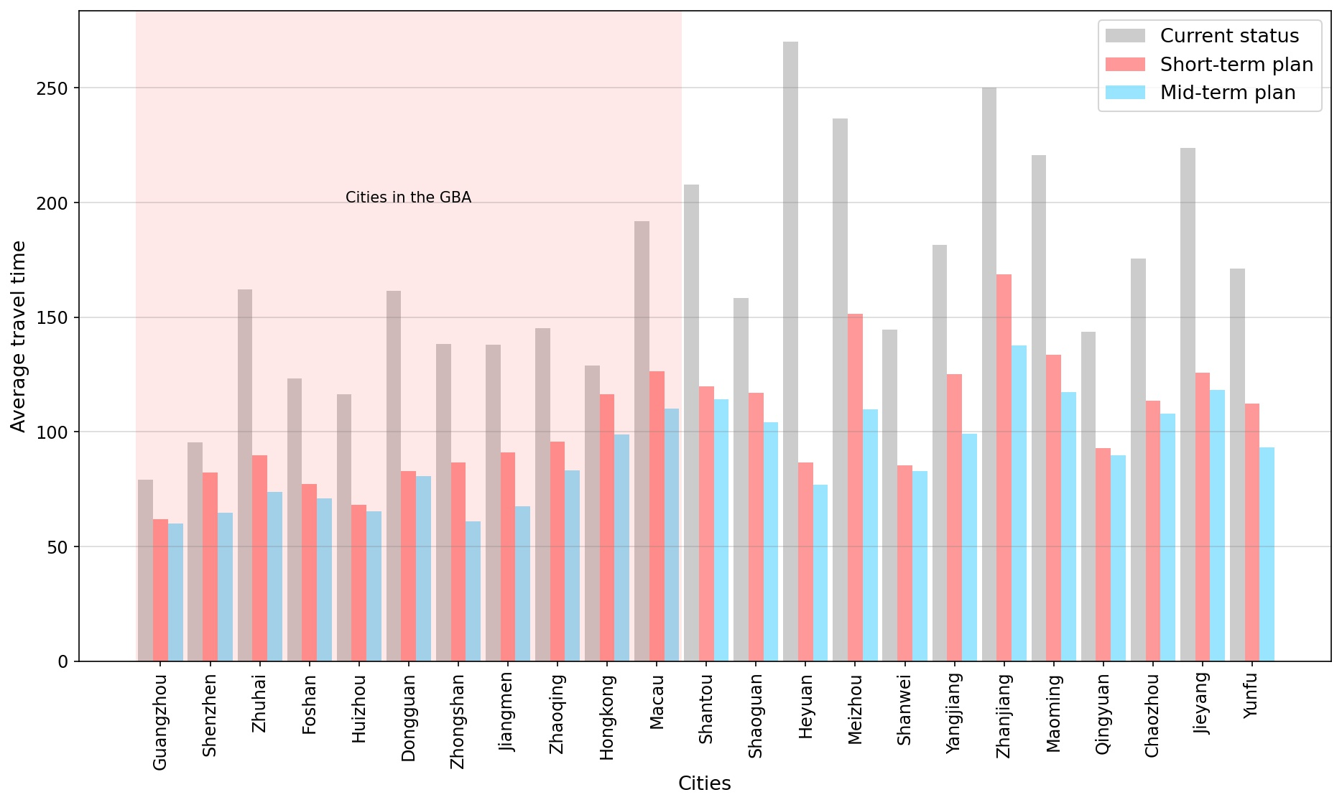

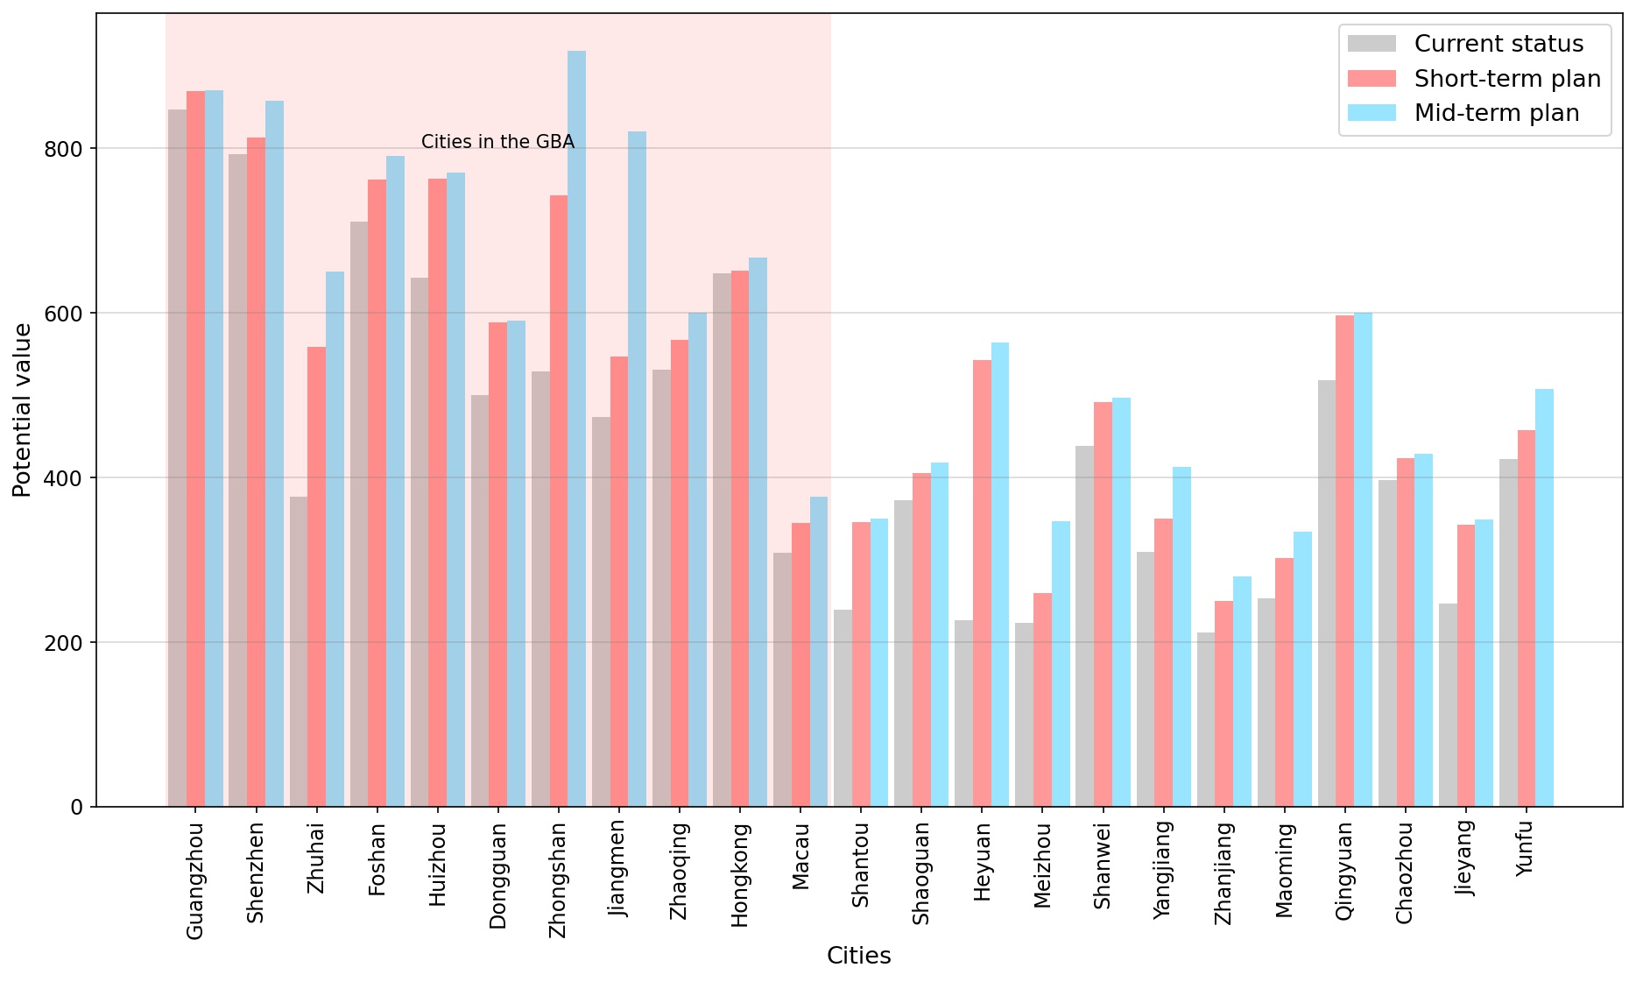

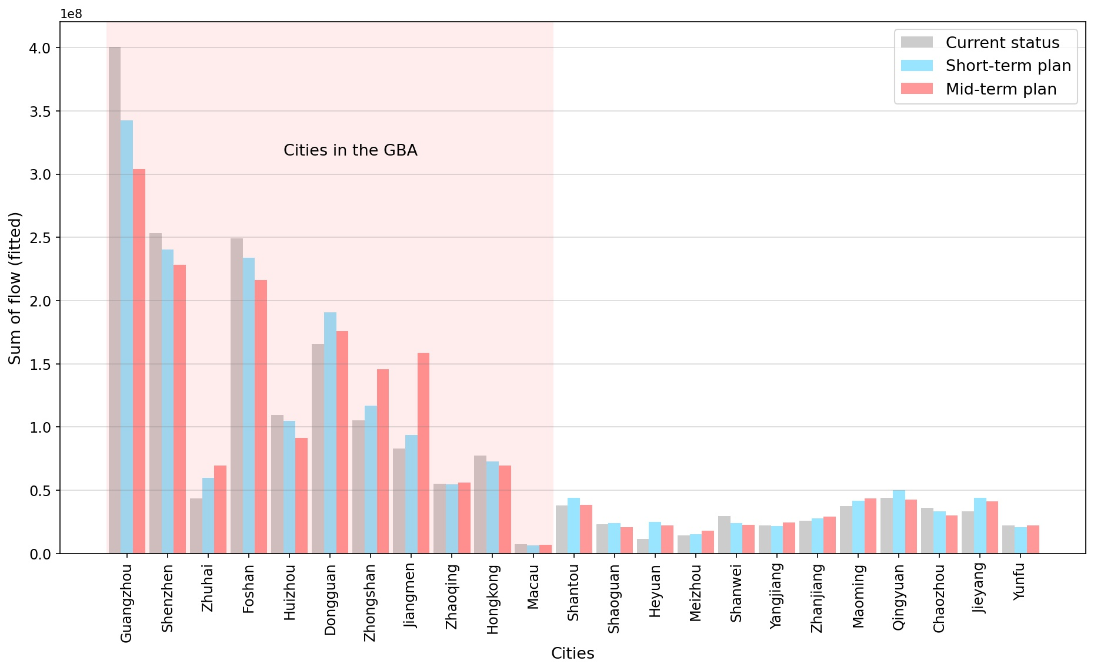

Figure 4-20 ATT, PV, and fitted TTF by train in different HSR scenarios (current, short-term planning and mid-term planning)

Figure 4-21 indicates that ATT changes in both planning scenarios have strong correlations with the ATT in the current HSR scenario, with correlation coefficients of -0.8512 and -0.9118, respectively. Thus, the higher the original ATT is, the greater the decrease in ATT will be, which helps mitigate transportation inequities. This corresponds to the nature of the planned networks and shows that it is aimed to reduce inequality. However, there are no similar findings in PV and TTF because ATT reflects the transportation infrastructure itself, whereas the PV and fitted TTF also reflect the influence of multiple socio-economic attributes.

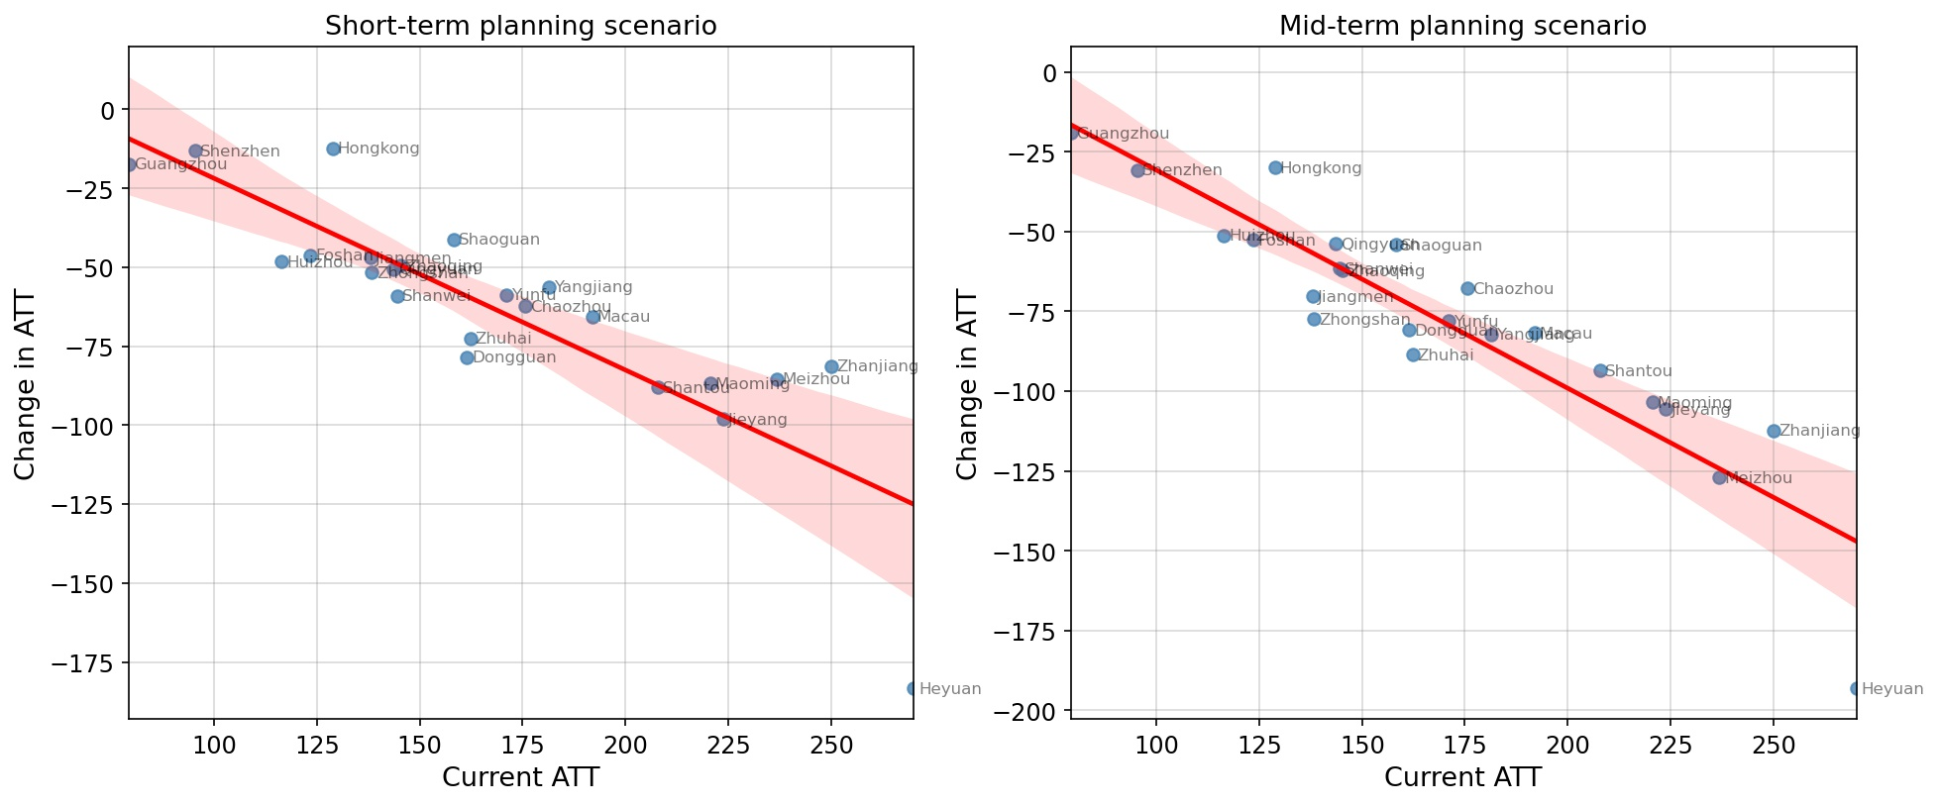

Figure 4-21 Change in ATT by train in planning scenarios compared to current ATT

### City classification

Cities of the same type are aggregated into clusters in the current scenario. However, the classified cities in the planning scenarios have no concentrated distributions. Moreover, although the results of city classification in the short-term and mid-term planning scenarios are not entirely consistent, they differ from or contradict the current scenario. Overall, successful cities are distributed on the west coast within the GBA and to the east of the GBA, while the unsuccessful cities are concentrated on the east and west ends of the study area, especially the west end. The potential cities are located within the GBA and on the north side, while the unclear cities comprise the central cities, such as Guangzhou, Shenzhen, and Hong Kong, and the cities on the north side of the GBA, in addition to some cities scattered to the east or west of the GBA.

The classification results indicate the central cities that have gained the most accessibility benefits in the current HSR scenario, such as Guangzhou and Shenzhen, become unclear cities with the fewest accessibility increments with neither significant reduction in ATT or increase in PV, whereas Heyuan and Shantou, originally unsuccessful or unclear cities, harvest the biggest promotion in accessibilities in the planning scenarios. Within the GBA, most cities on the west coast benefit more than east coast cities, and Dongguan no longer lags behind the surrounding central cities. These classification results are consistent with the analysis of the ATT, PV, and TTF indicators, which show an increase in transport equity both across the study area and within the GBA. However, the three cities on the western side of the study area (Zhanjiang, Maoming, and Yunfu) are unsuccessful or potential cities, both currently and in planning scenarios.

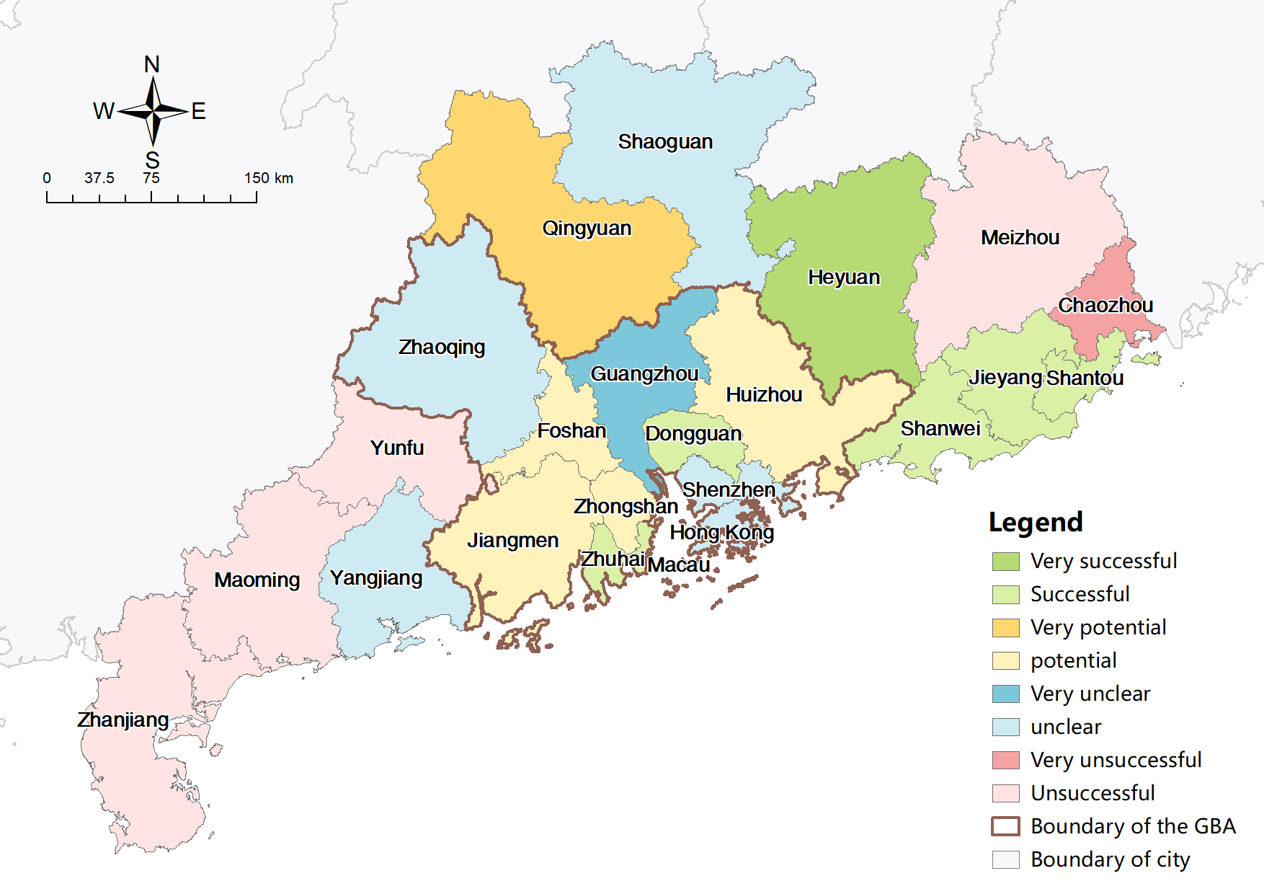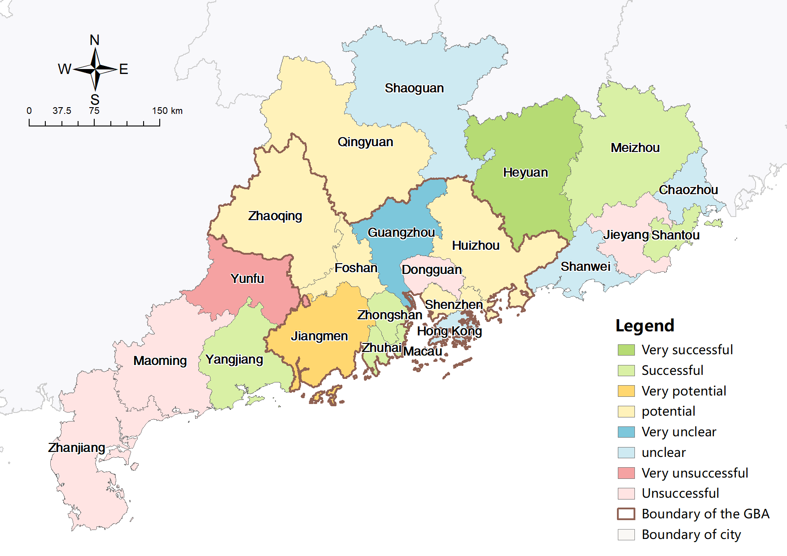

Figure 4-22 City classification by accessibility benefit in HSR construction in planning scenarios (left: short-term, right: mid-term)

Based on the above analysis, the last research questions can be answered.

**Question 4:** With the implementation of the plan, accessibility has been continuously improved in all cities, especially those that are currently less accessible under the HSR scenario, such as Heyuan, Jiangmen, and Shantou. Consequently, transport equity has improved. There are a few additional findings worth mentioning. First, the accessibility increase associated with HSR construction experienced a huge decrease in efficiency because accessibility gains in the mid-term plan are much smaller than that in the short-term plan, while the extent and efficiency of the social and economic impact need to be studied further. Secondly, when the ultimate HSR network is completed, the overall transport equity will resemble that of the current expressway network. Finally, cities at the western side of the study area remain unsuccessful in both the current and planning HSR scenarios, suggesting that they inevitably benefit less from the HSR construction process. These cities deserve targeted policy support and further attention in future HSR operations.

## Limitations

This research has several limitations that indicate the need for further research.

First, a prefecture-level city may have multiple HSR stations located in different districts or counties, especially in cities within a polycentric megacity region like the GBA. The scale of prefecture used in this research is limited by the accuracy of the flow data, which is relatively coarse, rendering it difficult to evaluate HSR impacts with explicit spatial insights. At the county level, HSR-led impacts, such as polarization, corridor, and bypass effects, and differences in accessibility are clearer.

Secondly, this research fails to consider the impacts of train frequency or the intercity traffic time. Although traffic times extracted from train timetables in this research combine the impacts of train speeds, stopovers, and transfers and are more realistic than those calculated from topological HSR networks, they do not capture the impact of intercity transportation to HSR stations and train frequency on accessibility, where small and peripheral cities differ significantly from central and large cities.

Finally, while transportation equity can be classified as horizontal and vertical equities, this study only focuses on horizontal equity, using location-based indicators to evaluate HSR extensions’ macro-scale spatial impact on accessibility. Hence, it can not reveal the full dimension of mobility impacts.

# Conclusion

This paper comprises a response to the central government’s request for more equitable development. Furthermore, it addresses the dearth of research into megacity scale transportation equity. Thus, this study examines the impact of HSR expansion on accessibility related to cities in the GBA and GD, in addition to related modifications in patterns of inequality under current and projected scenarios. Moreover, this study alters its reference from conventional rail services to expressways since the latter have a more even and concentrated coverage. Another innovation in this study is the use of train timetables and real-time navigation services compared to network-based calculation in previous studies. Moreover, traffic flow data from Tencent Location Big Data Platform is employed to supplement gravity-type theoretical estimations like ATT and PV to provide a critical evaluation of HSR-led traffic accessibility and equity changes.

The study concludes that HSR construction has enhanced current accessibility in most cities, with intra-city travel time decreasing from 210 min to 168 min, accompanied by a pattern of polarization towards T-shaped corridors. Transportation inequalities have also been exacerbated. There is a huge gap in accessibility between cities inside and outside the GBA, which is partly due to variations in construction progress. Heyuan has witnessed the smallest accessibility increase, whereas the central cities of Guangzhou and Shenzhen have reported the greatest benefits. Within the GBA, cities on the west coast of the Pearl River have fallen behind the eastern cities, resulting in greater accessibility differences between GBA cities than external cities.

In the planning scenario, accessibility gains have a largely reversed distribution and are concentrated in cities that were originally less accessible. HSR transportation will eventually outperform expressways in terms of transport equity. This study also concluded that the western area cities are unsuccessful, both currently and according to future HSR projections, with evident reductions in travel time but neglectable increases in socio-economic opportunities or traffic flow. The marginal benefits of HSR construction are narrowed, with significantly less accessibility gain in relation to the mid-term plans than in the short-term plan.

These findings serve as a reminder to the policymakers of the need to promote more synchronized progress in regional HSR construction, channel more resources into the enhancement of HSR infrastructure in western GD and optimize mid-term planning to render more efficient construction.

This research indicates important directions for future research. Firstly, the finer scale of spatio-temporary movement data provided by mobile APP companies means that future transportation equity research into intercity transportation systems can be refined from the prefecture-city level to the county level, thereby generating clearer spatial insights and facilitating comparisons of results at different scales. Secondly, future studies can consider the operational characteristics of HSR, such as train frequency and capacity, and include time for local access to the HSR stations as part of accessibility since it is typical that the low-rank cities have no convenient or stable access to HSR services. Finally, the focus of future studies can be shifted from spatial equity using utility-based accessibility measures to social equity based on demographic characteristics like age, gender and income to promote comprehensive research into equity issues.

# Bibliography

Albalate, D. and Bell, G. (2012) ‘High-speed rail: Lessons for policy makers from experiences abroad’, *Public Administration Review*, 72(3), pp. 336–349.

Bai, Y., Chen, B. and Wu, C. (2012) ‘Spatial accessibility of road network in Guanzhong-Tianshui Economic Region’, *Progress in Geography*, 31(6), pp. 724–732.

Berlie, J. A. (2021) ‘Hong Kong SAR, China and BRI’s Globalization’, *Open Access Library Journal*, 8(6), pp. 1–12.

Bonnafous, A. (1987) ‘The regional impact of the TGV’, *Transportation*, 14(2), pp. 127–137.

Campa, J. L., López-Lambas, M. E. and Guirao, B. (2016) ‘High speed rail effects on tourism: Spanish empirical evidence derived from China’s modelling experience’, *Journal of Transport Geography*, 57, pp. 44–54. doi: https://doi.org/10.1016/j.jtrangeo.2016.09.012.

Cao, J. *et al.* (2013) ‘Accessibility impacts of China’s high-speed rail network’, *Journal of Transport Geography*, 28, pp. 12–21. doi: https://doi.org/10.1016/j.jtrangeo.2012.10.008.

Cao, X. *et al.* (2019) ‘Transport Accessibility and Spatial Connections of Cities in the Guangdong-Hong Kong-Macao Greater Bay Area’, *Chinese Geographical Science*, 29(5), pp. 820–833. doi: 10.1007/s11769-019-1034-2.

Cascetta, E. *et al.* (2011) ‘Analysis of mobility impacts of the high speed Rome–Naples rail link using withinday dynamic mode service choice models’, *Journal of Transport Geography*, 19(4), pp. 635–643. doi: https://doi.org/10.1016/j.jtrangeo.2010.07.001.

Chacon-Hurtado, D. *et al.* (2020) ‘The role of transportation accessibility in regional economic resilience’, *Journal of Transport Geography*, 84, p. 102695. doi: https://doi.org/10.1016/j.jtrangeo.2020.102695.

Chen, C.-L. and Vickerman, R. (2017) ‘Can transport infrastructure change regions’ economic fortunes? Some evidence from Europe and China’, *Regional Studies*, 51(1), pp. 144–160. doi: 10.1080/00343404.2016.1262017.

Chen, J., Lu, F. and Cheng, C. (2007) ‘Advance in accessibility evaluation approaches and applications’, *Progress in Geography*, 26(5), pp. 100–110.

Chen, M. and Lu, H. (2020) ‘Analysis of transportation network vulnerability and resilience within an urban agglomeration: Case study of the greater Bay Area, China’, *Sustainability (Switzerland)*, 12(18). doi: 10.3390/SU12187410.

Chen, Z. and Haynes, K. E. (2015a) ‘Impact of high-speed rail on international tourism demand in China’, *Applied Economics Letters*, 22(1), pp. 57–60. doi: 10.1080/13504851.2014.925043.

Chen, Z. and Haynes, K. E. (2015b) ‘Impact of high speed rail on housing values: an observation from the Beijing–Shanghai line’, *Journal of Transport Geography*, 43, pp. 91–100. doi: https://doi.org/10.1016/j.jtrangeo.2015.01.012.

Chen, Z. and Haynes, K. E. (2017) ‘Impact of high-speed rail on regional economic disparity in China’, *Journal of Transport Geography*, 65, pp. 80–91.

China State Council (2020) *Guangdong Statistical Yearbook 2020*, *China Statistics Press*. Available at: http://stats.gd.gov.cn/gdtjnj/content/post_3098041.html (Accessed: 10 June 2021).

CMAB (2018) *Outline Development Plan for the Guangdong-Hong Kong-Macao Greater Bay Area*. Available at: https://www.bayarea.gov.hk/en/home/index.html (Accessed: 10 June 2021).

Dai, T., Jin, F. and Wang, J. (2005) ‘Spatial interaction and network structure evolvement of cities in term of China’s railway passenger flow in 1990s’, *Progress in Geography*, 24(2), pp. 80–89.

Ding, J. *et al.* (2013) ‘Competition game of high-speed rail and civil aviation and its spatial effect-a case study of Beijing-Shanghai high-speed rail’, *Economic geography*, 33(5), pp. 104–110.

DNRGP (2021) *Territorial spatial planning of Guangdong Province (2020-2035)*. Available at: http://nr.gd.gov.cn/zwgknew/tzgg/gg/content/post_3225138.html (Accessed: 10 July 2021).

Fan, C. C. (2005) ‘Modelling interprovincial migration in China, 1985-2000’, *Eurasian Geography and Economics*, 46(3), pp. 165–184.

Fröidh, O. (2005) ‘Market effects of regional high-speed trains on the Svealand line’, *Journal of Transport Geography*, 13(4), pp. 352–361. doi: https://doi.org/10.1016/j.jtrangeo.2004.12.006.

Geurs, K. T. and van Wee, B. (2004) ‘Accessibility evaluation of land-use and transport strategies: review and research directions’, *Journal of Transport Geography*, 12(2), pp. 127–140. doi: https://doi.org/10.1016/j.jtrangeo.2003.10.005.

Givoni, M. (2006) ‘Development and Impact of the Modern High‐speed Train: A Review’, *Transport Reviews*, 26(5), pp. 593–611. doi: 10.1080/01441640600589319.

Gutiérrez, J. (2001) ‘Location, economic potential and daily accessibility: an analysis of the accessibility impact of the high-speed line Madrid--Barcelona--French border’, *Journal of transport geography*, 9(4), pp. 229–242.

Gutiérrez, J., Gonzalez, R. and Gomez, G. (1996) ‘The European high-speed train network: predicted effects on accessibility patterns’, *Journal of transport geography*, 4(4), pp. 227–238.

Handy, S. L. and Niemeier, D. A. (1997) ‘Measuring accessibility: An exploration of issues and alternatives’, *Environment and Planning A*, 29(7), pp. 1175–1194. doi: 10.1068/a291175.

Hansen, W. G. (1959) ‘How Accessibility Shapes Land Use’, *Journal of the American Institute of Planners*, 25(2), pp. 73–76. doi: 10.1080/01944365908978307.

Hou, Q. and Li, S.-M. M. (2011) ‘Transport infrastructure development and changing spatial accessibility in the Greater Pearl River Delta, China, 1990–2020’, *Journal of Transport Geography*, 19(6), pp. 1350–1360. doi: https://doi.org/10.1016/j.jtrangeo.2011.07.003.

Hui, E. C. M. *et al.* (2020) ‘Deciphering the spatial structure of China’s megacity region: A new bay area—The Guangdong-Hong Kong-Macao Greater Bay Area in the making’, *Cities*, 105(June 2018), p. 102168. doi: 10.1016/j.cities.2018.10.011.

Jiang, H., Xu, J. and Qi, Y. (2010) ‘The influence of Beijing-Shanghai high-speed railways on land accessibility of regional center cities’, *Acta Geographica Sinica*, 65(10), pp. 1287–1298.

Jiang, X. *et al.* (2012) ‘Spatial pattern and evolution of road network accessibility in Anhui Province’, *Progress in Geography*, 31(12), pp. 1591–1599.

Jiao, J. *et al.* (2014) ‘Impacts on accessibility of China’s present and future HSR network’, *Journal of Transport Geography*, 40, pp. 123–132. doi: https://doi.org/10.1016/j.jtrangeo.2014.07.004.

Karemera, D., Oguledo, V. I. and Davis, B. (2000) ‘A gravity model analysis of international migration to North America’, *Applied economics*, 32(13), pp. 1745–1755.

Kim, H. and Sultana, S. (2015) ‘The impacts of high-speed rail extensions on accessibility and spatial equity changes in South Korea from 2004 to 2018’, *Journal of Transport Geography*, 45, pp. 48–61. doi: https://doi.org/10.1016/j.jtrangeo.2015.04.007.

Kim, K. S. (2000) ‘High-speed rail developments and spatial restructuring: A case study of the Capital region in South Korea1This paper is a revised and updated version of an article originally appearing in the Proceedings of the 1996 Symposium on the Impacts of High-Speed ’, *Cities*, 17(4), pp. 251–262. doi: https://doi.org/10.1016/S0264-2751(00)00021-4.

Li, T. *et al.* (2013) ‘High-speed rail’s influence on urban and regional spatial development: A review’, *Urban Development Studies*, 20(2), pp. 71–79.

Li, X. *et al.* (2018) ‘The spatial structure of GuangdongHong Kong-Macao Greater Bay Area examined from the perspective of mega-city region’, *Progress in Geography*, 37(12), pp. 1609–1622.

Li, Y., Li, Lifen and Li, Lijun (2021) ‘High-speed railway and other transportations of attracted radius location by passenger travel cost model’, *Arabian Journal of Geosciences*, 14(10), pp. 1–6.

Litman, T. (2002) ‘Evaluating transportation equity’, *World Transport Policy \& Practice*, 8(2), pp. 50–65.

Liu, L. and Zhang, M. (2017) ‘The Impacts of High-Speed Rail on Accessibility and Regional Economy in China’, *Urban Planning International*, 32(4), pp. 76–89.

Liu, L. and Zhang, M. (2018) ‘High-speed rail impacts on travel times, accessibility, and economic productivity: A benchmarking analysis in city-cluster regions of China’, *Journal of Transport Geography*, 73(July), pp. 25–40. doi: 10.1016/j.jtrangeo.2018.09.013.

Liu, L. and Zhang, M. (2021) ‘The impacts of high-speed rail on regional accessibility and spatial development-updated evidence from China’s mid-yangtze river city-cluster region’, *Sustainability (Switzerland)*, 13(8). doi: 10.3390/su13084227.

Liu, S., Wan, Y. and Zhang, A. (2020) ‘Does China’s high-speed rail development lead to regional disparities? A network perspective’, *Transportation Research Part A*, 138(June), pp. 299–321. doi: 10.1016/j.tra.2020.06.010.

López, E., Gutiérrez, J. and Gómez, G. (2008) ‘Measuring Regional Cohesion Effects of Large-scale Transport Infrastructure Investments: An Accessibility Approach’, *European Planning Studies*, 16(2), pp. 277–301. doi: 10.1080/09654310701814629.

Lutter, H., Pütz, T. and Spangenberg, M. (1992) ‘Accessibility and peripherality of community regions: The role of road-, long-distance railway-and airport networks’, in. Brussels: Commission of the European Communities.

McDaniel, P. R. and Repetti, J. R. (1992) ‘Horizontal and vertical equity: the Musgrave/Kaplow exchange’, *Fla. Tax Rev.*, 1, p. 607.

Monzon, A., Lopez, E. and Ortega, E. (2019) ‘Has HSR improved territorial cohesion in Spain? An accessibility analysis of the first 25 years: 1990–2015’, *European Planning Studies*, 27(3), pp. 513–532. doi: 10.1080/09654313.2018.1562656.

Monzón, A., Ortega, E. and López, E. (2013) ‘Efficiency and spatial equity impacts of high-speed rail extensions in urban areas’, *Cities*, 30, pp. 18–30. doi: https://doi.org/10.1016/j.cities.2011.11.002.

Moyano, A. and Dobruszkes, F. (2017) ‘Mind the services! High-speed rail cities bypassed by high-speed trains’, *Case Studies on Transport Policy*, 5(4), pp. 537–548. doi: https://doi.org/10.1016/j.cstp.2017.07.005.

Nakamura, H. *et al.* (1989) ‘Chemoembolization using iodized oil in the treatment of hepatocellular carcinoma’, in *Cancer chemotherapy: challenges for the future: proceedings of the Fourth Nagoya International Symposium on cancer treatment. ICS904*, pp. 95–103. Available at: https://www.scopus.com/inward/record.uri?eid=2-s2.0-0024836583&partnerID=40&md5=d2d13709338cbddb9880f01c8e2a1b14.

NBSC (2020) *China statistical yearbook 2020*, *China Statistics Press*. Available at: http://www.stats.gov.cn/tjsj/ndsj/2020/indexch.htm (Accessed: 10 August 2021).

NDRC (2016a) *China Mid-term and Long-term Railway Network Planning*. Available at: https://www.ndrc.gov.cn/xxgk/zcfb/ghwb/201607/t20160720_962188.html?code=&state=123 (Accessed: 8 August 2021).

NDRC (2016b) *National medium and long term railway plan*. Available at: http://www.nra.gov.cn/jgzf/flfg/gfxwj/zt/other/201607/t20160721_26055.shtml (Accessed: 10 August 2021).

NDRC (2016c) *The 13th Five-Year Plan from 2016 to 2020 is shortened for The 13th Five-year Plan for Economic and Social Development of the People’s Republic of China*. Available at: http://www.gov.cn/xinwen/2016-03/17/content_5054992.htm (Accessed: 20 June 2021).

Páez, A., Scott, D. M. and Morency, C. (2012) ‘Measuring accessibility: positive and normative implementations of various accessibility indicators’, *Journal of Transport Geography*, 25, pp. 141–153. doi: https://doi.org/10.1016/j.jtrangeo.2012.03.016.

Rees, P. and Dennett, A. (2019) ‘Alan Wilson--contributions to research on population and migration’, *Interdisciplinary Science Reviews*, 44(3–4), pp. 249–271.

de Rus, G. and Inglada, V. (1997) ‘Cost-benefit analysis of the high-speed train in Spain’, *The Annals of Regional Science*, 31(2), pp. 175–188. doi: 10.1007/s001680050044.

Shao, S., Tian, Z. and Yang, L. (2017) ‘High speed rail and urban service industry agglomeration: Evidence from China’s Yangtze River Delta region’, *Journal of Transport Geography*, 64, pp. 174–183. doi: https://doi.org/10.1016/j.jtrangeo.2017.08.019.

Shaw, S.-L. *et al.* (2014) ‘Impacts of high speed rail on railroad network accessibility in China’, *Journal of Transport Geography*, 40, pp. 112–122. doi: https://doi.org/10.1016/j.jtrangeo.2014.03.010.

Shen, J. (2017) ‘Modelling interregional migration in China in 2005--2010: The roles of regional attributes and spatial interaction effects in modelling error’, *Population, Space and Place*, 23(3), p. e2014.

Sun, W. *et al.* (2019) *Illustration of the Guangdong-Hong KongMacao Greater Bay Area based on big data*, *Cheng Plus*. Available at: https://mp.weixin.qq.com/s/xCapdkapz0eY79YbitzVWA (Accessed: 15 August 2021).

Talen, E. (1998) ‘Visualizing Fairness: Equity Maps for Planners’, *Journal of the American Planning Association*, 64(1), pp. 22–38. doi: 10.1080/01944369808975954.

The World Bank (2014) ‘People’s Republic of China Regional Economic Impact Analysis of High Speed Rail in China Main Report’. Available at: http://www.worldbank.org/content/dam/Worldbank/ document/EAP/China/high_speed-rail- in-china-en.pdf.

Ureña, J. M., Menerault, P. and Garmendia, M. (2009) ‘The high-speed rail challenge for big intermediate cities: A national, regional and local perspective’, *Cities*, 26(5), pp. 266–279.

Vickerman, R. (1997) ‘High-speed rail in Europe: Experience and issues for future development’, *Annals of Regional Science*, 31(1), pp. 21–38. doi: 10.1007/s001680050037.

Vickerman, R. (2015) ‘High-speed rail and regional development: the case of intermediate stations’, *Journal of Transport Geography*, 42, pp. 157–165. doi: https://doi.org/10.1016/j.jtrangeo.2014.06.008.

Vickerman, R., Spiekermann, K. and Wegener, M. (1999) ‘Accessibility and Economic Development in Europe’, *Regional Studies*, 33(1), pp. 1–15. doi: 10.1080/00343409950118878.

Wang, J. J., Xu, J. and He, J. (2013) ‘Spatial Impacts of High-Speed Railways in China: A TotalTravel Time Approach’, *Environment and Planning A: Economy and Space*, 45(9), pp. 2261–2280. doi: 10.1068/a45289.

Wang, L., Zhang, W. and Duan, X. (2019) ‘Understanding Accessibility Changes from the Development of a High-Speed Rail Network in the Yangtze River Delta, China: Speed Increases and Distance Deductions’, *Applied Spatial Analysis and Policy*, 12(4), pp. 1011–1029. doi: 10.1007/s12061-019-09305-7.

Welch, T. F. (2013) ‘Equity in transport: The distribution of transit access and connectivity among affordable housing units’, *Transport Policy*, 30, pp. 283–293. doi: https://doi.org/10.1016/j.tranpol.2013.09.020.

Wetwitoo, J. and Kato, H. (2017) ‘High-speed rail and regional economic productivity through agglomeration and network externality: A case study of inter-regional transportation in Japan’, *Case Studies on Transport Policy*, 5(4), pp. 549–559. doi: https://doi.org/10.1016/j.cstp.2017.10.008.

Wilson, A. G. (1971) ‘A Family of Spatial Interaction Models, and Associated Developments’, *Environment and Planning A: Economy and Space*, 3(1), pp. 1–32. doi: 10.1068/a030001.

Wu, H. and Levinson, D. (2020) ‘Unifying access’, *Transportation Research Part D: Transport and Environment*, 83(May), p. 102355. doi: 10.1016/j.trd.2020.102355.

Wu, Q. *et al.* (2017) ‘The spatial impacts model of trans-strait fixed links: A case study of the Pearl River Delta, China’, *Journal of Transport Geography*, 63(November 2016), pp. 30–39. doi: 10.1016/j.jtrangeo.2017.07.003.

Xu, D. and Lu, Y. (2004) ‘Impacts of the trunk highway system on accessibility of the municipalities in Jiangsu [J]’, *Economic Geography*, 24(6), pp. 830–833.

Xu, J. *et al.* (2019) ‘How does City-cluster high-speed rail facilitate regional integration? Evidence from the Shanghai-Nanjing corridor’, *Cities*, 85(November 2018), pp. 83–97. doi: 10.1016/j.cities.2018.12.003.

Yang, J. *et al.* (2018) ‘Study of the impact of a high-speed railway opening on China’s accessibility pattern and spatial equality’, *Sustainability (Switzerland)*, 10(8). doi: 10.3390/su10082943.

Yeh, A. G. O., Lin, G. C. S. and Yang, F. F. (2020) ‘Introduction and overview: Emerging mega-city regions in China’, in *Mega-City Region Development in China*. Routledge, pp. 3–21.

Yi, P., Li, W. and Zhang, D. (2021) ‘Sustainability assessment and key factors identification of first-tier cities in China’, *Journal of Cleaner Production*, 281, p. 125369.

Zhang, F. *et al.* (2020) ‘The effects of high-speed rail development on regional equity in China’, *Transportation Research Part A: Policy and Practice*, 141(October), pp. 180–202. doi: 10.1016/j.tra.2020.09.013.

Zhang, W., Nian, P. and Lyu, G. (2016) ‘A multimodal approach to assessing accessibility of a high-speed railway station’, *JTRG*, 54, pp. 91–101. doi: 10.1016/j.jtrangeo.2016.05.007.

Zheng, H. and Cao, X. (2021) ‘Impact of high-speed railway construction on spatial relationships in the Guanzhong Plain urban agglomeration’, *Regional Sustainability*, 2(1), pp. 47–59. doi: 10.1016/j.regsus.2021.01.001.

Zheng, S. and Kahn, M. E. (2013) ‘China’s bullet trains facilitate market integration and mitigate the cost of megacity growth’, *Proceedings of the National Academy of Sciences*, 110(14), pp. E1248--E1253.

Zhong, Y., Huang, J. and Wen, Y. (2015) ‘Impact of high-speed railway on spatial pattern of Chinese cities’ accessibility’, *Scientia Geographica Sinica*, 35(4), pp. 387–395.

Zhu, P., Yu, T. and Chen, Z. (2015) ‘High-Speed Rail and Urban Decentralization in China’, *Transportation Research Record*, 2475(1), pp. 16–26. doi: 10.3141/2475-03.

# Appendix

## Source of data employed in this research

Table 7‑1 Sources and description of data employed in this research

|  |  |  |  |  |
| --- | --- | --- | --- | --- |
| Data category | | Data name | Source description | Source link |
| Travel time | | Travel time by car in status quo | Obtained from Gaode Map Direction API with Python codes | https://lbs.amap.com/api/webservice/guide/api/direction |
| Travel time by train in status quo | Obtained manually from 12306 China Railway | https://www.12306.cn/index/ |
| Travel time by train in planning scenarios | Updated from current travel time with topological HSR network in planning scenarios，average speed set at 180km/h | https://www.ndrc.gov.cn/xxgk/zcfb/tz/202008/t20200804_1235517_ext.html |
| Travel flow | | Travel flows by car, by train, by plane | Downloaded from the Tencent Location Big Data Platform, from Jan 1st 2015 to Aug 31st 2019 | https://heat.qq.com/qianxi.php |
| Socio-economic data | Population-related | Population, labour force | Extracted from the statistical yearbook of Gd Province 2020, Hong Kong annual digest of statistics 2020 edition and Macau yearbook of statistics 2020 edition | http://stats.gd.gov.cn/gdtjnj/content/post_3098041.html |
| https://www.censtatd.gov.hk/tc/EIndexbySubject.html?scode=460&pcode=B1010003 |
| Economy-related | GDP, investment in fixed assets, foreign trade, R&D investment | <https://www.dsec.gov.mo/en-US/> |
| Driving-related | Car ownership, highway length |
| Life-related | Number of primary schools |
| Housing price | Real estate price data from Anjuke, an online real estate trade platform | https://www.anjuke.com/fangjia/ |
| Train-related | Railway length in status quo | Calculated from topological HSR networks in status quo and planning scenarios | http://download.geofabrik.de/ |
| Railway length in planning scenarios | https://www.ndrc.gov.cn/xxgk/zcfb/tz/202008/t20200804_1235517_ext.html |
| Topological data | | Expressway network in status quo | OpenStreetMap data from Geofabrik’s free download server, downloaded on 16 June, 2021 | http://download.geofabrik.de/ |
| Railway stations and networks in status quo |
| Administrative boundaries of cities and GD |
| Railway stations and network in planning scenarios | Manually updated according to the schematic diagram of the ICR construction plan for the GBA on the National Development and Reform Commission website | https://www.ndrc.gov.cn/xxgk/zcfb/tz/202008/t20200804_1235517_ext.html |

## Travel time data

The trips in the following tables are directed with indexes as origins and columns as destinations. Trips are planned with a preference for the shortest time. Travel time with bold frames is for trips between cities within the GBA.

In travel time matrixes by train, transparent cells represent trips by highspeed trains or intercity trains with train numbers starting with 'G' or 'C' (speed at or above 250 km/h); yellow cells represent trips by bullet trains or direct trains with train numbers starting with 'D' or 'Z' (speed between 160 and 200 km/h); green cells represent trips by ordinary trains including express trains and fast trains, with train numbers starting with 'D' or 'Z' (speed under140 km/h); orange cells represent trips with transfers; pink cells and blue cells represent travel time shortened in short-term planning scenario and mid-term scenario respectively.

Direct train trips from and to Macau aren’t available until a few years later with future HSR construction, so the current travel time is represented by travel time from and to Zhuhai plus 40 minutes, as the two cities are adjacent to each other.

Table 7‑2 Travel time matrix by car between cities in the study area

|  |  |  |  |  |  |  |  |  |  |  |  |  |  |  |  |  |  |  |  |  |  |  |  |
| --- | --- | --- | --- | --- | --- | --- | --- | --- | --- | --- | --- | --- | --- | --- | --- | --- | --- | --- | --- | --- | --- | --- | --- |
|  | **Gz** | **Sz** | **Zh** | **Fs** | **Hz** | **Dg** | **Zs** | **Jm** | **Zq** | **Hk** | **Mc** | **St** | **Sg** | **Hy** | **Mz** | **Sw** | **Yj** | **Zj** | **Mm** | **Qy** | **Cz** | **Jy** | **Yf** |
| **Gz** |  | 106 | 114 | 40 | 125 | 66 | 87 | 80 | 88 | 146 | 122 | 290 | 166 | 147 | 265 | 201 | 166 | 304 | 244 | 71 | 293 | 267 | 113 |
| **Sz** | 103 |  | 120 | 109 | 85 | 69 | 101 | 113 | 162 | 63 | 142 | 246 | 242 | 139 | 238 | 134 | 215 | 350 | 291 | 153 | 264 | 237 | 189 |
| **Zh** | 115 | 123 |  | 107 | 155 | 105 | 55 | 80 | 142 | 85 | 25 | 331 | 264 | 209 | 309 | 229 | 157 | 305 | 246 | 164 | 327 | 301 | 167 |
| **Fs** | 45 | 113 | 106 |  | 143 | 88 | 83 | 69 | 84 | 149 | 118 | 314 | 198 | 170 | 288 | 220 | 155 | 288 | 233 | 91 | 314 | 288 | 110 |
| **Hz** | 118 | 84 | 151 | 142 |  | 84 | 131 | 144 | 185 | 122 | 172 | 215 | 226 | 80 | 184 | 114 | 248 | 381 | 323 | 151 | 218 | 190 | 210 |
| **Dg** | 65 | 67 | 110 | 87 | 83 |  | 91 | 103 | 133 | 122 | 133 | 267 | 200 | 133 | 249 | 156 | 197 | 332 | 274 | 115 | 263 | 236 | 157 |
| **Zs** | 85 | 101 | 55 | 79 | 131 | 83 |  | 59 | 124 | 133 | 75 | 310 | 241 | 187 | 290 | 207 | 161 | 300 | 240 | 137 | 311 | 285 | 150 |
| **Jm** | 76 | 112 | 74 | 64 | 143 | 95 | 57 |  | 86 | 142 | 86 | 322 | 228 | 201 | 301 | 218 | 122 | 259 | 198 | 123 | 320 | 294 | 112 |
| **Zq** | 88 | 165 | 142 | 85 | 193 | 133 | 124 | 89 |  | 202 | 153 | 354 | 222 | 214 | 329 | 269 | 161 | 250 | 198 | 108 | 356 | 330 | 58 |
| **Hk** | 152 | 66 | 86 | 152 | 121 | 118 | 128 | 146 | 206 |  | 95 | 279 | 286 | 172 | 269 | 168 | 221 | 366 | 308 | 199 | 293 | 266 | 231 |
| **Mc** | 121 | 141 | 29 | 116 | 172 | 124 | 71 | 90 | 153 | 95 |  | 363 | 278 | 228 | 335 | 248 | 169 | 314 | 256 | 175 | 355 | 329 | 180 |
| **St** | 281 | 252 | 318 | 303 | 209 | 251 | 300 | 313 | 345 | 285 | 341 |  | 339 | 197 | 139 | 143 | 416 | 559 | 497 | 291 | 67 | 72 | 375 |
| **Sg** | 174 | 250 | 271 | 191 | 234 | 212 | 247 | 234 | 220 | 287 | 283 | 356 |  | 197 | 267 | 309 | 315 | 429 | 380 | 137 | 341 | 322 | 243 |
| **Hy** | 150 | 141 | 210 | 167 | 85 | 138 | 190 | 209 | 209 | 180 | 232 | 214 | 192 |  | 148 | 164 | 292 | 424 | 365 | 154 | 218 | 190 | 239 |
| **Mz** | 263 | 241 | 306 | 285 | 182 | 238 | 288 | 301 | 324 | 270 | 329 | 142 | 259 | 148 |  | 160 | 409 | 540 | 490 | 271 | 129 | 112 | 353 |
| **Sw** | 200 | 134 | 226 | 214 | 111 | 157 | 205 | 218 | 266 | 174 | 247 | 136 | 302 | 162 | 160 |  | 321 | 454 | 397 | 227 | 154 | 127 | 292 |
| **Yj** | 166 | 218 | 158 | 153 | 249 | 192 | 162 | 121 | 159 | 224 | 170 | 420 | 310 | 287 | 401 | 321 |  | 173 | 116 | 209 | 424 | 398 | 140 |
| **Zj** | 299 | 354 | 305 | 287 | 388 | 329 | 297 | 255 | 255 | 362 | 312 | 554 | 440 | 420 | 534 | 460 | 173 |  | 92 | 335 | 559 | 531 | 234 |
| **Mm** | 244 | 297 | 244 | 229 | 327 | 271 | 239 | 198 | 197 | 306 | 255 | 498 | 386 | 365 | 479 | 401 | 116 | 90 |  | 282 | 505 | 477 | 179 |
| **Qy** | 71 | 153 | 162 | 87 | 152 | 114 | 138 | 126 | 102 | 197 | 174 | 296 | 138 | 156 | 270 | 230 | 209 | 326 | 276 |  | 301 | 273 | 135 |
| **Cz** | 292 | 262 | 327 | 314 | 217 | 259 | 309 | 321 | 351 | 293 | 349 | 66 | 325 | 202 | 123 | 157 | 426 | 566 | 507 | 297 |  | 49 | 381 |
| **Jy** | 265 | 238 | 303 | 286 | 192 | 235 | 285 | 298 | 324 | 267 | 326 | 74 | 307 | 175 | 108 | 133 | 401 | 543 | 482 | 271 | 50 |  | 354 |
| **Yf** | 116 | 194 | 171 | 113 | 217 | 161 | 153 | 115 | 60 | 228 | 182 | 376 | 243 | 237 | 350 | 292 | 141 | 231 | 179 | 143 | 379 | 353 |  |

Table 7‑3 Travel time matrix by train between cities in the study area in status quo

|  |  |  |  |  |  |  |  |  |  |  |  |  |  |  |  |  |  |  |  |  |  |  |  |
| --- | --- | --- | --- | --- | --- | --- | --- | --- | --- | --- | --- | --- | --- | --- | --- | --- | --- | --- | --- | --- | --- | --- | --- |
|  | **Gz** | **Sz** | **Zh** | **Fs** | **Hz** | **Dg** | **Zs** | **Jm** | **Zq** | **Hk** | **Mc** | **St** | **Sg** | **Hy** | **Mz** | **Sw** | **Yj** | **Zj** | **Mm** | **Qy** | **Cz** | **Jy** | **Yf** |
| **Gz** |  | 29 | 54 | 18 | 59 | 27 | 26 | 30 | 34 | 46 | 94 | 147 | 51 | 140 | 206 | 90 | 85 | 150 | 116 | 24 | 124 | 176 | 72 |
| **Sz** | 29 |  | 113 | 54 | 22 | 35 | 86 | 91 | 68 | 19 | 153 | 114 | 85 | 138 | 171 | 47 | 145 | 225 | 188 | 58 | 87 | 141 | 118 |
| **Zh** | 54 | 112 |  | 78 | 167 | 204 | 28 | 106 | 101 | 152 | 40 | 288 | 110 | 363 | 306 | 173 | 166 | 264 | 221 | 129 | 228 | 270 | 126 |
| **Fs** | 17 | 54 | 82 |  | 128 | 78 | 54 | 55 | 42 | 94 | 122 | 214 | 112 | 230 | 290 | 157 | 114 | 206 | 163 | 85 | 185 | 352 | 38 |
| **Hz** | 61 | 27 | 170 | 127 |  | 41 | 141 | 125 | 144 | 50 | 210 | 100 | 125 | 48 | 133 | 21 | 179 | 259 | 222 | 131 | 70 | 111 | 186 |
| **Dg** | 35 | 48 | 219 | 77 | 40 |  | 192 | 198 | 111 | 88 | 259 | 170 | 200 | 91 | 218 | 224 | 246 | 335 | 293 | 180 | 261 | 189 | 158 |
| **Zs** | 28 | 87 | 25 | 54 | 142 | 178 |  | 81 | 76 | 127 | 65 | 246 | 85 | 317 | 280 | 148 | 141 | 239 | 196 | 110 | 202 | 244 | 101 |
| **Jm** | 33 | 91 | 135 | 55 | 120 | 182 | 76 |  | 116 | 131 | 175 | 236 | 94 | 318 | 300 | 151 | 52 | 132 | 107 | 70 | 210 | 301 | 137 |
| **Zq** | 34 | 71 | 98 | 38 | 138 | 96 | 70 | 109 |  | 111 | 138 | 223 | 130 | 269 | 272 | 167 | 175 | 261 | 224 | 106 | 207 | 336 | 20 |
| **Hk** | 46 | 19 | 153 | 94 | 45 | 75 | 126 | 131 | 108 |  | 193 | 154 | 98 | 178 | 211 | 81 | 185 | 265 | 228 | 98 | 127 | 181 | 158 |
| **Mc** | 79 | 137 | 25 | 103 | 192 | 229 | 53 | 131 | 126 | 177 |  | 313 | 135 | 388 | 331 | 198 | 191 | 289 | 246 | 154 | 253 | 295 | 151 |
| **St** | 168 | 124 | 286 | 229 | 101 | 293 | 255 | 255 | 253 | 164 | 326 |  | 235 | 400 | 151 | 77 | 309 | 389 | 352 | 250 | 23 | 63 | 308 |
| **Sg** | 56 | 88 | 117 | 117 | 160 | 192 | 88 | 129 | 133 | 104 | 157 | 236 |  | 327 | 326 | 188 | 185 | 257 | 222 | 31 | 208 | 263 | 161 |
| **Hy** | 153 | 133 | 306 | 251 | 51 | 95 | 277 | 280 | 342 | 173 | 346 | 293 | 299 |  | 191 | 205 | 344 | 452 | 594 | 267 | 375 | 250 | 322 |
| **Mz** | 206 | 163 | 321 | 310 | 145 | 277 | 292 | 281 | 310 | 203 | 361 | 116 | 318 | 168 |  | 108 | 346 | 421 | 387 | 311 | 40 | 27 | 358 |
| **Sw** | 92 | 53 | 203 | 162 | 29 | 80 | 165 | 147 | 177 | 82 | 243 | 77 | 156 | 331 | 115 |  | 205 | 285 | 248 | 171 | 46 | 88 | 219 |
| **Yj** | 84 | 150 | 197 | 112 | 176 | 241 | 146 | 51 | 174 | 190 | 237 | 292 | 160 | 380 | 334 | 207 |  | 77 | 40 | 126 | 266 | 357 | 200 |
| **Zj** | 150 | 226 | 279 | 175 | 252 | 302 | 256 | 124 | 237 | 266 | 319 | 368 | 236 | 470 | 461 | 283 | 80 |  | 32 | 202 | 342 | 433 | 268 |
| **Mm** | 116 | 192 | 234 | 141 | 218 | 268 | 217 | 90 | 183 | 232 | 274 | 334 | 202 | 445 | 427 | 249 | 46 | 32 |  | 168 | 308 | 391 | 234 |
| **Qy** | 29 | 64 | 90 | 92 | 140 | 144 | 62 | 103 | 114 | 104 | 130 | 233 | 32 | 294 | 300 | 171 | 167 | 231 | 197 |  | 224 | 270 | 139 |
| **Cz** | 124 | 88 | 249 | 197 | 67 | 254 | 220 | 199 | 211 | 132 | 289 | 23 | 206 | 358 | 40 | 48 | 254 | 334 | 296 | 202 |  | 16 | 244 |
| **Jy** | 195 | 151 | 286 | 281 | 116 | 171 | 257 | 270 | 309 | 191 | 326 | 86 | 305 | 470 | 28 | 85 | 341 | 392 | 358 | 271 | 17 |  | 325 |
| **Yf** | 57 | 95 | 137 | 42 | 167 | 133 | 106 | 137 | 20 | 135 | 177 | 287 | 161 | 306 | 333 | 198 | 194 | 251 | 216 | 132 | 229 | 314 |  |

Table 7‑4 Travel time matrix by train between cities in the study area in short-term planning scenario

|  |  |  |  |  |  |  |  |  |  |  |  |  |  |  |  |  |  |  |  |  |  |  |  |
| --- | --- | --- | --- | --- | --- | --- | --- | --- | --- | --- | --- | --- | --- | --- | --- | --- | --- | --- | --- | --- | --- | --- | --- |
|  | **Gz** | **Sz** | **Zh** | **Fs** | **Hz** | **Dg** | **Zs** | **Jm** | **Zq** | **Hk** | **Mc** | **St** | **Sg** | **Hy** | **Mz** | **Sw** | **Yj** | **Zj** | **Mm** | **Qy** | **Cz** | **Jy** | **Yf** |
| **Gz** |  | 29 | 54 | 18 | 38 | 27 | 29 | 30 | 34 | 46 | 94 | 129 | 51 | 61 | 167 | 77 | 85 | 131 | 106 | 24 | 126 | 135 | 72 |
| **Sz** | 29 |  | 56 | 54 | 27 | 35 | 37 | 91 | 68 | 19 | 96 | 104 | 85 | 50 | 171 | 47 | 145 | 225 | 188 | 58 | 87 | 141 | 118 |
| **Zh** | 54 | 56 |  | 78 | 75 | 62 | 19 | 36 | 78 | 96 | 40 | 165 | 110 | 98 | 198 | 108 | 86 | 264 | 125 | 129 | 157 | 172 | 89 |
| **Fs** | 17 | 54 | 82 |  | 46 | 78 | 54 | 55 | 42 | 94 | 122 | 137 | 112 | 69 | 175 | 85 | 87 | 123 | 98 | 85 | 134 | 145 | 38 |
| **Hz** | 38 | 27 | 75 | 46 |  | 41 | 56 | 74 | 70 | 67 | 115 | 103 | 104 | 23 | 140 | 44 | 124 | 169 | 144 | 61 | 100 | 110 | 81 |
| **Dg** | 35 | 48 | 62 | 77 | 40 |  | 43 | 61 | 111 | 88 | 102 | 143 | 91 | 63 | 180 | 84 | 111 | 151 | 126 | 49 | 134 | 144 | 158 |
| **Zs** | 29 | 37 | 19 | 54 | 56 | 43 |  | 81 | 76 | 77 | 59 | 141 | 85 | 79 | 183 | 89 | 141 | 239 | 196 | 52 | 139 | 149 | 101 |
| **Jm** | 33 | 91 | 36 | 55 | 74 | 61 | 76 |  | 116 | 131 | 76 | 163 | 94 | 96 | 201 | 106 | 52 | 132 | 107 | 70 | 156 | 166 | 137 |
| **Zq** | 34 | 71 | 78 | 38 | 70 | 96 | 70 | 109 |  | 111 | 118 | 160 | 130 | 93 | 198 | 108 | 175 | 147 | 122 | 106 | 158 | 168 | 20 |
| **Hk** | 46 | 19 | 96 | 94 | 67 | 75 | 77 | 131 | 108 |  | 136 | 144 | 98 | 90 | 211 | 81 | 185 | 265 | 228 | 98 | 127 | 181 | 158 |
| **Mc** | 94 | 96 | 40 | 118 | 115 | 102 | 59 | 76 | 118 | 136 |  | 205 | 150 | 138 | 238 | 148 | 126 | 304 | 165 | 169 | 197 | 212 | 129 |
| **St** | 129 | 104 | 165 | 137 | 103 | 143 | 141 | 163 | 160 | 144 | 205 |  | 194 | 125 | 151 | 52 | 213 | 260 | 235 | 152 | 23 | 21 | 172 |
| **Sg** | 56 | 88 | 117 | 117 | 104 | 91 | 88 | 129 | 133 | 104 | 157 | 194 |  | 127 | 232 | 142 | 157 | 193 | 168 | 31 | 192 | 202 | 161 |
| **Hy** | 61 | 50 | 98 | 69 | 23 | 63 | 79 | 96 | 93 | 90 | 138 | 125 | 127 |  | 163 | 73 | 156 | 192 | 167 | 84 | 123 | 133 | 104 |
| **Mz** | 167 | 163 | 198 | 175 | 140 | 180 | 183 | 201 | 198 | 203 | 238 | 116 | 232 | 163 |  | 90 | 247 | 298 | 273 | 190 | 40 | 27 | 209 |
| **Sw** | 77 | 53 | 108 | 85 | 44 | 84 | 89 | 106 | 108 | 82 | 148 | 52 | 142 | 73 | 90 |  | 157 | 208 | 183 | 100 | 46 | 88 | 119 |
| **Yj** | 84 | 150 | 86 | 87 | 124 | 111 | 146 | 51 | 174 | 190 | 126 | 213 | 157 | 156 | 247 | 157 |  | 77 | 40 | 126 | 206 | 217 | 200 |
| **Zj** | 131 | 226 | 279 | 123 | 169 | 151 | 256 | 124 | 147 | 266 | 319 | 260 | 193 | 192 | 298 | 208 | 80 |  | 32 | 151 | 257 | 268 | 158 |
| **Mm** | 106 | 192 | 125 | 98 | 144 | 126 | 217 | 90 | 122 | 232 | 165 | 235 | 168 | 167 | 273 | 183 | 46 | 32 |  | 126 | 232 | 243 | 133 |
| **Qy** | 29 | 64 | 90 | 92 | 61 | 49 | 52 | 103 | 114 | 104 | 130 | 152 | 32 | 84 | 190 | 100 | 167 | 151 | 126 |  | 149 | 160 | 139 |
| **Cz** | 126 | 88 | 157 | 134 | 100 | 134 | 139 | 156 | 158 | 132 | 197 | 23 | 192 | 123 | 40 | 48 | 206 | 257 | 232 | 149 |  | 16 | 169 |
| **Jy** | 135 | 151 | 172 | 145 | 110 | 144 | 149 | 166 | 168 | 191 | 212 | 21 | 202 | 133 | 28 | 85 | 217 | 268 | 243 | 160 | 17 |  | 179 |
| Yf | 57 | 95 | 89 | 42 | 81 | 133 | 106 | 137 | 20 | 135 | 129 | 172 | 161 | 104 | 209 | 119 | 194 | 158 | 133 | 132 | 169 | 179 |  |

Table 7‑5 Travel time matrix by train between cities in the study area in mid-term planning scenario

|  |  |  |  |  |  |  |  |  |  |  |  |  |  |  |  |  |  |  |  |  |  |  |  |
| --- | --- | --- | --- | --- | --- | --- | --- | --- | --- | --- | --- | --- | --- | --- | --- | --- | --- | --- | --- | --- | --- | --- | --- |
|  | **Gz** | **Sz** | **Zh** | **Fs** | **Hz** | **Dg** | **Zs** | **Jm** | **Zq** | **Hk** | **Mc** | **St** | **Sg** | **Hy** | **Mz** | **Sw** | **Yj** | **Zj** | **Mm** | **Qy** | **Cz** | **Jy** | **Yf** |
| **Gz** |  | 29 | 54 | 18 | 38 | 27 | 29 | 30 | 34 | 46 | 94 | 129 | 51 | 61 | 122 | 77 | 85 | 131 | 106 | 24 | 126 | 135 | 72 |
| **Sz** | 29 |  | 46 | 54 | 27 | 35 | 27 | 38 | 68 | 19 | 86 | 104 | 85 | 50 | 107 | 47 | 89 | 153 | 128 | 58 | 87 | 141 | 118 |
| **Zh** | 54 | 46 |  | 51 | 73 | 62 | 19 | 21 | 62 | 86 | 40 | 150 | 110 | 96 | 153 | 98 | 71 | 136 | 111 | 129 | 147 | 158 | 60 |
| **Fs** | 17 | 54 | 51 |  | 46 | 78 | 54 | 29 | 42 | 94 | 91 | 137 | 112 | 69 | 126 | 85 | 87 | 123 | 98 | 85 | 134 | 145 | 38 |
| **Hz** | 38 | 27 | 73 | 46 |  | 41 | 54 | 66 | 70 | 67 | 113 | 103 | 104 | 23 | 80 | 44 | 116 | 169 | 144 | 61 | 100 | 110 | 81 |
| **Dg** | 35 | 48 | 62 | 77 | 40 |  | 43 | 61 | 111 | 88 | 102 | 143 | 91 | 63 | 120 | 84 | 111 | 151 | 126 | 49 | 134 | 144 | 158 |
| **Zs** | 29 | 27 | 19 | 54 | 54 | 43 |  | 13 | 55 | 67 | 59 | 131 | 85 | 77 | 134 | 79 | 64 | 128 | 103 | 52 | 129 | 139 | 52 |
| **Jm** | 33 | 38 | 21 | 29 | 66 | 61 | 13 |  | 41 | 78 | 61 | 143 | 94 | 89 | 145 | 91 | 52 | 132 | 107 | 70 | 140 | 151 | 39 |
| **Zq** | 34 | 71 | 62 | 38 | 70 | 96 | 55 | 41 |  | 111 | 102 | 160 | 130 | 93 | 149 | 108 | 91 | 135 | 110 | 106 | 158 | 168 | 20 |
| **Hk** | 46 | 19 | 86 | 94 | 67 | 75 | 67 | 78 | 108 |  | 126 | 144 | 98 | 90 | 147 | 81 | 129 | 193 | 168 | 98 | 127 | 181 | 158 |
| **Mc** | 94 | 86 | 40 | 91 | 113 | 102 | 59 | 61 | 102 | 126 |  | 190 | 150 | 136 | 193 | 138 | 111 | 176 | 151 | 169 | 187 | 198 | 100 |
| **St** | 129 | 104 | 150 | 137 | 103 | 143 | 131 | 143 | 160 | 144 | 190 |  | 148 | 107 | 151 | 52 | 193 | 257 | 232 | 152 | 23 | 21 | 172 |
| **Sg** | 56 | 88 | 117 | 117 | 104 | 91 | 88 | 129 | 133 | 104 | 157 | 148 |  | 89 | 98 | 142 | 157 | 193 | 168 | 31 | 138 | 128 | 161 |
| **Hy** | 61 | 50 | 96 | 69 | 23 | 63 | 77 | 89 | 93 | 90 | 136 | 107 | 89 |  | 57 | 73 | 139 | 203 | 178 | 67 | 97 | 87 | 104 |
| **Mz** | 122 | 107 | 153 | 126 | 80 | 120 | 134 | 145 | 149 | 147 | 193 | 116 | 98 | 57 |  | 90 | 196 | 260 | 235 | 124 | 40 | 27 | 160 |
| **Sw** | 77 | 53 | 98 | 85 | 44 | 84 | 79 | 91 | 108 | 82 | 138 | 52 | 142 | 73 | 90 |  | 141 | 205 | 180 | 100 | 46 | 88 | 119 |
| **Yj** | 84 | 89 | 71 | 87 | 116 | 111 | 64 | 51 | 91 | 129 | 111 | 193 | 157 | 139 | 196 | 141 |  | 77 | 40 | 126 | 190 | 201 | 89 |
| **Zj** | 131 | 153 | 136 | 123 | 169 | 151 | 128 | 124 | 135 | 193 | 176 | 257 | 193 | 203 | 260 | 205 | 80 |  | 32 | 151 | 255 | 265 | 119 |
| **Mm** | 106 | 128 | 111 | 98 | 144 | 126 | 103 | 90 | 110 | 168 | 151 | 232 | 168 | 178 | 235 | 180 | 46 | 32 |  | 126 | 230 | 240 | 93 |
| **Qy** | 29 | 64 | 90 | 92 | 61 | 49 | 52 | 103 | 114 | 104 | 130 | 152 | 32 | 67 | 124 | 100 | 167 | 151 | 126 |  | 149 | 154 | 139 |
| **Cz** | 126 | 88 | 147 | 134 | 100 | 134 | 129 | 140 | 158 | 132 | 187 | 23 | 138 | 97 | 40 | 48 | 190 | 255 | 230 | 149 |  | 16 | 169 |
| **Jy** | 135 | 151 | 158 | 145 | 110 | 144 | 139 | 151 | 168 | 191 | 198 | 21 | 128 | 87 | 28 | 85 | 201 | 265 | 240 | 154 | 17 |  | 179 |
| **Yf** | 57 | 95 | 60 | 42 | 81 | 133 | 52 | 39 | 20 | 135 | 100 | 172 | 161 | 104 | 160 | 119 | 89 | 119 | 93 | 132 | 169 | 179 |  |

## Travel flow data

Trips in the following tables are directed with indexes as origins and columns as destinations. Flow data with bold frames are for trips between cities within the GBA.

Table 7‑6 Travel flow matrix by car between cities in the study area (observed, from Jan 1st, 2017 to Apr 30th, 2019)

|  |  |  |  |  |  |  |  |  |  |  |  |  |  |  |  |  |  |  |  |  |  |  |  |
| --- | --- | --- | --- | --- | --- | --- | --- | --- | --- | --- | --- | --- | --- | --- | --- | --- | --- | --- | --- | --- | --- | --- | --- |
|  | **Gz** | **Sz** | **Zh** | **Fs** | **Hz** | **Dg** | **Zs** | **Jm** | **Zq** | **Hk** | **Mc** | **St** | **Sg** | **Hy** | **Mz** | **Sw** | **Yj** | **Zj** | **Mm** | **Qy** | **Cz** | **Jy** | **Yf** |
| **Gz** |  | 19011356 | 3609614 | 56708266 | 12067273 | 33622827 | 9792224 | 7089829 | 5717035 |  |  | 1481892 | 2798740 | 1920131 | 1775576 | 1617021 | 2019870 | 1382813 | 1610032 | 14477921 | 615570 | 1443508 | 2347570 |
| **Sz** | 18709722 |  | 2207176 | 5001459 | 37243587 | 89568106 | 3954945 | 2258008 | 1055765 | 12570039 |  | 1668629 | 884257 | 3387380 | 2340150 | 3141190 | 992537 | 1017261 | 1361085 | 1178639 | 392511 | 2805283 | 1028369 |
| **Zh** | 3703842 | 2254846 |  | 1137733 | 101405 | 1086167 | 23951747 | 3138345 | 17382 | 479878 | 5442156 | 269 |  | 7684 |  | 16423 | 685053 | 95496 | 483337 | 16912 |  |  | 14017 |
| **Fs** | 56196075 | 4935771 | 1015198 |  | 1719501 | 6445209 | 18632331 | 10437748 | 11090818 |  |  | 46502 | 701218 | 457416 | 103686 | 248131 | 1194321 | 774718 | 830681 | 5628687 | 19344 | 246793 | 2985323 |
| **Hz** | 12026763 | 36090113 | 82628 | 1696433 |  | 25221297 | 623673 | 11951 | 23522 | 101514 |  | 590803 | 358515 | 4316116 | 1434095 | 2858635 | 1975 |  | 278 | 299650 | 253038 | 1404063 | 13876 |
| **Dg** | 33946623 | 88695331 | 1249777 | 6630349 | 25879753 |  | 4076150 | 2124704 | 642254 | 319177 |  | 545573 | 642668 | 1417032 | 771467 | 638113 | 886649 | 682869 | 1566120 | 3100173 | 170391 | 719284 | 886818 |
| **Zs** | 9941609 | 3950142 | 21094588 | 19092684 | 651143 | 3904619 |  | 9029972 | 1158536 | 14596 | 894333 |  | 234401 | 115925 | 10657 | 86933 | 796793 | 42194 | 346323 | 350178 |  | 14154 | 327760 |
| **Jm** | 7127742 | 2194499 | 3201153 | 10356351 | 3654 | 1862843 | 9020904 |  | 358771 | 18854 |  |  | 564 |  |  | 216 | 2968216 | 1542805 | 1526417 | 62675 |  |  | 1423701 |
| **Zq** | 5884813 | 1025309 | 40757 | 11174803 | 30855 | 815300 | 1182520 | 406256 |  |  |  | 1090 |  | 641 |  |  | 14492 |  | 14600 | 1554801 | 1185 |  | 3540644 |
| **Hk** | 8452 | 11987415 | 565906 | 1911 | 86780 | 249839 | 26084 | 28191 |  |  |  | 220 |  |  |  | 88187 |  |  |  |  |  |  |  |
| **Mc** |  | 2564 | 6015914 |  |  |  | 932355 | 7637 |  |  |  |  |  |  |  |  |  |  |  |  |  |  |  |
| **St** | 1672756 | 1622863 | 463 | 52131 | 597822 | 530643 |  |  | 1398 | 991 |  |  |  | 54778 | 717635 | 842441 |  |  |  | 4166 | 10392483 | 15424014 |  |
| **Sg** | 2676498 | 1040253 |  | 652587 | 349530 | 623716 | 235291 |  |  |  |  |  |  | 678189 | 2371 |  |  |  |  | 2289852 | 273 |  |  |
| **Hy** | 2153687 | 3407711 | 1819 | 467681 | 4311603 | 1340757 | 105786 | 110 | 565 | 201 |  | 57723 | 686283 |  | 1828138 | 66019 |  |  |  | 20049 | 10262 | 179946 |  |
| **Mz** | 1973377 | 2375469 |  | 117544 | 1481904 | 847755 | 1876 |  |  |  |  | 795434 | 4395 | 1751775 |  | 228916 |  |  |  |  | 762697 | 1607596 |  |
| **Sw** | 1703593 | 3113421 | 13701 | 257669 | 2949004 | 672784 | 74652 | 238 |  | 110196 |  | 866095 |  | 49889 | 209669 |  |  |  |  | 3942 | 141111 | 2751742 |  |
| **Yj** | 2082305 | 908955 | 701758 | 1246168 |  | 861374 | 753144 | 2956458 | 14026 |  |  |  |  |  |  |  |  | 1798361 | 3107956 |  |  |  | 690142 |
| **Zj** | 1310225 | 1050781 | 136099 | 1010450 |  | 654031 | 36703 | 1421940 |  |  |  |  |  |  |  |  | 1492715 |  | 7526161 |  |  |  | 25742 |
| **Mm** | 1541299 | 1033381 | 510816 | 797116 |  | 1856220 | 243726 | 1669992 | 1075 |  |  |  |  | 349 |  |  | 2996448 | 7556551 |  |  |  |  | 1315752 |
| **Qy** | 14674830 | 1152469 | 35256 | 5651124 | 318689 | 3128311 | 306683 | 47585 | 1517610 |  |  |  | 2297312 | 20217 |  | 3408 |  |  |  |  |  | 531 | 1558 |
| **Cz** | 630658 | 381306 | 217 | 14152 | 247153 | 162879 | 91 |  | 550 |  |  | 9799606 |  | 11068 | 773806 | 124887 |  | 328 |  | 2564 |  | 2905399 |  |
| **Jy** | 1552563 | 2745483 |  | 260952 | 1446139 | 651268 | 9724 |  |  |  |  | 15315054 | 551 | 158699 | 1528205 | 2714379 |  |  |  | 2210 | 2706925 |  |  |
| **Yf** | 2442473 | 913565 | 12821 | 2987111 | 9296 | 779548 | 306344 | 1419581 | 3609098 |  |  |  |  |  |  |  | 726871 | 9758 | 1391822 | 1032 |  |  |  |

Table 7‑7 Travel flow matrix by train between cities in the study area in status quo (observed, from Jan 1st, 2017 to Apr 30th, 2019)

|  |  |  |  |  |  |  |  |  |  |  |  |  |  |  |  |  |  |  |  |  |  |  |  |
| --- | --- | --- | --- | --- | --- | --- | --- | --- | --- | --- | --- | --- | --- | --- | --- | --- | --- | --- | --- | --- | --- | --- | --- |
|  | **Gz** | **Sz** | **Zh** | **Fs** | **Hz** | **Dg** | **Zs** | **Jm** | **Zq** | **Hk** | **Mc** | **St** | **Sg** | **Hy** | **Mz** | **Sw** | **Yj** | **Zj** | **Mm** | **Qy** | **Cz** | **Jy** | **Yf** |
| **Gz** |  | 26018922 | 3408160 | 74583493 | 4981041 | 25136746 | 9018320 | 3306249 | 3515595 |  |  | 4142658 | 7616347 | 3180326 | 2600671 | 2667671 | 3902545 | 3466646 | 3445705 | 13267708 | 2108667 | 3164662 | 4328033 |
| **Sz** | 26438695 |  | 2208397 | 6938656 | 24644800 | 40055420 | 2763769 | 1978642 | 1653517 | 10140891 |  | 4130586 | 2976125 | 6358870 | 3018969 | 4972453 | 1107490 | 1774804 | 2339503 | 2964622 | 1790971 | 5069026 | 1697717 |
| **Zh** | 3852672 | 2456890 |  | 1130549 | 19229 | 803013 | 19424264 | 1552301 | 134344 | 16937 | 6927661 | 3185 | 59805 | 34099 | 21866 | 30819 | 192705 | 76839 | 139230 | 280505 | 484 | 15287 | 54675 |
| **Fs** | 71719904 | 6704880 | 834487 |  | 1502006 | 4392795 | 8469362 | 3150562 | 8028956 |  |  | 201528 | 2057310 | 795412 | 562592 | 408515 | 1063498 | 1069951 | 1022761 | 4125614 | 137206 | 480943 | 3090069 |
| **Hz** | 4879696 | 23572500 | 26232 | 1044112 |  | 12391735 | 58392 | 15246 | 83150 | 73215 |  | 342554 | 37357 | 4348018 | 572218 | 1293811 | 10532 |  | 1502 | 135253 | 452579 | 334873 | 87244 |
| **Dg** | 26265681 | 39612532 | 792221 | 4652679 | 12687059 |  | 1016247 | 1248443 | 1192654 | 60868 |  | 720033 | 790194 | 3257063 | 809287 | 843563 | 842461 | 873104 | 1106870 | 1361691 | 488840 | 947108 | 1287031 |
| **Zs** | 9434165 | 2747600 | 16710208 | 8663917 | 80802 | 1050853 |  | 5378624 | 538921 |  | 298100 |  | 190781 | 125726 | 43470 | 33016 | 341913 | 98040 | 350615 | 268772 | 445 | 4382 | 448693 |
| **Jm** | 3038096 | 1781829 | 1534202 | 2889930 | 9450 | 1062424 | 5298028 |  | 419043 | 26992 | 14568 |  | 39163 |  |  |  | 414099 | 1116217 | 673125 | 41580 |  |  | 152815 |
| **Zq** | 3516682 | 1588059 | 149966 | 8016604 | 100808 | 1148210 | 547223 | 428713 |  |  |  | 7129 | 13405 | 2627 |  | 831 | 156274 | 53307 | 692152 | 54539 | 1951 | 3127 | 2790247 |
| **Hk** | 4070 | 10338825 | 55719 |  | 56264 | 114217 | 784 | 21919 |  |  |  | 2181 |  | 363 |  | 42927 |  |  |  |  |  |  |  |
| **Mc** |  |  | 8823812 |  |  |  | 551856 | 24312 |  |  |  |  |  |  |  |  |  |  |  |  |  |  |  |
| **St** | 4091529 | 4007706 | 4207 | 148515 | 514479 | 721677 |  |  | 13350 | 3272 |  |  |  | 59103 | 801372 | 444549 |  |  |  |  | 3892459 | 3699744 | 6760 |
| **Sg** | 4611205 | 2601387 | 48284 | 1223024 | 85608 | 953967 | 185808 | 34330 | 10037 |  |  |  |  | 6021 | 1646 | 464 | 544 |  | 812 | 2059715 |  |  | 914 |
| **Hy** | 3063201 | 5758877 | 35360 | 817406 | 4389820 | 2580607 | 113159 | 379 | 6122 | 533 |  | 28992 | 12949 |  | 1029347 | 302 |  |  | 4547 |  | 995 | 11343 |  |
| **Mz** | 2723173 | 3202426 | 15908 | 597273 | 701633 | 1026945 | 57591 |  | 1649 |  |  | 703802 | 717 | 938355 |  | 21309 |  |  |  |  | 293240 | 1323497 | 480 |
| **Sw** | 2412365 | 4662107 | 34380 | 394548 | 1360662 | 806679 | 38234 |  | 4416 | 57281 |  | 453336 |  | 998 | 25614 |  |  |  |  | 417 | 223412 | 744847 |  |
| **Yj** | 3526542 | 1088895 | 193274 | 1013119 | 4339 | 782284 | 318048 | 411112 | 121868 |  |  |  | 626 |  |  |  |  | 863577 | 1145041 | 324 |  |  | 642087 |
| **Zj** | 3216987 | 1883232 | 72292 | 1206546 |  | 1072566 | 152012 | 1071530 | 10515 |  |  |  |  |  |  |  | 575647 |  | 3523782 |  |  |  | 64102 |
| **Mm** | 3247834 | 2353620 | 207904 | 1124121 | 11828 | 719304 | 408173 | 849283 | 356435 |  |  |  | 4432 | 2623 |  |  | 976807 | 3505637 |  |  |  |  | 134466 |
| **Qy** | 12459158 | 2558024 | 185086 | 3892171 | 74431 | 1137552 | 298452 | 19312 | 40344 |  |  |  | 2164553 |  |  |  |  | 961 | 990 |  |  |  | 3287 |
| **Cz** | 2010004 | 1697919 | 3839 | 95954 | 451804 | 489585 | 601 |  | 3525 |  |  | 3675605 |  |  | 312431 | 176687 |  |  |  |  |  | 2058147 | 735 |
| **Jy** | 2979642 | 4983875 | 11088 | 349459 | 360309 | 1122423 | 4170 |  | 2887 |  |  | 3538436 |  | 28228 | 1381686 | 730864 |  |  |  |  | 2034720 |  |  |
| **Yf** | 4011442 | 1465568 | 46344 | 2918753 | 91434 | 1068709 | 510694 | 141859 | 2829758 |  |  | 2547 |  | 414 |  |  | 723548 | 37208 | 136326 | 3851 |  |  |  |

Table 7‑8 Travel flow matrix by train between cities in the study area in short-term planning scenario (fitted)

|  |  |  |  |  |  |  |  |  |  |  |  |  |  |  |  |  |  |  |  |  |  |  |  |
| --- | --- | --- | --- | --- | --- | --- | --- | --- | --- | --- | --- | --- | --- | --- | --- | --- | --- | --- | --- | --- | --- | --- | --- |
|  | **Gz** | **Sz** | **Zh** | **Fs** | **Hz** | **Dg** | **Zs** | **Jm** | **Zq** | **Hk** | **Mc** | **St** | **Sg** | **Hy** | **Mz** | **Sw** | **Yj** | **Zj** | **Mm** | **Qy** | **Cz** | **Jy** | **Yf** |
| **Gz** |  | 23866687 | 3671496 | 45999776 | 8043311 | 25914552 | 12445372 | 13394572 | 6855171 |  |  | 1705064 | 2976972 | 1709689 | 654568.5 | 1410199 | 1537185 | 1643799 | 2456591 | 9265381 | 1022813 | 1403170 | 1344858 |
| **Sz** | 23760494 |  | 3348812 | 11235860 | 11470713 | 17798659 | 8651573 | 3227504 | 2759488 | 22862875 |  | 2095264 | 1500179 | 2056408 | 599054.6 | 2439325 | 752748.3 | 799145.8 | 1146037 | 2954012 | 1531958 | 1260778 | 691891.3 |
| **Zh** | 3327200 | 3048339 |  | 2151407 | 1002461 | 2650254 | 6060506 | 3047719 | 697181.6 | 940660.7 | 1141554 | 356924.8 | 328899.4 | 273344 | 151061.3 | 264626.9 | 430051.7 | 197685.3 | 568180.5 | 332323.2 | 222444.7 | 297338.7 | 293137.3 |
| **Fs** | 52797396 | 12072994 | 2387804 |  | 6939684 | 7630703 | 6241811 | 6906748 | 5749501 |  |  | 1723661 | 1228899 | 1600941 | 672194.5 | 1359386 | 1620972 | 1931549 | 2941941 | 2122624 | 1032558 | 1405514 | 3216039 |
| **Hz** | 7783925 | 11150411 | 1070521 | 6278147 |  | 6750656 | 2380271 | 1933466 | 1229876 | 2213817 |  | 984292.8 | 541522.3 | 2499282 | 352228.7 | 1203700 | 421520.8 |  | 732311.6 | 1269894 | 594029.3 | 784822.3 | 507660.1 |
| **Dg** | 21533441 | 13859446 | 3345667 | 8291404 | 8226706 |  | 8119835 | 6069342 | 1723875 | 3951645 |  | 1614295 | 1579698 | 1784415 | 641056.8 | 1353527 | 1195669 | 1490995 | 2144852 | 4202380 | 1027042 | 1397828 | 551724.9 |
| **Zs** | 13599293 | 9495989 | 7307714 | 6375982 | 2687640 | 7755764 |  | 2113963 | 1365381 |  | 1342477 |  | 851302.2 | 668290.3 | 312103.7 | 630072.6 | 442139.2 | 420985.6 | 617790 | 1921617 | 489501.3 | 668167.1 | 475575.2 |
| **Jm** | 12878576 | 3505434 | 3636449 | 6981359 | 2160285 | 5736525 | 2262668 |  | 908237.3 | 1346347 | 1092263 |  | 842251.7 |  |  |  | 1692503 | 979805.2 | 1458591 | 1489155 |  |  | 365850.2 |
| **Zq** | 6710553 | 2572789 | 753095.5 | 5951844 | 1244049 | 1764005 | 1353598 | 887781.4 |  |  |  | 422650.1 | 305358.2 | 332404 |  | 299476.9 | 205135.9 | 464335.5 | 672740.2 | 482806 | 252361.9 | 348122.8 | 2117435 |
| **Hk** | 7199098 | 20325715 | 918703.8 |  | 2024679 | 3722703 | 1874904 | 1102039 |  |  |  | 750851.3 |  | 535016.9 |  | 667272.9 |  |  |  |  |  |  |  |
| **Mc** |  |  | 1082956 |  |  |  | 1056206 | 868438.1 |  |  |  |  |  |  |  |  |  |  |  |  |  |  |  |
| **St** | 1800719 | 2222700 | 415955 | 1701708 | 1074152 | 1490244 |  |  | 455980.7 | 895944.3 |  |  |  | 317463.4 | 332160 | 1023190 |  |  |  |  | 3753705 | 6441695 | 207606.6 |
| **Sg** | 2598793 | 1414365 | 329501.5 | 1066389 | 548143.3 | 1352647 | 731235.2 | 516630.9 | 297100.4 |  |  |  |  | 162401.9 | 101220.3 | 153534.4 | 167316.6 |  | 323190.2 | 1572734 |  |  | 116093.9 |
| **Hy** | 1563585 | 1889081 | 275853.3 | 1368698 | 2361870 | 1426492 | 559321 | 495741.7 | 310549.4 | 552832.6 |  | 274911.4 | 151619.1 |  | 104688.4 | 232568.4 |  |  | 218671 |  | 165014.8 | 222808.1 |  |
| **Mz** | 660771 | 644372.1 | 168272.5 | 634335.1 | 367415 | 565667.5 | 288327.6 |  | 176833.1 |  |  | 439374.7 | 104309 | 115555.3 |  | 262930 |  |  |  |  | 956027.5 | 2314956 | 81796.7 |
| **Sw** | 1343934 | 2013799 | 278288.7 | 1211067 | 1185365 | 1127544 | 549515.1 |  | 291555.3 | 707712.9 |  | 923311.9 |  | 242350.4 | 248222.9 |  |  |  |  | 283745.2 | 630108.9 | 422733.2 |  |
| **Yj** | 1521294 | 707295.2 | 462849.1 | 1477944 | 424824.6 | 1019376 | 378058.5 | 1563637 | 205836.7 |  |  |  | 166591.1 |  |  |  |  | 710940.5 | 1831116 | 269590.8 |  |  | 85731.99 |
| **Zj** | 1711532 | 831239.2 | 212179.9 | 1880052 |  | 1357005 | 368575.9 | 1019041 | 493887.5 |  |  |  |  |  |  |  | 724041.1 |  | 4694346 |  |  |  | 223367.2 |
| **Mm** | 2658290 | 1213778 | 678453.3 | 2975990 | 818844.8 | 2028784 | 539683.5 | 1806529 | 743664.1 |  |  |  | 357014.7 | 258735.5 |  |  | 1710196 | 4878748 |  |  |  |  | 330441.4 |
| **Qy** | 7559197 | 2707374 | 588615.2 | 1854083 | 1351690 | 3783884 | 1811473 | 881466.6 | 464487 |  |  |  | 1590373 |  |  |  |  | 414914.3 | 596799.6 |  |  |  | 179893.9 |
| **Cz** | 1089873 | 1616767 | 261556.6 | 1028542 | 654069 | 956614 | 477336.7 |  | 274702.9 |  |  | 3787339 |  |  | 1009146 | 668535.4 |  |  |  |  |  | 5178475 | 124993.6 |
| **Jy** | 1473896 | 1222552 | 344645.1 | 1380128 | 851851.7 | 1283451 | 642292.8 |  | 373550.2 |  |  | 6406948 |  | 255907.4 | 2303263 | 486278.6 |  |  |  |  | 4737393 |  |  |
| **Yf** | 1668156 | 844386.9 | 300878.3 | 2472017 | 487938.3 | 554643.5 | 381427.2 | 314717.3 | 2011990 |  |  | 182848.5 |  | 135991.6 |  |  | 84887.24 | 199544.1 | 284040.8 | 173120.1 |  |  |  |

Table 7‑9 Travel flow matrix by train between cities in the study area in mid-term planning scenario (fitted)

|  |  |  |  |  |  |  |  |  |  |  |  |  |  |  |  |  |  |  |  |  |  |  |  |
| --- | --- | --- | --- | --- | --- | --- | --- | --- | --- | --- | --- | --- | --- | --- | --- | --- | --- | --- | --- | --- | --- | --- | --- |
|  | Gz | Sz | Zh | Fs | Hz | Dg | Zs | Jm | Zq | Hk | Mc | St | Sg | Hy | Mz | Sw | Yj | Zj | Mm | Qy | Cz | Jy | Yf |
| Gz |  | 20502248 | 3476314 | 39622927 | 7072621 | 24122997 | 10937978 | 12459228 | 6352516 |  |  | 1494919 | 2595300 | 1475124 | 859166.8 | 1335230 | 1455466 | 1556413 | 2325995 | 8024510 | 918647.6 | 1328576 | 1166519 |
| Sz | 20021384 |  | 3744608 | 8971302 | 9349627 | 15357948 | 10359012 | 8046487 | 2370360 | 20066198 |  | 1702841 | 1212311 | 1644672 | 884212.2 | 2140937 | 1210706 | 1127372 | 1616695 | 2371515 | 1275433 | 1106554 | 556303.3 |
| Zh | 3194356 | 3523531 |  | 3340367 | 958365.3 | 2605548 | 5625513 | 5779557 | 905535.7 | 1076635 | 1116598 | 373307 | 302830.8 | 254660.2 | 195808.9 | 298107 | 543165.8 | 448653.7 | 663877.2 | 303976.5 | 228646.4 | 330694.2 | 439042.4 |
| Fs | 44651407 | 9648652 | 3817980 |  | 5677113 | 6608372 | 5103665 | 12911651 | 4956784 |  |  | 1405954 | 996715.5 | 1285077 | 836711.3 | 1197460 | 1427886 | 1701469 | 2591506 | 1710294 | 862798.5 | 1238093 | 2595249 |
| Hz | 6767474 | 9161106 | 997959.8 | 5172137 |  | 6010093 | 2079888 | 1971467 | 1090025 | 2004773 |  | 825370.8 | 451519.8 | 2062408 | 605571 | 1090039 | 413186 |  | 663161.8 | 1051890 | 510279.5 | 710714.1 | 421149.3 |
| Dg | 20207492 | 12290623 | 3270222 | 7372888 | 7467758 |  | 7367074 | 5828041 | 1649119 | 3862536 |  | 1461096 | 1421692 | 1589374 | 980987 | 1323005 | 1168707 | 1457373 | 2096486 | 3757243 | 952268.8 | 1366307 | 494033.8 |
| Zs | 11815558 | 11458899 | 6613252 | 5249229 | 2348069 | 6900328 |  | 17360059 | 1819366 |  | 1188340 |  | 709339.5 | 566423.1 | 391913.2 | 659562 | 1067547 | 822585.3 | 1238264 | 1590668 | 460461.5 | 658238.4 | 888097.1 |
| Jm | 12073432 | 8979510 | 6854397 | 13397290 | 2245341 | 5507051 | 17513500 |  | 3105013 | 2473108 | 1364804 |  | 757246.5 |  |  |  | 1652677 | 956749.5 | 1424269 | 1330080 |  |  | 1542753 |
| Zq | 6259353 | 2267798 | 971012.8 | 5260576 | 1122468 | 1684916 | 1659535 | 2807425 |  |  |  | 380232.3 | 273157.5 | 294285.4 |  | 290957.9 | 443235.3 | 500615 | 741931 | 429060.8 | 232577.2 | 338220 | 1884588 |
| Hk | 6911661 | 18440779 | 1051504 |  | 1880294 | 3659906 | 2062936 | 2036624 |  |  |  | 695272.7 |  | 487532 |  | 667272.9 |  |  |  |  |  |  |  |
| Mc |  |  | 1051334 |  |  |  | 951769.8 | 1083527 |  |  |  |  |  |  |  |  |  |  |  |  |  |  |  |
| St | 1559457 | 1819019 | 423796.7 | 1396443 | 899826.2 | 1321576 |  |  | 402551.1 | 808172.5 |  |  |  | 317152.2 | 282706.6 | 922952.5 |  |  |  |  | 3211884 | 5810630 | 171555.1 |
| Sg | 2233548 | 1148720 | 294969.1 | 868460 | 455704.1 | 1190462 | 607616.4 | 454345.1 | 260299.9 |  |  |  |  | 205200.3 | 247708.4 | 137443.7 | 149781.5 |  | 289319.3 | 1287816 |  |  | 95206.86 |
| Hy | 1325289 | 1513103 | 248988.1 | 1099277 | 1936467 | 1238128 | 471091.8 | 476427.7 | 268328.5 | 488065.5 |  | 273145.3 | 190900.6 |  | 321192.4 | 205321.8 |  |  | 178346.9 |  | 185417.7 | 335326.3 |  |
| Mz | 862194.1 | 908639 | 213843.3 | 799464.8 | 635106.2 | 853588 | 364082.9 |  | 226858 |  |  | 376361.3 | 257404.3 | 358765.8 |  | 243225.4 |  |  |  |  | 838910.7 | 2141467 | 96177.62 |
| Sw | 1290275 | 1827046 | 313497.4 | 1101750 | 1100834 | 1108524 | 590016.8 |  | 285346.4 | 707712.9 |  | 854967.5 |  | 220840.8 | 234211 |  |  |  |  | 259542.2 | 597712.4 | 422733.2 |  |
| Yj | 1460553 | 1226109 | 584589.6 | 1344537 | 427053.5 | 1002181 | 977356.2 | 1536110 | 444870.5 |  |  |  | 153387.1 |  |  |  |  | 710940.5 | 1831116 | 246595.1 |  |  | 212483.2 |
| Zj | 1643196 | 1218819 | 515479.8 | 1710349 |  | 1334114 | 803948.9 | 1001101 | 536395.2 |  |  |  |  |  |  |  | 724041.1 |  | 4694346 |  |  |  | 291332.9 |
| Mm | 2552153 | 1816491 | 792722.9 | 2707362 | 760450.9 | 1994561 | 1257749 | 1774726 | 826185.9 |  |  |  | 328717.6 | 217812 |  |  | 1710196 | 4878748 |  |  |  |  | 466941.7 |
| Qy | 6439738 | 2179566 | 522299.6 | 1496691 | 1113871 | 3300940 | 1492015 | 768387.8 | 403379 |  |  |  | 1299344 |  |  |  |  | 368168.5 | 529561.9 |  |  |  | 146232.6 |
| Cz | 974871.7 | 1366621 | 264057.5 | 871774.3 | 565927 | 876224.9 | 452350 |  | 250485.2 |  |  | 3267403 |  |  | 887128.9 | 622861.7 |  |  |  |  |  | 4824687 | 106682.8 |
| Jy | 1415048 | 1109177 | 383307.4 | 1255551 | 791104 | 1261801 | 649009.3 |  | 365595.3 |  |  | 5932700 |  | 397530.8 | 2173246 | 486278.6 |  |  |  |  | 4493824 |  |  |
| Yf | 1424014 | 681158.4 | 437381.1 | 1999584 | 402909.7 | 484840.4 | 752594.7 | 1295912 | 1750857 |  |  | 150544.8 |  | 110184.6 |  |  | 196679.7 | 252605.4 | 389567.4 | 140799.2 |  |  |  |

## Socio-economic data

Data with bold frames are of cities within the GBA.

Table 7‑10 Socio-economic data of cities in the study area in 2019

|  |  |  |  |  |  |  |  |  |  |  |  |  |  |  |
| --- | --- | --- | --- | --- | --- | --- | --- | --- | --- | --- | --- | --- | --- | --- |
| **City name** | **Population-related data** | | **Economy-related data** | | | | | **Life-related data** | | **Driving-related data** | | **Train-related data** | | |
| **Population** | **Labour force** | **Per capita GDP** | **GDP** | **Investment in fixed assets** | **Foreign trade** | **R&D investment** | **Housing price** | **Primary school number** | **Car ownership** | **Highway length** | **Railway length** | **Railway length_ST** | **Railway length_MT** |
| Gz | 1531 | 1126 | 15.44 | 23629 | 7462 | 10004 | 6777378 | 31692 | 0.64 | 1822 | 5.88 | 369 | 538 | 623 |
| Sz | 1344 | 1283 | 20.04 | 26927 | 7375 | 29781 | 13282829 | 54790 | 0.25 | 2552 | 0.55 | 199 | 220 | 313 |
| Zh | 202 | 161 | 16.98 | 3436 | 2128 | 2909 | 1083105 | 21134 | 0.65 | 3415 | 7.23 | 78 | 96 | 96 |
| Fs | 816 | 531 | 13.18 | 10751 | 4748 | 4828 | 2874060 | 12652 | 0.51 | 3353 | 6.51 | 329 | 414 | 583 |
| Hz | 488 | 318 | 8.56 | 4177 | 2659 | 2710 | 1093536 | 9956 | 1.14 | 2682 | 27.08 | 245 | 462 | 603 |
| Dg | 846 | 711 | 11.20 | 9483 | 2129 | 13834 | 2899619 | 16105 | 0.39 | 3822 | 6.24 | 230 | 260 | 276 |
| Zs | 338 | 237 | 9.17 | 3101 | 1085 | 2387 | 653709 | 11202 | 0.63 | 3577 | 7.90 | 70 | 125 | 164 |
| Jm | 463 | 272 | 6.80 | 3147 | 2105 | 1425 | 710632 | 7149 | 0.70 | 1905 | 20.55 | 207 | 207 | 221 |
| Zq | 419 | 232 | 5.37 | 2249 | 1825 | 404 | 248688 | 7263 | 0.56 | 1441 | 34.17 | 332 | 343 | 371 |
| Hk | 752 | 385 | 38.14 | 28682 | 4896 | 73999 | 2192125 | 150000 | 0.78 | 980 | 2.86 | 120 | 120 | 120 |
| Mc | 68 | 39 | 63.96 | 4347 | 742 | 880 | 10000 | 85000 | 1.03 | 3534 | 1.00 | 20 | 24 | 26 |
| St | 566 | 248 | 4.76 | 2694 | 2700 | 601 | 283194 | 9564 | 1.31 | 1398 | 6.92 | 42 | 98 | 129 |
| Sg | 303 | 134 | 4.35 | 1318 | 764 | 182 | 191000 | 5793 | 0.67 | 1397 | 56.13 | 436 | 436 | 588 |
| Hy | 311 | 142 | 3.48 | 1080 | 998 | 303 | 38773 | 6405 | 1.17 | 1359 | 53.33 | 219 | 384 | 538 |
| Mz | 438 | 169 | 2.71 | 1187 | 826 | 121 | 31226 | 5798 | 1.04 | 1325 | 44.85 | 315 | 315 | 388 |
| Sw | 302 | 125 | 3.58 | 1080 | 898 | 168 | 48227 | 7039 | 1.49 | 947 | 18.38 | 112 | 227 | 227 |
| Yj | 257 | 112 | 5.03 | 1292 | 650 | 152 | 50782 | 6246 | 0.60 | 1676 | 40.78 | 292 | 404 | 404 |
| Zj | 736 | 392 | 4.16 | 3065 | 1809 | 414 | 135571 | 7763 | 1.28 | 919 | 30.09 | 355 | 422 | 422 |
| Mm | 641 | 324 | 5.07 | 3252 | 1339 | 196 | 146015 | 7862 | 2.15 | 1120 | 29.10 | 327 | 390 | 390 |
| Qy | 389 | 201 | 4.37 | 1698 | 848 | 416 | 136536 | 7309 | 0.88 | 1779 | 60.06 | 272 | 272 | 376 |
| Cz | 266 | 109 | 4.06 | 1081 | 550 | 216 | 75221 | 6927 | 2.24 | 1416 | 19.85 | 115 | 115 | 140 |
| Jy | 611 | 198 | 3.44 | 2102 | 2129 | 325 | 198989 | 6775 | 2.04 | 970 | 12.01 | 149 | 183 | 183 |
| Yf | 255 | 124 | 3.62 | 922 | 776 | 110 | 25801 | 6293 | 0.68 | 1416 | 34.82 | 239 | 288 | 395 |

## Results of gravity models

Table ‑ Results of the gravity models for driving flows

|  |  |  |  |  |  |  |
| --- | --- | --- | --- | --- | --- | --- |
| **N=341** | **Coefficient** | **Standard error** | **z** | **p-value** | **[0.025** | **0.975]** |
| $$ln constant$$ | -17.5119 | 0.004 | -3912.718 | 0 | -17.521 | -17.503 |
| $$lnt_{ij}$$ | -2.4143 | 7.46E-05 | -3.24E+04 | 0 | -2.414 | -2.414 |
| $$lnPop_{j}$$ | 2.3856 | 0 | 1.04E+04 | 0 | 2.385 | 2.386 |
| $$lnPop_{i}$$ | 2.2109 | 0 | 9682.464 | 0 | 2.21 | 2.211 |
| $$lnGdp_{j}$$ | -1.9603 | 0 | -6584.607 | 0 | -1.961 | -1.96 |
| $$lnGdp_{i}$$ | -1.8309 | 0 | -6194.325 | 0 | -1.831 | -1.83 |
| $$lnIfa_{i}$$ | 0.4201 | 0 | 3006.952 | 0 | 0.42 | 0.42 |
| $$lnIfa_{i}$$ | 0.4462 | 0 | 3221.962 | 0 | 0.446 | 0.447 |
| $$lnHp_{j}$$ | 1.0623 | 0 | 4770.752 | 0 | 1.062 | 1.063 |
| $$lnHp_{i}$$ | 0.9123 | 0 | 4131.646 | 0 | 0.912 | 0.913 |
| $$lnCo_{j}$$ | 1.4387 | 0 | 7783.783 | 0 | 1.438 | 1.439 |
| $$lnCo_{i}$$ | 1.4068 | 0 | 7663.508 | 0 | 1.406 | 1.407 |
| $$lnHwl_{j}$$ | -0.0323 | 6.05E-05 | -534.363 | 0 | -0.032 | -0.032 |
| $$lnHwl_{i}$$ | -0.0759 | 6.01E-05 | -1262.074 | 0 | -0.076 | -0.076 |

Table ‑ Results of the gravity model for HSR flows

|  |  |  |  |  |  |  |
| --- | --- | --- | --- | --- | --- | --- |
| **N=362** | **Coefficient** | **Standard error** | **z** | **p-value** | **[0.025** | **0.975]** |
| $$ln constant$$ | 23.3216 | 0.001 | 1.74E+04 | 0 | 23.319 | 23.324 |
| $$lnt_{ij}$$ | -1.2321 | 4.98E-05 | -2.47E+04 | 0 | -1.232 | -1.232 |
| $$lnPop_{j}$$ | -0.0257 | 0 | -159.539 | 0 | -0.026 | -0.025 |
| $$lnPop_{i}$$ | 0.0449 | 0 | 278.266 | 0 | 0.045 | 0.045 |
| $$lnGdp_{j}$$ | 1.1664 | 0 | 7260.014 | 0 | 1.166 | 1.167 |
| $$lnGdp_{i}$$ | 1.3378 | 0 | 8279.308 | 0 | 1.338 | 1.338 |
| $$lnIfa_{i}$$ | -0.1813 | 0 | -1440.809 | 0 | -0.182 | -0.181 |
| $$lnIfa_{i}$$ | -0.2905 | 0 | -2245.568 | 0 | -0.291 | -0.29 |
| $$lnHp_{j}$$ | -0.8332 | 0 | -7215.596 | 0 | -0.833 | -0.833 |
| $$lnHp_{i}$$ | -1.0214 | 0 | -8983.343 | 0 | -1.022 | -1.021 |
| $$lnRwl_{j}$$ | -0.2761 | 8.73E-05 | -3161.866 | 0 | -0.276 | -0.276 |
| $$lnRwl_{i}$$ | -0.3702 | 8.74E-05 | -4235.317 | 0 | -0.37 | -0.37 |

1. Processed datasets and python codes for data crawling and processing are available in the GitHub repository: <https://github.com/lizhiyuan913/Traffic_Equity_in_the_GBA>;
2. Gaode Map Direction API: https://lbs.amap.com/api/webservice/guide/api/direction, accessed on various dates in June 2021;
3. 12306 China Railway: https://www.12306.cn/index/, accessed on various dates in June 2021, accessed on various dates in June 2021.
4. This time matrix does not reflect the cost of tickets. However, the equity impact of ticket price belongs to vertical equity. Hence it is deferred to future studies.
5. Baidu map migration platform: http://qianxi.baidu.com/, accessed 10 June 2021. It specializes in flow information during annual peak periods to visualize national migration pattern;
6. Tencent location big data platform: <https://heat.qq.com/qianxi.php> , accessed on various dates in June 2021;
7. Gaode map migration platform: https://trp.autonavi.com/migrate/page.do, accessed 10 June 2021. It visualizes app users’ will of migration to specific cities according to real-time navigation searches.
8. Anjuke online real estate trade platform: https://www.anjuke.com/fangjia/, accessed 24 June 2021;
9. Hong Kong annual digest of statistics 2020 : https://www.censtatd.gov.hk/tc/EIndexbySubject.html?scode=460&pcode=B1010003, accessed 24 June 2021;
10. The Macau yearbook of statistics 2020 : <https://www.dsec.gov.mo/en-US/>, accessed 24 June 2021.
11. Geofabrik's free download server: <http://download.geofabrik.de/>, accessed 16 June 2021
12. While the speed limit of ICR trains are only slightly slower than HSR, ICR lines are designed with more stations and targeted towards short-range transportation within the polycentric mega-city agglomaration of the GBA. The current flow is not distinguished between HSR and ICR, but in the planning scenarios only the HSR lines are considered as ICR lines with limited influence on the well-connected regional traffic is ignored.